ACUTE CARE HOSPITAL
COVID-19 Emergency Response Plan

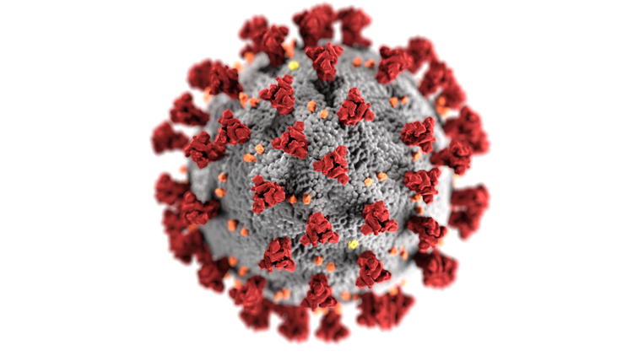

THIS COVID-19 PLAN TEMPLATE AND SELF ASSESSMENT DOCUMENT
FOR ACUTE CARE HOSPITALS WAS PREPARED AS A PUBLIC HEALTH SERVICE BY
Cesar Figueroa Ortiz, Nivedita Ramajayam, Stephanie Parchment, and Zachary Ballard
In Fulfillment of their Graduate Studies Course Requirements
GU-5150: Emergency Preparedness for Healthcare Organizations
NYU School of Global Public Health, New York, NY.
July, 2020

Disaster Plan: COVID-19
[Enter hospital title here]
[Enter hospital city and state here]

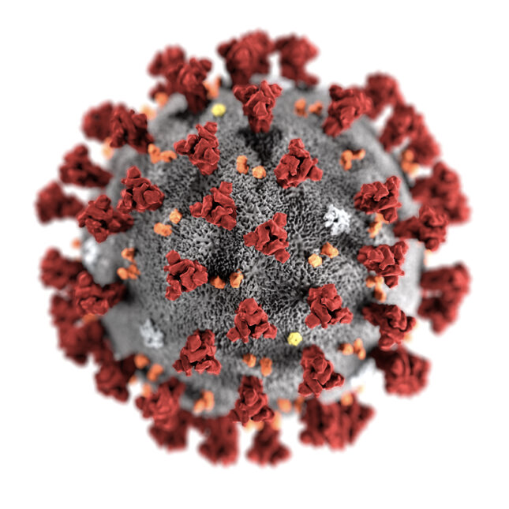

[Enter date of plan here]

Table of Contents
 | Page(s) #
Cover Page, Table of Contents | 1-4
Preface, Signature Page | 5-6
Mission Statement, Scope and Objectives | 7-8
Authorities, Definitions | 8-10
Communication Plans, Mutual Aid Agreements | 10-13
Threat and Hazard Assessment and Risk Identification (THIRA) | 13-14
Incident Command Organizational Chart | 15
Facility Profile Document | 16-17
Patient Care Capacity | 17-18
Other Healthcare Facility Resources | 19-20
Back-Up Plan Document | 20-21
Facilities Readiness Document | 21
Continuity of Business Document | 22
Designation of the Incident Commander and Succession Plan | 23
Location of the Command Center | 23-25
Emergency Management Committee Document | 25-26
Training Plan | 26-28
Emergency Communications Document | 28-32
Decision Tree for Determining Evacuation vs Shelter-in-Place | 33-34
Mutual Aid Agreement (Response Sponsors) | 35
Annexes  Annex 1: Additional Key Stakeholders  Annex 2: Mental Health  References | 36  36-37  38-39

Preface
The first case of the recent coronavirus disease, COVID-19, was reported in Wuhan City, China on December 8, 2019.¹ More than three weeks later, on December 31, the World Health Organization (WHO) received the first report of a cluster of similar cases.¹ After initiating an investigation and activating protocols for a major disease outbreak, WHO received another report from a Chinese laboratory which identified a novel coronavirus through genomics on January 7, 2020.^{1,2} The first documented case of COVID-19 in the United States (US) was reported on January 20.³ By January 30, 2020, WHO declared the outbreak a Public Health Emergency of International Concern^{1,3} During the subsequent weeks, additional cases of COVID-19 were increasingly recognized throughout the world, and several countries began restricting travel and instituting quarantine or shelter-in-place measures. On March 11, WHO declared COVID-19 a pandemic because of the rapid rise in cases outside of China.¹ By March 26, the US reported the highest number of cases in the world, with over 80,000 confirmed cases and 1,000 deaths.³ Although much of the US then followed stringent shelter-in-place and social distancing measures, the healthcare system was severely challenged by the large and growing number of COVID-19 patients requiring hospitalization.

As early as March 20, 2020, in New York State (NYS), then the epicenter of the pandemic in the US, 18% of the 10,356 COVID-19 patients (approximately 1,864 people) required hospitalization.⁴ This surge of gravely ill patients severely taxed the entire health care infrastructure in NYS and especially in New York City (NYC) where cases were most prevalent. Hospitals in NYC and across the country began struggling to keep up with personal protective equipment (PPE) demand, problems with supply chain bottlenecks, lack of durable medical equipment such as ventilators and dialysis machines, inadequate ICU capacity, and clinician and staff shortages.^{3,5} As of September 5, 2020, data from the Johns Hopkins COVID-19 Dashboard indicates there have been 6,269,916 million COVID-19 cases in the United States and 188,791 deaths.³ Rates of transmission have fallen recently in some parts of the United States, whereas in other parts, rates are rapidly increasing following recent relaxation of social distancing measures.

Signature Page

___________________________________________________________________
[Insert name], President and CEO

___________________________________________________________________
[Insert name], Board Chairperson

___________________________________________________________________
[Insert name], Physician-in-Chief

___________________________________________________________________
[Insert name], Chief Operating Officer

___________________________________________________________________
[Insert name], Hospital Incident Command Center Administrator

___________________________________________________________________
[Insert other names and titles as appropriate. Additional roles and suggestions can be found in Annex 1.]

Mission Statement
{insert you own hospital’s mission here}

Example: To provide compassionate, high quality and cost effective healthcare to residents of {insert name of your community}, by promoting health, educating health professionals and participating in clinical research.

Statement of Purpose
The purpose of this plan is to ensure adequate preparedness of {insert name of your hospital} for the provision of safe and best practices health care for increasing numbers of patients suffering from COVID-19, and to provide guidance to protect the health and safety of all hospital staff. This includes guidelines on case identification and testing, best isolation practices, surge capacity and management, and education and training of frontline healthcare workers.

The objective of this disaster plan is to guide the organization during the COVID-19 pandemic by the following:
- Defining the parameters for implementing the plan and providing timely information regarding the number of suspected and known patient cases in the hospital as well as infection rates among staff.
- Defining roles and establishing responsibilities of the hospital staff and departments within the organization to respond to the pandemic.
- Ensuring the effective operationalization of HICS.
- Assuring adequate surge capacity to meet needs at a minimum of 30% surge in new COVID-19 cases (staff, supplies, space and equipment).
- Ensuring staff safety and health including mental health.
- Ensuring that the needs of vulnerable populations in the community (children, pregnant women, elderly, disabled, non-English speaking, homeless, etc.) are addressed appropriately and with compassion.
- Identifying primary/alternative emergency communication systems.
- Establishing communication processes for public and patient information.
- Identifying appropriate policies for admission, transfer and discharge of patients.
- Managing surge and alternate care processes.
- Effectively managing morgue operations to address surge in decedents.
- Communication with local and state government authorities and mutual aid partners.
- Finding and using relevant community resources, including family assistance programs.
- Providing resources to response partners, including community organizations
- Recovery process for operations of the hospital.

Authorities
- Presidential emergency declaration: {In US: Presidential declaration of a national emergency took place on March 1, 2020, under sections 201 and 301 of the National Emergencies Act (50 U.S.C. 1601 et seq.) and consistent with section 1135 of the Social Security Act (SSA), as amended (42 U.S.C. 1320b-5)} {If not in the US, insert presidential emergency declaration equivalent here}
- National Health Minister or Health Secretary emergency declaration: {In US: The Secretary of Health and Human Services (HHS) declaration of a public health emergency took place on January 31, 2020, under section 319 of the Public Health Service Act (42 U.S.C. 247d)} {If not in the US, insert the health minister/secretary emergency declaration here}.
- Insurance administration authority response: {In US: As a result of presidential and health secretary’s response, the Centers for Medicare and Medicaid Services (CMS) issued activated blanket waivers to ease certain requirements for impacted institutions in order to allow them to respond to the pandemic. This allowed waiving Medicare, Medicaid requirements, making enrollment more flexible, providing greater relief to state Medicaid agencies and suspending enforcement activities} {If not in the US, insert insurance administration response here}
- Statement from hospital accreditation agency: {In US: As a result of the emergency declaration, the Joint Commission (JCAHO) paused all accreditation and inspection related activities in hospitals in order to allow them to focus on treatment of patients suffering from COVID-19. JCAHO is the main legal authority who allows hospitals in the US to prepare for an outbreak} {If not in the US, insert accreditation agency response here}

Definitions/Acronyms
Disaster: A natural or man-made event that results in great loss of life or physical damage and that overwhelms the response capacity of local emergency systems.
CDC: Centers for Disease Control and Prevention. The federal agency that serves as the leading national public health institute of the United States under the Department of Health and Human Services.
HIPAA: Health Insurance Portability and Accountability Act. Enforces the protection of personally identifiable information maintained by the healthcare and healthcare insurance industries from fraud and theft, and address limitations on healthcare insurance coverage.
JCAHO: The Joint Commission. A United States-based nonprofit tax-exempt 501(c) organization that accredits US health care organizations and programs.
SARS-CoV-2: Severe Acute Respiratory Syndrome Coronavirus 2
COVID-19: Coronavirus Disease 2019
PPE: Personal protective equipment. Clothing, helmets, goggles, or other garments or equipment designed to protect the wearer's body from injury or infection. The hazards addressed by PPE include physical, electrical, heat, chemicals, biohazards, and airborne particulate matter.
LIP: Licensed independent practitioner. Defined as an individual, as permitted by law and regulation, and also by the organization, to provide care and services without direction or supervision within the scope of the individual’s license and consistent with the privileges granted by the organization
EHS: Emergency Health and Safety Services.
EOC: Emergency Operations Center
ED: Emergency Department
EMS: Emergency Medical Services
GNYHA: Greater New York Hospital Association
HICS: Hospital Incident Command System:
ICU: Intensive Care Unit. Hospital department that provides care to critically ill patients who have, are at risk of, or are recovering from conditions that may be life-threatening. It includes providing life support, invasive monitoring techniques, resuscitation, and end-of-life care.
PACU: Post-anesthesia Care Unit
SACU: Surgical Acute Care Unit
OR: Operating Room
MCI: Mass Casualty Incident
MOU: Memoranda of Understanding

Communication Plan
Internal Communications:
{Describe how clinical and nonclinical communications are conducted in your institution}.

Below are examples of components that may be included in an institution’s internal communications strategy:

- Center-wide Notification of HICS Activation
Communication of non-life-threatening situations may be done by email, intranet announcements or messaging to personal communication devices. Overhead announcements can be made for immediate life threats and in selected cases, notifications can be made through radio or television as directed by the Public Information Officer.

- Staff Communications during Emergencies
Hospital staff may be directed to only use landline phone communications for disaster-related matters. Institutions may consider installing designated emergency-use only phones if there is a failure of the regular phone system. If designated emergency-use only phones are installed, a list of the numbers and locations should be maintained in an easily accessible location.

External Communications:
{Describe how your institution communicates with external entities and partner institutions}

Below are examples of components that may be included in an institution’s external communications strategy:

- Notifying & Communicating with External Authorities
When a disaster plan is activated, appropriate external authorities and community partners should be notified whenever necessary. This is important in order to facilitate response and prevent disruptions to patient care.

- Coordinating with Healthcare Organizations and Public Safety Agencies
Local Emergency Management Agencies may activate Emergency Operation Centers and/or Situation Rooms during major incidents. Within these centers, representatives of hospital and healthcare organizations may receive important information that is necessary to coordinate response efforts. Hospitals should maintain an Emergency Contact Directory in electronic and hard copies and should commit to providing important information regarding patient occupancy and evacuation needs to jurisdictional authorities when needed {insert the number of your local hospital organization and jurisdictional authority here}.

- Communicating Patient Information
Hospitals should have a predefined process to transfer patient information in case of a disaster. Such information includes patient demographics and aspects related to clinical care. Such processes should be kept in electronic and hardcopy formats in case of computer system failures, and should adhere to current privacy rules and laws.

- Communicating with Patients & Family Members
Hospitals may consider the establishment of a family support center that will facilitate communication with the family members of patients. This center will coordinate and serve as a link between key staff and patients’ family members to keep them informed on the location and status of patients, to address the family’s needs and concerns, and to provide information on helpful resources to aid the families during difficult times. Translation services should be available for assistance of family members who are not fluent in local language.

- Communicating with the Media & the Public
The Public Information Officer (PIO) is responsible for communicating with the media and for providing all public information. This will avoid sending conflicting information or mixed messages to the public.

- Communicating with Supply Chain Vendors
The Procurement Director and the Director of Emergency Management (or equivalent personnel) should be responsible for maintaining a list of vendors, contractors, and consultants that can provide necessary services before, during, and after an emergency event. They should also be responsible for maintaining a list of alternative and emergency sources of supplies. For facilitating services during a community event, there should be a Memoranda of Understandings (MOUs) to help coordinate response with key partner agencies, whenever necessary.

- Redundant Communication Capabilities
In case of communication failure, hospitals should keep alternate communication systems and devices that are tested regularly. These systems and devices should be listed in a Communications Plan that describes all communications capabilities maintained by the hospital.

Mutual Aid Agreement

The following institutions will provide mutual aid to {insert name of your hospital} in the event of a COVID-19 outbreak {list all that apply to your institution. See some examples below}:
- Local Department of Health and Mental Hygiene
- State Department of Health and Mental Hygiene
- Local Hospital Association
- Neighboring Hospitals and Medical Facilities
- Department of Homeland Security and Emergency Services
- Local Emergency Management Agency
- National Public Health Institute(s) (e.g. in the US, this would be the Centers for Disease Control and Prevention (CDC))
- Local Department of Social Services
- Local Department of Sanitation
- Local Police Department
- Local Fire Department
- Emergency Medical Services (EMS)
- Local Red Cross
- Mayor’s office

Sample Threat and Hazards Assessment Table:

New York City
[Use as a reference point in creating or editing your facility’s THIRA]

Natural | Technological | Human-caused
Resulting from acts of nature | Involves accidents or the failures of systems and structures | Caused by the intentional actions of an adversary
- Epidemic/Pandemic: Communicable disease spreads quickly in densely populated cities, and the ongoing COVID-19 pandemic has exemplified New York’s vulnerability; the city has sustained 204,000 confirmed cases and 16,410 deaths as of 6/1/20.⁷  - Hurricane: As a hospital situated on the United States’ eastern coast (and within an urban context), Hospitals are vulnerable to hurricanes and hurricane-related damage. New York has a long history of being affected by hurricanes.⁸  - Flood: In addition to hurricane damage, flooding is a serious concern in many areas of New York. Hurricane Sandy, for example, caused widespread damage, including extended MTA train issues.^{9,10} Further, the boroughs of New York are situated between active rivers and were constructed before modern floodproofing. Another hazard is that many patients have low mobility in an evacuation.  - Winter storm: Winter storms can often cause power outages and/or prevent patients and workers from reaching hospitals for services and their work.  - Heat wave: Though hospitals have heat protection and backup generators, heat waves are dangerous for elderly populations and people physically weakened due to cancer treatment.¹¹ | - Hazardous materials release: Many precautions surround hazardous material disposal in the hospital environment, but New York is home to many different material processing and dump sites.¹² Should any releases happen, the hospital is potentially within the range of effect from some sites.  - Power failure: Though hospitals are built with backup generators and emergency power failure plans, extended blackouts are serious threats to immunocompromised patients, research property, food services, and other vital functions within a hospital.  - Train derailment: Any delay or halt of train traffic in New York immediately impacts providers, administrators, environmental services and other crucial roles in the day-to-day operations of a hospital. Both short- and long-term train issues can impact the quality and timelines of care many cancer patients need on a regular basis, including chemotherapy.  - Infrastructure collapse: Many patients commute to Manhattan or nearby satellite sites to seek treatment, and any interruption of commonly used bridges or tunnels could delay care or affect the ability of some workers to be physically present for their shifts.  - Urban conflagration: Fires can spread quickly in urban environments, and hospitals are particularly vulnerable when situated in residential communities or when buildings are very close together. | - Cyber incident: Patient data is protected information, but hospitals are vulnerable to cyber-attacks or acts of cyber terrorism. Though hospitals have the appropriate cautionary measures in place, protected health information (PHI) or intellectual property (IP) are particularly valuable.¹³  - Explosives attack: Whether threats or actually carried out, New York is often a target of explosive attacks. Recent attacks or threats have included Times Square, bus terminals, and train stations.¹⁴ Hospitals in Manhattan are in busy and densely populated areas and are potentially vulnerable to explosives attacks.  - Acts of violence: Acts of violence are common in New York, and the workplace is no exception.¹⁵ Though hospitals have robust plans to counteract violent trespassers (e.g., “Code Silver” and other codes and precautions), there is always a possibility a violent act could occur at the hospital.¹⁶  - Arson/Fire: Hospitals contain flammable and hazardous materials that must be protected from patients, staff, and visitors to maintain safe operating conditions.¹⁶ Purposeful and accidental fires pose serious threats due to their ability to spread rapidly within a hospital and the overall lack of mobility some patients have.

SAMPLE HOSPITAL INCIDENT COMMAND CHART
{adapt to your own facility and add names}
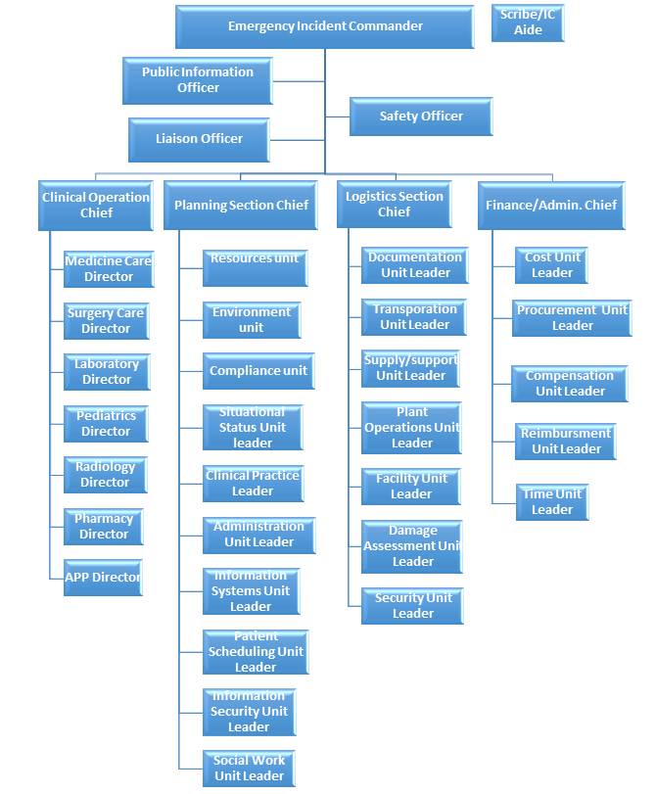
Hospital Profile
Hospital Name | Total # of Licensed Beds (per NDMS)
(Insert Hospital Name Here) | (Insert Total # of beds here)

Hospital Information
Facility Address | (insert address here)
Facility is located: | (check the corresponding box)  □ As a part of a medical center/medical school  □ Stand-alone  □ Part of a regional hospital system  □ Part of a national hospital chain  □ Military
JCAHO Accreditation | □ Yes Year of Accreditation: _____________  □ No
Facility Phone # | (insert phone number here)
Facility Fax # | (insert fax number here)
Facility Email | (insert email here)
Facility Online Website | (insert online website URL here)

Hospital Staffing
Clinical | (insert # of clinical personnel here)
Non Clinical | (insert # of non clinical personnel here)
Licensed Practitioners | (insert # of licensed practitioners here)
Residents (if teaching hospital) | (insert # of residents here IF a teaching hospital)
TOTAL HOSPITAL STAFF | (insert total # of staff here)

Non-hospital based (Satellite) Clinics and Staffing
# of Clinics | (insert # of clinics here)
Clinic Staff | (insert # of clinic staff here)
Full Time Staff | (insert # of full time staff here)
Contract Staff | (insert # of contract staff here)

Facility is a National Disaster Medical System (NDMS) member | □ Yes  □ No
If yes, site of Federal Coordinating Center (FCC): | (insert name and address of FCC if applicable)

Facility is located in a Metropolitan Medical Response System Region | □ Yes  □ No  □ Don’t know

Facility has an on-site heliport/helipad | □ Yes  □ No
Capacity of helipad: | Weight: ____________  Number of pads: ___________  (N/A if no heliport/helipad)
Lighted: | □ Yes □ No
Access: | (insert how heliport/helipad is accessed here)
Support: | (insert support information for heliport/helipad here)
How is it coordinated?
Temporary heliport/helipad? | □ Yes  □ No
Landing zone is maintained by:
Crash response provided by:
Hospital response team | □ Yes □ No
Local Fire Department | □ Yes Fire Department Address: ________________________  □ No

FACILITY PATIENT CARE CAPACITY
 | LICENSED BED CAPACITY | AVERAGE BED USE (average number of beds utilized and staffed in the last 6 months) | NEGATIVE PRESSURE ROOMS  (single rooms available for airborne isolation) | OTHER ISOLATION ROOMS  (single rooms that can be used for any type of isolation) | MONITORED BEDS  (bed with cardiac and respiratory monitoring) | VENTILATORS  (number of  available  ventilators) | SURGE CAPACITY  (Number of additional beds that can be equipped and staffed w/in 12hrs)
Acute Rehabilitation Unit
Ambulatory
Behavioral Health
Burn Unit
Emergency Department
Medical Intensive Care
Neonatal Intensive Care
Pediatric Intensive Care
Surgical Intensive Care
Medical Surgical
Nursery
OB-GYN (peripartum labor and delivery)
Operating Room
Pediatrics
Post Anesthesia Care
Step Down, Intermediate
Care
Skilled Nursing Facility

SELF-ASSESSMENT: OTHER HOSPITAL CAPACITIES

Category | Element | Detail
Laboratory | Lab Biosafety Level | [Enter 1, 2, 3, or 4]
 | Laboratory volume per hour that stimulates additional/urgent staffing plan | [Enter volume per hour]
 | COVID-19 antibody testing kits | [Enter #]
 | COVID-19 respiratory swabs | [Enter #]
Trauma Level Designation | Level | [Enter I, II, III, or IV]
 | Certified by ACS?  Certified by State? | [Enter Y/N]  [Enter Y/N]
Ambulance/EMS | Does the hospital lease or own ambulances? | [Enter Y/N]
 | Ground or air? | [Enter ground, air, or both]
Morgue | Capacity | [Enter #]
Transportation | List types and number of vehicles facility owns/operates for patient transport (not including EMS rigs): | [Enter #]
PPE supplies on hand | Gloves | [Enter actual # or number of days of supply ]
 | Gowns | [Enter #]
 | N95 Masks | [Enter #]
 | Face Shields | [Enter #]
Other Resources | HEPA Filters | [Enter #]
 | Portable cardiac monitors | [Enter #]
 | Portable X-ray | [Enter #]
 | Portable sonograms | [Enter #]
 | Portable ventilators | [Enter #]
 | Portable dialysis units | [Enter #]
 | Automatic resuscitation devices | [Enter #]
 | Total number of ventilators | [Enter #]
 | Average % of ventilators in use within last 6 months | [Enter %]
 | Radiation therapy | [Enter #]

LOGISTICS AND FACILITIES AND BACK-UP PLAN
Emergency Power | a. Emergency power duration is ______ hours.
 | b. Emergency power generation capability is:
c. Emergency power generator is located: (physical location)
□ At grade □ Above grade □ Below grade
 | d. Emergency power generator was last tested:
 | e. How often is it tested?
d. Do you have: □ None □ Partial Load of Operation
□ Full Load of Operations
 | e. How long can it be run without refueling?
 | f. Does it power only Life Safety? □ Yes □ No
 | g Does it power Life Safety and full facility? □ Yes □ No
 | h. Does it power elevators? □ Yes □ No
 | i. Does it power the critical branches? □ Yes □ No
 | j. Load shed?
 | k. Preservation of food?
Water Supply | a. Source of facility water is: □ community □ facility
b. Secondary source of water if primary source is cut off:
□ Yes □ No Capacity:
 | c. Can you attach non-potable water to your facility? □ Yes □ No
Fuel | a. Facility has ______ days of fuel on-hand.
 | b. How does the facility get additional fuel?
 | c. How long can boilers run?
 | d. What is the amount of time (in hours) that boilers can operate w/o refueling?
Respirators and Ventilators | a. Number of respirators in long term use that signifies need surpasses available devices?
 | b. Number of ventilators in long term use that signifies need surpasses available devices?
c. Source of additional respiratory water is: □ hospitals
□ manufacturers □ NGOs □ Government

FACILITY READINESS
Respiratory Protection Equipment Status | a. Percent of total clinical staff with fit-testing for N95 or N99 respirators annually:
 | b. Percent of non-clinical staff with fit-testing for N95 or N99 respirators annually:
 | c. Quantity of powered air purifying respirators:
Disaster Readiness Training | a. Percent of total staff who have completed disaster response/preparedness training:
 | b. Percent of medical staff who have completed disaster response/preparedness training:
 | c. Percent of nursing staff who have completed disaster response/preparedness training:
 | d. Percent of total staff who have trained with facility’s own disaster plan:
 | e. Percent of medical staff who have trained with facility’s own disaster plan:
 | f. Percent of nursing staff who have trained with facility’s own disaster plan:
Location of Readiness Literature | a. Percent of total staff with access to their own readiness cheat sheet.
 | b. Percent of medical staff with access to their own readiness cheat sheet.
 | b. Percent of nursing staff with access to their own readiness cheat sheet.
 | d. Quantity of facility specific disaster response/preparedness manuals.

CONTINUITY OF BUSINESS OPERATIONS
1. Hospital has a leadership succession plan (LSP) | □ Yes  □ No | (include reference to LSP and any other important notes)
a. Hospital has a continuity of operations plan (COOP) | □ Yes  □ No | (include reference to COOP and any other important notes)
b. Has COOP been exercised in the last 6 months? | □ Yes  □ No | (include date exercised & reference to documentation of COOP exercised if applicable)
c. If no, when was the last time it was exercised? |  |  | (include date exercised & reference to documentation of COOP exercised if applicable)
d. Facility has a business continuity plan | □ Yes  □ No | (include reference to business continuity plan and any other important notes)
e. Hospital has a business continuity plan administrator and/or team with specified roles and responsibilities | □ Yes  □ No | (include contact information, reference to section of business continuity plan with roles and responsibilities, and any other important notes)
f. What are the three priority functions restored first? |  |  | (include three priority functions and any other notes)
g. Is there a process/plan to track financial resources used? | □ Yes  □ No | (include reference to process/plan and any other important notes)

DESIGNATION OF INCIDENT COMMANDER AND SUCCESSION
Item | Y/N | Notes
1. A Hospital Incident Command System (HICS) is in place | □ Yes  □ No | (reference to HICS)
a. HICS is exercised at least twice annually | □ Yes  □ No | (date last exercised)
b. HICS is coordinated by a Unified Command Structure when appropriate with fire, law enforcement, and EMS | □ Yes  □ No | (reference to Unified Command Structure)
c. 1. Incident Commander is known by all staff  2. Incident commander succession plan is in place | □ Yes  □ No  □ Yes  □ No | (incident commander information, reference to incident commander succession plan)
d. There is a procedure to designate an Incident Commander | □ Yes  □ No | (reference to procedure)
e. Staff assigned to HICS leadership roles are oriented to their responsibilities | □ Yes  □ No | (reference to staff and roles)
f. Staff assigned to key roles wear identifying gear during an event | □ Yes  □ No | (reference to key roles)
g. All staff know where to report when the HICS is activated | □ Yes  □ No | (reference to reporting location)
h. Staff understands the flexibility of their positions in the HICS if leadership is unavailable | □ Yes  □ No
i. Is HICS NIMS compliant? | □ Yes  □ No
j. Are after action reports completed after all exercises? | □ Yes  □ No | (reference to reports)

HOSPITAL COMMAND CENTER
# | Subject and Item |  | Y/N | Notes
1 | A Hospital Command Center (HCC) is fully operational and integrated into local/county emergency planning and operations. |  | □ Yes  □ No
2 | In the HCC, telephone numbers are available for:
 |  | The local health department | □ Yes  □ No
 |  | State health department | □ Yes  □ No
 |  | Local FBI field office | □ Yes  □ No
 |  | CDC Emergency Preparedness Office | □ Yes  □ No
 |  | Others [list in notes] | □ Yes  □ No
3 | HCC is equipped with:
 |  | Telephones | □ Yes  □ No
 |  | Satellite phones | □ Yes  □ No
 |  | Fax | □ Yes  □ No
 |  | Two-way radios | □ Yes  □ No
 |  | Generator | □ Yes  □ No
 |  | Maps of hospital | □ Yes  □ No
 |  | Maps of local area | □ Yes  □ No
 |  | Bullhorns | □ Yes  □ No
 |  | Flashlights | □ Yes  □ No
 |  | Copy of the emergency management plan | □ Yes  □ No
 |  | Other [list in notes] | □ Yes  □ No
4 | HCC is located in a secure location. |  | □ Yes  □ No
5 | An alternate HCC site exists and can be used if the preliminary site is inaccessible. |  | □ Yes  □ No
6 | HCC can maintain 24-hour operations for a minimum of 1 week. |  | □ Yes  □ No
7 | HCC can monitor local media. |  | □ Yes  □ No
8 | Each section chief has a designated telephone line. |  | □ Yes  □ No
9 | The ICS command staff has an adequate, pre-defined communications system. |  | □ Yes  □ No

HOSPITAL EMERGENCY MANAGEMENT/DISASTER PREPAREDNESS COMMITTEE
A hospital emergency management/disaster preparedness committee exists and provides leadership and governance. | Yes □ No□
a. The committee is multidisciplinary. | Yes □ No□
b. Open meetings are held regularly. | Yes □ No□
How Often
c. The committee minutes/actions plan are available for review. | Yes □ No□
d. The committee forwards critiques of all drills to appropriate services in a timely manner. | Yes □ No□
e. The committee is knowledgeable of hospital “systems” plans that could override local plans. | Yes □ No□
f. The committee communicates with and/or cooperates with other hospitals in the community. | Yes □ No□
g. Facility representative attends at least 75% of local/community emergency planning committee meetings. | Yes □ No□
h. Facility representative reports to governance of the hospital on community planning, exercises and after-action reports. | Yes □ No□
i. Facility participates in joint training exercises. | Yes □ No□

TRAINING, DRILLS AND EXERCISES
Training
All staff receive orientation to the Emergency Management Plan (EMP). | Yes □ No□
Hospital staff complete annual training/education in CBRNE. | Yes □ No□
a. Emergency Department staff receive at least twice-annual training on response to Chemical, Biological, Radiological, Nuclear and Explosive (CBRNE) events. | Yes □ No□
b. All other clinicians receive annual CBRNE training. | Yes □ No□
c. All non-clinicians receive annual CBRNE/emergency preparedness training. | Yes □ No□
d. All clinicians receive annual blood-borne pathogens training. | Yes □ No□
e. All clinicians maintain current Basic Life Support (BLS) registration. | Yes □ No□
f. Percentage of staff who have taken a NIMS course and/or are NIMS certified. | Yes □ No□
Drills and Exercises
Facility exercises an Emergency Management Plan (EMP) at least twice per year. | Yes □ No□
a. Exercises are conducted at least 4 months apart and no more than 8 months apart. | Yes □ No□
b. Date of last exercise.
c. Facilities that offer emergency services include an influx of simulated patients in one exercise. | Yes □ No□
d. Facility participates in at least one community-wide exercise per year. | Yes □ No□
Drills/exercises take place on all shifts, on all units and include all facility departments. | Yes □ No□
a. Contract staff is included in drills/exercises. | Yes □ No□
Facility has conducted an exercise with casualties. | Yes □ No□
Exposed to a hazardous material | Yes □ No□
Agent requiring decontamination | Yes □ No□
Responded to an actual event in the last 12 months | Yes □ No□
All ED personnel participate in at least twice-annual mass casualty exercises. | Yes □ No□
At least one exercise in the last year was unannounced. | Yes □ No□
Facility has drilled evacuation of staff and patients in the last 12 months. | Yes □ No□
a. Exercise includes horizontal evacuation (to other units). | Yes □ No□
b. Exercise includes vertical evacuation (to other floors). | Yes □ No□

COMMUNICATIONS, WARNING, AND NOTIFICATION
FACILITY NOTIFICATION
Facility can send and receive emergency warning and notification information.
- Yes
- No
a. Facility can receive warnings of imminent emergency conditions from external agencies.
- Yes
- No
b. Facility can send warnings to external agencies.
- Yes
- No
c. Redundant communication system is in place in the event that the primary system fails.
- Yes
- No

STAFF NOTIFICATION
Facility can notify on-duty and off-duty staff of emergency status and recall to duty.
- Yes
- No
a. Facility has a plan to notify on-duty and off-duty staff of emergency status.
- Yes
- No
b. Staff notification system has been tested in the past 6 months.
- Yes
- No
c. Facility has staff notification with up-to-date, verified phone and other contact information.
- Yes
- No
d. Facility has either an automated call-back system or staff identified and dedicated to staff notification.
- Yes
- No
e. Staff can receive warnings from the Digital Emergency Alert System by either voice or text messages on their wireless phones.
- Yes
- No
f. Facility keeps a current and updated list of staff that volunteer and are likely to be deployed during an emergency (NDMS, National Guard, etc.)
- Yes
- No
g. The EMP takes into account staff backfill issues.
- Yes
- No
COMMUNICATIONS
Command uses compatible radios (e.g. 800 mhz) for communications with local agencies.
- Yes
- No
Emergency Operations Center has a dedicated telephone trunk line.
- Yes
- No
Two-way radio communication (walkie-talkie) is available for all units and essential personnel.
- Yes
- No
Facility has access to communications on wheels (COWS).
- Yes
- No
Facility has access to an amateur radio system (Ham/RACES).
- Yes
- No
A back-up communications system is in place in the event that the primary system fails.
- Yes
- No
If all technology-based communications fail, staff members who will serve as ‘runners’ have been identified.
- Yes
- No
Runners have access to a base communication for direction and information
- Yes
- No
Runners have access to materials such as paper and pens to note important details that need to be relayed.
- Yes
- No

INFORMATION MANAGEMENT/TELECOMMUNICATIONS
Essential information systems and data storage have offsite storage and recovery capabilities.
- Yes
- No
Information management staff participate in facility emergency exercises.
- Yes
- No
System has protection from viruses and intentional attacks (hacking).
- Yes
- No

PUBLIC INFORMATION AND MEDIA RELATIONS
Facility has a designated public information officer (PIO).
- Yes
- No
a. In the event of multi-agency response, media activities will be coordinated through Joint Information Center (JIC).
- Yes
- No
b. PIO has established relationships with counterparts in Public Health and emergency management agencies.
- Yes
- No
Staff know where and to whom media inquiries are to be referred.
- Yes
- No
A site is designated for regular meetings with media.
- Yes
- No
a. PIO has developed generic press releases about the facility and possible emergency conditions.
- Yes
- No
b. PIO has established relationships with local media.
- Yes
- No
c. The press conference location is outside the facility.
- Yes
- No

Sample Decision Tree for Evacuations vs. Shelter in Place
Option 2: Epidemic

Sample Decision Tree for disaster events that OCCUR During COVID-19 Response:
- Determine Scope of Impending Disaster/Event
  - COVID-specific spread and local context
- Complete Pre-Disaster Self-Assessment
  - Includes Hospital Command Center (HCC) preparedness
- Decision: Order Pre-Event Evacuation?
- Shelter in Place
- Event Occurs
- Assess Status
- Potential/Evolving Threat to Patient/Staff Safety
- Decision: Order Post-Event Evacuation?
- Start Evacuation
- Determine Sequence of Patient Evacuation
- Carry Out Evacuation

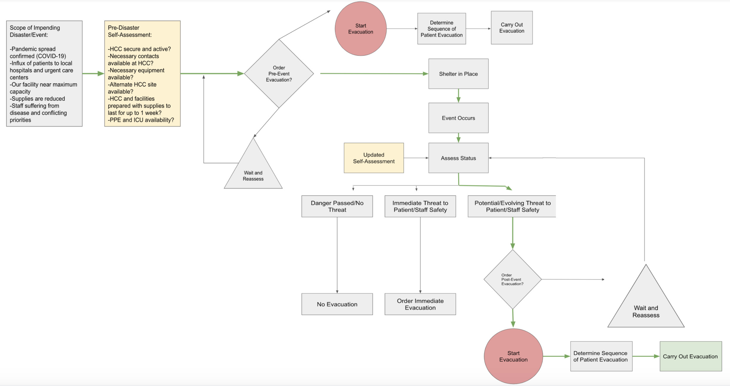
Note: Green arrows represent a sample decision process for events that occur during COVID-19.

MUTUAL AID AGREEMENTS (RESPONSE PARTNERS)
a. Facility has current mutual aid Memorandum of Understanding (MOUs) in place? | Yes □ No□
Memorandum of Understanding (MOUs) are in place with: | Yes □ No□
Law enforcement | Yes □ No□
Fire | Yes □ No□
Emergency medical services (EMS) | Yes □ No□
Public Safety | Yes □ No□
Military installations | Yes □ No□
Other local and regional care facilities | Yes □ No□
Burn Center | Yes □ No□
Red cross | Yes □ No□
MMRS | Yes □ No□
CERT | Yes □ No□
Other | Yes □ No□
b. Memorandum of Understanding (MOUs) are in place for:
Portable MRI | Yes□ No□
Portable CT | Yes □ No□
Portable Dialysis | Yes□ No□
Generator | Yes □ No□

Annex 1: Additional Key Stakeholders for Disaster Plan Signatures

[Include in Signature Page or as an addendum when necessary/useful]

Chief Officer Roles:
Facilities Management, Infection Control, Emergency Department, Public Relations and Communications, Finance, Health Information, Human Resources, Security, Compliance/Integrity, Legal, Medical Officer, Operating Officer, Patient Safety, Population Health

Others (if applicable):
Local DOH
Local Office of Emergency Management
Local Hospital Association(s)

Annex 2. Mental Health

Take the following steps to cope with a disaster and make this information available to employees, residents, and their family members:
- Take care of your body
  - Try to eat healthy well-balanced meals,
  - Exercise regularly
  - Try to get a good night’s rest
  - Avoid alcohol, tobacco, and other drugs.
- Connect with others
  - Share your concerns and how you are feeling with a friend or family member.
  - Maintain healthy relationships and build a strong support system.
- Take breaks
  - Make time to unwind and remind yourself that strong feelings will fade.
  - Try taking in deep breaths.
  - Try to do activities you usually enjoy.
- Stay informed
  - Watch, listen to, or read the news for updates from officials.
  - Be aware that there may be rumors during a crisis, especially on social media.
  - Always check your sources and turn to reliable sources of information like your local government authorities.
- Avoid too much exposure to news
  - Take breaks from watching, reading, or listening to news stories. It can be upsetting to hear about the crisis and see images repeatedly.
- Seek professional psychological support if needed
  - If an employee is experiencing a difficult time at work, your SNF site should provide you access to a professional psychologist or counselor
  - If a resident is exhibiting signs of stress or loneliness, your SNF site should connect them with a psychologist or counselor and try to incorporate technology to allow them to interact with friends and family
  - In the event that a resident or staff passes away from COVID-19, it is important to acknowledge grief. Allow for virtual access to connect with your SNF community to allow time to grieve and heal.
Stress during an infectious disease outbreak can sometimes cause the following:
- Fear and worry about your own health and the health of your loved ones, your financial situation or job, or loss of support services you rely on.
- Changes in sleep or eating patterns.
- Difficulty sleeping or concentrating.
- Worsening of chronic health problems.
- Worsening of mental health conditions.
- Increased use of tobacco, and/or alcohol and other substances.
Get immediate help in a crisis, facilities should be sure to post these resources for all employees and residents to see:
- Call 911
- Disaster Distress Helpline 1-800-985-5990 (press 2 for Spanish), or text TalkWithUs for English or Hablanos for Spanish to 66746. Spanish speakers from Puerto Rico can text Hablanos to 1-787-339-2663.
- National Suicide Prevention Lifeline 1-800-273-TALK (8255) for English, 1-888-628-9454 for Spanish
- National Domestic Violence Hotline 1-800-799-7233 or text LOVEIS to 22522
- National Child Abuse Hotline 1-800-4AChild (1-800-422-4453) or text 1-800-422-4453
- The Eldercare Locator 1-800-677-1116
- Crisis Chat text: 8388255
References:
https://emergency.cdc.gov/coping/selfcare.asp
https://www.cdc.gov/coronavirus/2019-ncov/daily-life-coping/managing-stress-anxiety.html

Resources
- WHO Coronavirus Disease (COVID-19) Dashboard. Who.int. https://covid19.who.int/?gclid=Cj0KCQjw_ez2BRCyARIsAJfg-kvy0pOqliMCXV9DcsxV4sGmYMPP4GuoSk9CbbcgCntWW_qJBIplXA8aAjsoEALw_wcB. Accessed June 6, 2020.
- Global Biodefense Staff. (2020, February 28). Lab that first shared novel Coronavirus genome still shut down by Chinese government | global biodefense. Retrieved June 13, 2020, from Global Biodefense website: https://globalbiodefense.com/headlines/chinese-lab-that-first-shared-novel-coronavirus-genome-shut-down/
- CDC. Cases in the U.S. 2020. https://www.cdc.gov/coronavirus/2019-ncov/cases-updates/cases-in-us.html. Accessed June 6, 2020.
- Workbook: NYS-COVID19-Tracker. (n.d.). Retrieved June 13, 2020, from Health.ny.gov website: https://covid19tracker.health.ny.gov/views/NYS-COVID19-Tracker/NYSDOHCOVID-19Tracker-DailyTracker?%3Aembed=yes&%3Atoolbar=no&%3Atabs=n
- Ranney ML, Griffeth V, Jha AK. Critical supply shortages - the need for ventilators and personal protective equipment during the covid-19 pandemic. N Engl J Med. 2020;382(18):e41.
- Hospital Evacuation Decision Guide (Figure 1) | agency for health research and quality. (n.d.). Retrieved June 29, 2020, from Ahrq.gov website: https://www.ahrq.gov/research/shuttered/hospevacfig1.html
- Cases in the U.S. Centers for Disease Control and Prevention. https://www.cdc.gov/coronavirus/2019-ncov/cases-updates/cases-in-us.html. Published May 29, 2020. Accessed June 1, 2020.
- NBC New York. A history of major storms in NYC. NBC New York. https://www.nbcnewyork.com/news/local/hurricane-sandy-storm-tri-state-major-storms-history/1966316/. Published October 26, 2012. Accessed June 2, 2020.
- National Weather Service. Flooding in New York. 2018. https://www.weather.gov/safety/flood-states-ny. Accessed June 2, 2020.
- Calgary O. Sandy Inundation Zone. NYC Open Data. https://data.cityofnewyork.us/Environment/Sandy-Inundation-Zone/uyj8-7rv5. Accessed June 1, 2020.
- Cdc.gov. https://www.cdc.gov/pictureofamerica/pdfs/picture_of_america_heat-related_illness.pdf. Accessed June 2, 2020.
- Plan for hazards - hazardous materials chemical spills radiation - NYCEM. Nyc.gov. https://www1.nyc.gov/site/em/ready/hazardous-materials-chemical-spills-radiation.page. Accessed June 2, 2020.
- Information Security at MSK. Memorial Sloan Kettering Cancer Center Careers. https://careers.mskcc.org/learn-about-msk/careers-blog/posts/2018/september/close-up-information-security-at-msk/. Accessed June 2, 2020.
- BBC News. Attacker targets Manhattan bus terminal. BBC. December 11, 2017.
- Violent crime rate by borough – NYC – mayor’s office of criminal justice. Cityofnewyork.us. https://criminaljustice.cityofnewyork.us/individual_charts/violent-crime-rate-by-borough/. Accessed June 2, 2020.
- Memorial Sloan Kettering Cancer Center. Memorial Sloan Kettering Cancer Center. https://www.mskcc.org. Accessed June 2, 2020.

