**COVID-19 RESPONSE PLAN TEMPLATE for LARGE ACUTE CARE HOSPITALS**

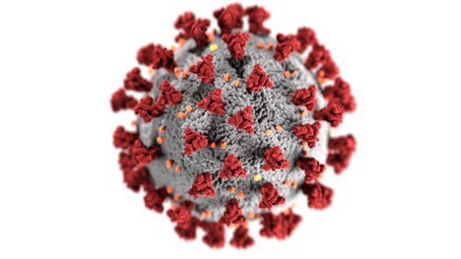

THIS COVID-19 PLAN TEMPLATE FOR ACUTE CARE HOSPITAL WAS PREPARED AS A PUBLIC HEALTH SERVICE BY:

Robin Allen

Marisa DeFilippis

Lauren Fox

Rebecca Sherrod

GPH-GU 5150 Emergency Preparedness for Healthcare Organizations

New York University School of Global Public Health

July, 2020



**Table of Contents**

**Preface** **3**

**Signature Page** **4**

**Mission Statement** **5**

**Purpose of the Plan** **5**

**Facility Profile Document** **6**

**Definitions & Acronyms** **8**

**Communications Plan** **9**

**Internal Communication** **9**

**External Communication** **10**

**Other Hospital Capacities** **10**

**Patient Care Capacity** **11**

**Logistics and Facilities and Back-Up Plan** **12**

**Emergency Power** **12**

**Facilities Readiness** **13**

**Continuity of Business Operations** **14**

**Designation of Incident Commander and Succession** **15**

**Training, Drills, and Exercise** **16**

**Best Practices** **17**

**Personal Protective Equipment** **17**

**Use of PPE for COVID-19** **18**

**Don and Doff Facemask:** **18**

**Don and Doff Respirator:** **18**

**Healthcare Professional Preparedness Checklist** **18**

**Telehealth** **19**

**Communications, Warning, and Notification** **20**

**Sample Decision Tree for Evacuation vs shelter in place 23**

**Hospital Emergency Management & Disaster Preparedness Committee** **24**

**Appendices 28**

**Appendix A: HCP use of PPE** **28**

**Appendix B: CDC Facemask Do’s and Don’ts** **29**

**Appendix C: CDC Respirator On and Off** **30**

**Appendix D: Mental Health and Psychosocial Support (MHPSS) Needs 31**

# **Preface**

COVID-19 is a respiratory illness caused by the novel coronavirus, SARS-CoV-2. It is spread primarily by droplets, as well as aerosol and to a lesser extent by direct contact with contaminated inanimate objects. The presentation of the virus ranges from mild/moderate symptoms (80% of infections) similar to the common cold, to more severe illness (15% of infections) and finally to critical and possibly fatal conditions (5% of infections) requiring intensive treatment. The first case of COVID-19 was confirmed in Wuhan, China in late 2019; its rapid spread led to a declaration of a pandemic by the WHO in early March of 2020. While a source has not been definitively identified, data are strongly suggestive of its emergence from an animal source. Lack of vaccination, high transmissibility, high fatality in certain populations, and lack of established treatment has made this disease hard to manage.

As of July 11th, 2020, there have been approximately 13 million COVID-19 cases with 563 thousand deaths worldwide**,** and over 3 million cases and 135 thousand deaths in the United States (US). New York City (NYC) alone accounts for 223 thousand of the US cases and about 24 thousand deaths to date, putting it at the forefront of the COVID-19 pandemic in the US. New York City, with its high population density, poses significant challenges in managing disease outbreaks of this magnitude. Its residents are largely reliant on public transportation methods and, additionally, as a major tourist destination and transit hub, millions of people pass through the city annually, potentially increasing the spread within the city confines and beyond. NYC is home to over 60 acute care hospitals, including several that are large, state-of-the-art, nationally recognized medical centers. These hospitals, as well as others across the US and around the world, continue to be at the front line in delivery of care to COVID-19 patients. Few facilities have had the opportunity to prepare their own COVID-19 Disaster Plans. This Self-Assessment Tool is designed to help assist hospitals in the development or refinement of those plans.

# **Signature Page**

(Facilities should attach their own Organizational Chart as an Annex (Annex 1)

____________________________________________________________________________

Hospital Chief Executive Officer Date

____________________________________________________________________________

Chief Financial Officer Date

____________________________________________________________________________Chief Medical Director Date

____________________________________________________________________________

Chief Operating Officer Date

____________________________________________________________________________Chief Nursing Officer Date

____________________________________________________________________________

Chief Legal Officer Date

____________________________________________________________________________

Chief Emergency Manager Date

____________________________________________________________________________

Chief of Facilities Management Date

____________________________________________________________________________

Chief of Infection Control Date

____________________________________________________________________________

Chief of Public Relations and Communications Date

___________________________________________________________________________

Chief health Information Officer Date

____________________________________________________________________________

Chief Public Safety Officer Date

____________________________________________________________________________

Chief of Human Resources Date

____________________________________________________________________________

Chief of Security Date

____________________________________________________________________________

Local Office of Emergency Management Date

____________________________________________________________________________

Local Fire Department Date

____________________________________________________________________________

Local Police Department Date

____________________________________________________________________________

Local Department of Health Date

____________________________________________________________________________

Local Hospital Association Date

# **Mission Statement**

The mission of (insert facility name and tailor to your own mission statement) is to ensure that we provide highest possible quality of patient-centered care to the population that we serve; to provide a safe and healthy work environment for all employees; and to provide a fast, safe and effective response to the COVID-19 pandemic.

# **Purpose of the Plan**

**Statement of Purpose**

The purpose of this plan is to ensure that (hospital name goes here) can safely and effectively meet the COVID-19-related healthcare needs of our community. This Plan provides best practices guidance that emphasizes elements of infection prevention and control programs that should be in place to prevent the transmission of any infectious agents including in healthcare settings. These recommendations are informed by published evidence-based infection prevention and control and occupational health and safety regulations and guidelines and the following considerations:

* Current lack of a safe and effective vaccine and any chemoprophylaxis
* A possible high rate of mortality among some infected patients
* High levels of community transmission in some locations
* Incompletely defined modes of transmission of SARS-CoV-2
* Past experience with patient surge that requires readiness for additional periods of surge

Due to the rapidly changing situation, we will continue to evaluate new information as it becomes available and will update or expand this plan as needed.

# **Facility Profile Document**

Directions: Fill in the information in accordance with your specific hospital's information.

|  |
| --- |
| **Hospital Name**: |
| **Total Licensed Beds (Based on NDMS definition):** |

|  |
| --- |
| **Facility Information** |
| **Address:** |
| **Main Phone Number:** |
| **Main Fax Number:** |
| **Main Email:** |

|  |  |
| --- | --- |
| **Affiliations** | |
| **JCAHO Accreditation** | □ Yes  □ No |
| **Year of Accreditation** |  |
| **Facility Affiliation** | □ As part of a medical center/school  □ Stand-alone or community  □ Part of a regional hospital system  □ Part of a national hospital chain  □ Military or Government |
| **National Disaster Medical System (NDMS) member?** | □ Yes  □ No |
| **If YES - Site of Federal Coordinating Center (FCC)** |  |
| **Is Facility located in a Metropolitan Medical Response System Region** | □ Yes  □ No  □ Unsure |

|  |  |
| --- | --- |
| **Important Contact Information** | |
| **Patient Condition Information** |  |
| **Page Operator** |  |
| **Emergency Department** |  |

|  |  |
| --- | --- |
| **Hospital Staffing # of FT/PT** | |
| **Clinical** |  |
| **Non-Clinical** |  |
| **Licensed Practitioners** |  |
| **Residents (if teaching hospital)** |  |
| **Total Hospital Staff** | |

|  |  |
| --- | --- |
| **Non-Hospital or Satellite Clinics and Staffing** | |
| **Number of Clinics** |  |
| **Clinic Staff** |  |
| **Full-Time Staff** |  |
| **Contract Staff** |  |
| **Total Staff** | |

|  |  |
| --- | --- |
| **Helipad Access** | |
| Facility has on-site heliport or helipad? | □ Yes  □ No |
| **If YES** | |
| **Capacity of helipad** | Weight: |
|  | Number of Pads: |
| **Lighted** | □ Yes  □ No |
| **Access?** |  |
| **Support?** |  |
| **How is it coordinated?** |  |
| **Temporary helipad available?** | □ Yes  □ No |
| **Landing zone maintained by?** |  |
| **Crash Response provided by:** |  |
| **Hospital Response Team**  **(unit)** | □ Yes ________________________________  □ No  □ Unsure |
| **Local Fire Department**  **(location)** | □ Yes ________________________________  □ No  □ Unsure |

# 

# **Definitions & Acronyms**

# 

**ER**- Emergency Room

**ED**- Emergency Department

**EM+ER**- Emergency management + Enterprise Resilience

**ICU**- Intensive Care Unit

**SICU**- Surgical Intensive Care Unit

**MICU**- Medical Intensive Care Unit

**PPE**- Personal Protective Equipment

**Precaution Signs-** Signage placed in front of the door to alert medical personnel on the appropriate PPE to wear.

**N95**- a respiratory protective equipment created to have a close facial fit and effective air filtration

**Eye Protection-** eyewear barrier to protect eyes from splash back and droplets

**Isolation-** A hospital measure used to prevent the spread of a contagious disease from patient to patient

**RRT-** Rapid Response Team

**Negative Pressure-** Used as a giant vacuum for environmental contaminants, by sending more air out than the room takes in.

**Intubated-** an inserted tube commonly placed in trachea to help patient receive Oxygen

**Surge Space-** Additional spaces used in the medical center to accept a surplus of patients

**Command Center-** A touchdown space for the Emergency Management team and specialist

**OHS-** Occupational Health and Safety

**IPC-** Infection Prevention Control

**Hand Hygiene-** A practice that should be performed upon entry and exit of all patient care areas. This practice can be used with soap and water or with hand sanitizer.

# **Communications Plan**

Directions: In this section, describe how you will relay information to employees and to the public during a COVID-19 outbreak. You should use the Hospital Incident Command System to assign the responsibilities of Public Information Officer, Liaison Officer, and under the Logistics Section the Communication Unit Leader (see .

## Internal Communication

*[Please describe your hospital's internal communication plan and system in this section. For example, you can describe existing communication methods within your hospital such as the landline phone system, electronic paging system, overhead paging system, email, text message alerts, etc. Then describe how, in an emergency situation, the hospital will relay information to employees - examples include but are not limited to text, email, overhead page, or phone tree system. Determine what backup methods of communication you will have if the traditional methods are unavailable. For example, will team leaders receive radios, and do you have enough? Take this time to establish a Radio Channel or Frequency. Describe how frequently you will provide updates.*

|  |  |
| --- | --- |
| 1. Has a primary and backup person been assigned responsibility for internal communications with staff, patients, and their families regarding COVID-19? | * Yes * No |
| 1. Primary Contact (name, title, contact information): |  |
| 1. Backup Contact (name, title, contact information): |  |

## **External Communication**

*[Similar to the above statements, describe how you will communicate with outside organizations and the media. For example, will you rely on a landline, cell phone, or email updates? Provide and guidelines for your Public Communication and Liaison officers and how they will interact with their respective parties. Additionally describe how you will communicate with outside MUA contacts including but not limited to other hospitals, fire departments, local governments, etc. Determine how you plan to communicate with patients and family members.]*

|  |  |
| --- | --- |
| 2. Has a primary and backup person been assigned responsibility for public health authorities (i.e. case counts and status updates) | * Yes * No |
| 1. Primary Contact (name, title, contact information): |  |
| 1. Backup Contact (name, title, contact information): |  |

# **Other Hospital Capacities**

|  |  |
| --- | --- |
| **Trauma Level Designation:**  **Certified by:** | I ___ II ___ III___ IV___ V____  ACS _____ or STATE _____ |
| **Laboratory Bio-Safety Level** | 1___ 2___ 3___ 4___ |
| **Ambulance/EMS** | Lease #___ or Own # ___ Ground or Air?_____ |
| **Morgue Capacity** | # _________ |
| **Radiology (# machines)** | CT scan ______ X-Ray _______ MRI _______ |
| **Ventilators (# portable machines)** | # _________ |
| **Defibrillators (# machines)** | #__________ |
| **Average ICU ventilator use** | % _________ |
| **Ultrasound (# machines)** | #__________ |
| **Portable cardiac monitors (# machines)** | #__________ |
| **Pulse oximetry monitors (# machines)** | #__________ |
| **Dialysis (# machines)** | #__________ |

# **Patient Care Capacity**

*Please fill in the with appropriate numbers for your hospital*

|  |  |  |  |  |  |  |  |
| --- | --- | --- | --- | --- | --- | --- | --- |
|  | Licensed Bed Capacity | Average Staffed Beds  (Avg. beds actually in use and staged in last 6 months) | Beds with Negative Air Flow  (For use in respiratory isolation) | Monitored Beds  (Beds equipped with cardiac and vital signs) | Ventilators  (number of ventilators owned or rented in each unit) | Surge Capacity  (# of additional beds that can be staffed & equipped w/in 12 hours) | Negative Pressure Beds/ Isolation |
| Ambulatory |  |  |  |  |  |  |  |
| Behavioral Health |  |  |  |  |  |  |  |
| Burn |  |  |  |  |  |  |  |
| Emergency Department |  |  |  |  |  |  |  |
| Intensive Care, Medical |  |  |  |  |  |  |  |
| Intensive Care, Neonatal |  |  |  |  |  |  |  |
| Intensive Care, Pediatric |  |  |  |  |  |  |  |
| Intensive Care, Stepdown |  |  |  |  |  |  |  |
| Intensive Care, Surgical |  |  |  |  |  |  |  |
| Medical-Surgical |  |  |  |  |  |  |  |
| Nursery |  |  |  |  |  |  |  |
| Obstetric (Ante/post – partum, labor, delivery) |  |  |  |  |  |  |  |
| Operating Room |  |  |  |  |  |  |  |
| Pediatrics |  |  |  |  |  |  |  |
| Post Anesthesia Care |  |  |  |  |  |  |  |
| Skilled Nursing Facility Care |  |  |  |  |  |  |  |

# **Logistics and Facilities and Back-Up Plan**

|  |  |
| --- | --- |
| **Emergency Power** | a. Emergency power duration is ____ hours. |
| b. Emergency power generation capability is: |
| c. Emergency power generator is located: (physical location)  At grade Above grade Below grade |
| d. Emergency power generator was last tested: |
| e. How often is it tested? |
| d. Do you have: None Partial Load of Operations Full Load of Operations |
| e. How long can it be run without refueling? |
| f. Does it power only Life Safety? Yes No |
| g Does it power Life Safety and full facility? Yes No |
| h. Does it power elevators? Yes No |
| i. Does it power the critical branches? Yes No |
| j. Load shed? |
| k. Preservation of food? |
| **Water Supply** | a. Source of facility water is: community facility |
| b. Secondary source of water if primary source is cutoff: Yes No Capacity: |
| c. Can you attach non-potable water to your facility? Yes No |
| **Fuel** | a. Facility has days of fuel on-hand. |
| b. How does the facility get additional fuel? |
| c. How long can boilers run? |
| d. What is the amount of time (in hours) that boilers can operate w/o refueling? |

# **Facilities Readiness**

|  |  |
| --- | --- |
| **Respiratory Protection Equipment Status** | **%** |
| Percent of total clinic staff with fit-testing for N95 or N99 respirators annually |  |
| Percent of non clinical staff with fit-testing for N95 or N99 respirators annually |  |
| Quantity of powered air purifying respirators |  |

|  |  |
| --- | --- |
| **Disaster Readiness Training** | **%** |
| Percent of total staff who have completed disaster response/preparedness training |  |
| Percent of medical staff who have completed disaster response/preparedness training |  |
| Percent of nursing staff who have completed disaster response/preparedness training |  |
| Percent of total staff who have trained with facility’s own disaster plan |  |
| Percent of medical staff who have trained with facility’s own disaster plan |  |
| Percent of nursing staff who have trained with facility’s own disaster plan |  |

# **Continuity of Business Operations**

|  |  |
| --- | --- |
| Leadership succession plan in place? | * Yes * No |
| Facility has continuity of operations plan  (COOP)? | * Yes * No |
| Has COOP been exercised in last 6 months? | * Yes * No |
| If no, when was it last exercised? | Date:_________________ |
| Facility has a business continuity plan? | * Yes * No |
| Priority functions to be restored first? | 1. _________________ 2. _________________ 3. _________________ |
| System in place to track use of financial resources? | * Yes * No |

# **Designation of Incident Commander and Succession**

|  |  |
| --- | --- |
| An Incident Command System (ICS) or Hospital Incident Command System is in place? | * Yes * No |
| 1. ICS is exercised at least twice annually? | * Yes * No   Last Exercised:____________ |
| 1. ICS is coordinated by a United Command Structure coordinated appropriately with law enforcement, fire, EMS. | * Yes * No |
| 1. Incident Commander is known by all staff? | * Yes * No |
| 1. Incident Commander succession is in place. | * Yes * No |
| 1. There is a procedure to designate an Incident 2. Commander. | * Yes * No |
| 1. Staff assigned to ICS leadership role are oriented to their responsibilities. | * Yes * No |
| 1. Staff assigned to key roles wear identifying gear during an event. | * Yes * No |
| 1. All staff know where to report when the ICS is activated. | * Yes * No |
| 1. Staff understands the flexibility of their position in the ICS if leadership is unavailable. | * Yes * No |
| 1. ICS or HICS is NIMS compliant? | * Yes * No |
| 1. After action reports are completed after all exercises? | * Yes * No |

# **Training, Drills, and Exercise**

|  |  |
| --- | --- |
| **TRAINING** |  |
| Staff oriented to Emergency Management Plan (EMP)? | * Yes * No |
| Annual training completed in chemical, biological, radiological, nuclear and explosive events (CBRNE) for all staff? | * Yes * No |
| ED department completes bi-annual training on CBRNE events? | * Yes * No |
| All other clinicians receive CBRNE training? | * Yes * No |
| All non-clinical staff receive CBRNE training? | * Yes * No |
| All clinicians receive blood-borne pathogen training? | * Yes * No |
| All clinicians maintain Basic Life Support (BLS) training? | * Yes * No |
| Percentage of staff who are NIMS certified or have taken course? | % _________________ |

|  |  |
| --- | --- |
| **DRILLS AND EXERCISES** |  |
| Facility exercises EMP bi-annually? | * Yes * No |
| 1. Exercises are conducted at least 4 months apartment and no less than 8 months apart | * Yes * No |
| 1. Date of last exercise? | Date: ______________ |
| Influx of simulated patients included in exercise? | * Yes * No |
| Facility participates in at least one community exercise per year? | * Yes * No |
| Exercises take play on all shifts/all units? | * Yes * No |
| Outside contractors included in exercise? | * Yes * No |
| Facility has concluded casualty exercises?   1. Exposed to a hazardous material? 2. Agent requiring decontamination? 3. Responded to a real event in the last 12 months? | * Yes * No * Yes * No * Yes * No |
| All ED staff participate in bi-annual mass casualty events? | * Yes * No |
| At least one exercise in the last year was announced? | * Yes * No |
| Facility has had patient and staff evacuation drill in the past 12 months?   1. Horizontal evacuation drill (to other units)? 2. Vertical evacuation drill (to other floors)? | * Yes * No * Yes * No * Yes * No |

# **Best Practices**

## Personal Protective Equipment

### Use of PPE for COVID-19

Please see Appendix A for visual guidance on use of PPE when caring for patients with confirmed or suspected COVID-19. Facilities may find it helpful to utilize a Burn Rate Calculator to continuously monitor and optimize their PPE use. A sample from the CDC can be accessed at <https://www.cdc.gov/coronavirus/2019-ncov/hcp/ppe-strategy/burn-calculator.html>

|  |  |
| --- | --- |
| **Healthcare Providers must:** |  |
| Have all received comprehensive training on when what PPE is necessary, how to don and doff PPE, limitation of PPE, proper care, maintenance and disposal of PPE? | * Yes * No |
| Demonstrate competency in performing appropriate infection control practices and procedures | * Yes * No |

#### **Don and Doff Facemask:**

Please review the CDC’s guide to donning and doffing facemasks (Appendix B).

#### **Don and Doff Respirator:**

Please review the CDC’s guide to donning and doffing respirators (Appendix C).

## Healthcare Professional Preparedness Checklist

The CDC recommends ensuring every healthcare personnel has reviewed the following best practices and protocols for each of the following areas for the transport and arrival of patients with confirmed or possible COVID-19. The hospital should frequently update the source of ‘Best Practices’ to ensure providers are using the most up to date information available.

|  |
| --- |
| 1. Assessment and triage of patients with acute respiratory symptoms |
| 1. Patient placement within hospital |
| 1. Implementation of Standard, Contact, and Airborne Precautions, including the use of eye protection |
| 1. Visitor management and exclusion |
| 1. Source control measures for patients (e.g. put facemask on suspect patients) |
| 1. Requirements for performing aerosol generating procedures |
| 1. Identifying and being alert for patients with PUI |
| 1. Reporting potential COVID-19 acase or expire to facility infection control leads and public health officials |
| 1. Know who, when, and how to seek evaluation by occupational health following an unprotected exposure to a suspected or confirmed COVID-19 patient |
| 1. Remain at home, and notify occupational health services if you are ill |
| 1. Know how to contact receive information form you state and local public health agency |

## **Telehealth**

When applicable and if services are available, the hospital will transition to telehealth practices. The CDC recommends telehealth for the following situations:

* Screen patients who may have symptoms of COVID-19 and refer as appropriate
* Provide low-risk urgent care for non-COVID-19 conditions, identify those persons who may need additional medical consultation or assessment, and refer as appropriate
* Access primary care providers and specialists, including mental and behavioral health, for chronic health conditions and medication management
* Provide coaching and support for patients managing chronic health conditions, including weight management and nutrition counseling
* Participate in physical therapy, occupational therapy, and other modalities as a hybrid approach to in-person care for optimal health
* Monitor clinical signs of certain chronic medical conditions (e.g., blood pressure, blood glucose, other remote assessments)
* Engage in case management for patients who have difficulty accessing care (e.g., those who live in very rural settings, older adults, those with limited mobility)
* Follow up with patients after hospitalization
* Deliver advance care planning and counseling to patients and caregivers to document preferences if a life-threatening event or medical crisis occurs
* Provide non-emergent care to residents in long-term care facilities
* Provide education and training for HCP through peer-to-peer professional medical consultations (inpatient or outpatient) that are not locally available, particularly in rural areas

*Please visit* <https://www.matrc.org/matrc-telehealth-resources-for-covid-19/> *for a comprehensive list of COVID-19 telehealth resources available.*

|  |  |
| --- | --- |
| Telehealth Service Utilized: _________________________________________________ | |
| Basic Telehealth Checklist | |
| 1. 1. Telehealth Policies |  |
| 1. Check federal and state laws and regulations governing telehealth and reimbursement |  |
| 1. Check professional license laws, regulations and guidance documents |  |
| 1. Check for professional ethics and guidelines and standards |  |
| 1. Check for professional practice guidelines |  |
| 2. Reimbursement | Do the following reimburse for telehealth? |
| 1. Medicare (Fee for Service) |  |
| 1. Medicare Advantage |  |
| 1. Medicaid (Fee for Service) |  |
| 1. Medicaid (Managed Care) |  |
| 1. Shared Savings Plan |  |
| 1. Private (Commercial) |  |
| 1. Private (Self Insured) |  |
| 1. Tricare |  |
| 3. Technology Needs |  |
| 1. Is this a temporary stopgap measure or a longer term model |  |
| 1. What is my program model? |  |
| 1. What is the ideal workflow? (good patient and provider experience) |  |
| 4. Plan and Test |  |
| 1. Engaged and trained all applicable staff on telehealth platform |  |
| 1. Developed clear written protocols |  |
| 1. Pilot test? |  |

# **Communications, Warning, and Notification**

|  |  |
| --- | --- |
| **FACILITY NOTIFICATION** |  |
| Facility can send and receive emergency warning and notification information? | * Yes * No |
| Facility can receive warnings of imminent emergency conditions from external agencies? | * Yes * No |
| Facility can send warnings to external agencies? | * Yes * No |
| Redundant communication system is in place in the event the primary system fails? | * Yes * No |

|  |  |
| --- | --- |
| **STAFF NOTIFICATION** |  |
| Facility can notify on-duty and off-duty of emergency status and recall to duty? | * Yes * No |
| 1. Facility has plan to notify on-duty and off-duty staff of emergency status? | * Yes * No |
| 1. Staff notification system been tested in the past 6 months? | * Yes * No |
| 1. Facility has staff notification with up-to-date, verified phone and other contact information? | * Yes * No |
| 1. Facility has either an automated call-back system or staff identified and dedicated to staff notification? | * Yes * No |
| 1. Staff can receive warnings from the Digital Emergency Alert System by either voice or text messages on their wireless phones? | * Yes * No |
| 1. Facility keeps a current and updated list of staff that volunteer and are likely to be deployed during an emergency (NDMS, National Guard, etc.)? | * Yes * No |
| 1. The EMP takes into account staff backfill issues? | * Yes * No |

|  |  |
| --- | --- |
| **COMMUNICATIONS** |  |
| Command uses compatible radios for communications with local agencies? | * Yes * No |
| Emergency Operations Center has a dedicated telephone trunk line? | * Yes * No |
| Two-way radio communication (ex- walkie talkie) is available for all units and essential personnel? | * Yes * No |
| Facility has access to communications on wheels (ex- COWS)? | * Yes * No |
| Facility has access to an amateur radio system? | * Yes * No |
| A backup communications system is in place in the event that the primary system fails? | * Yes * No |
| If all technology-base communications fail, staff members who will serve as “runners” have been identified? | * Yes * No |

|  |  |
| --- | --- |
| **INFORMATION MANAGEMENT/TELECOMMUNICATIONS** |  |
| Essential information systems and data storage have offsite storage and recovery capabilities? | * Yes * No |
| Information management staff participate in facility emergency exercises? | * Yes * No |
| System has protection from viruses and intentional attacks (hacking)? | * Yes * No |

|  |  |
| --- | --- |
| **PUBLIC INFORMATION AND MEDIA** |  |
| Facility has a designated public information officer (PIO)? | * Yes * No |
| 1. In the event of a multi-agency response, media activities will be coordinated through Joint Information Center (JIC)? | * Yes * No |
| 1. PIO has established relationships with counterparts in Public Health and emergency management agencies? | * Yes * No |
| Staff know where to and whom media inquiries are to be referred? | * Yes * No |
| A site is designated for regular meetings with media? | * Yes * No |
| 1. PIO has developed generic press releases about the facility and possible emergency conditions? | * Yes * No |
| 1. PIO has established relationships with local media? | * Yes * No |
| 1. The press conference location is outside the facility? | * Yes * No |

**Sample Decision Tree For Evacuations vs. Shelter in Place**

(tailor decision tree according to your facility needs)

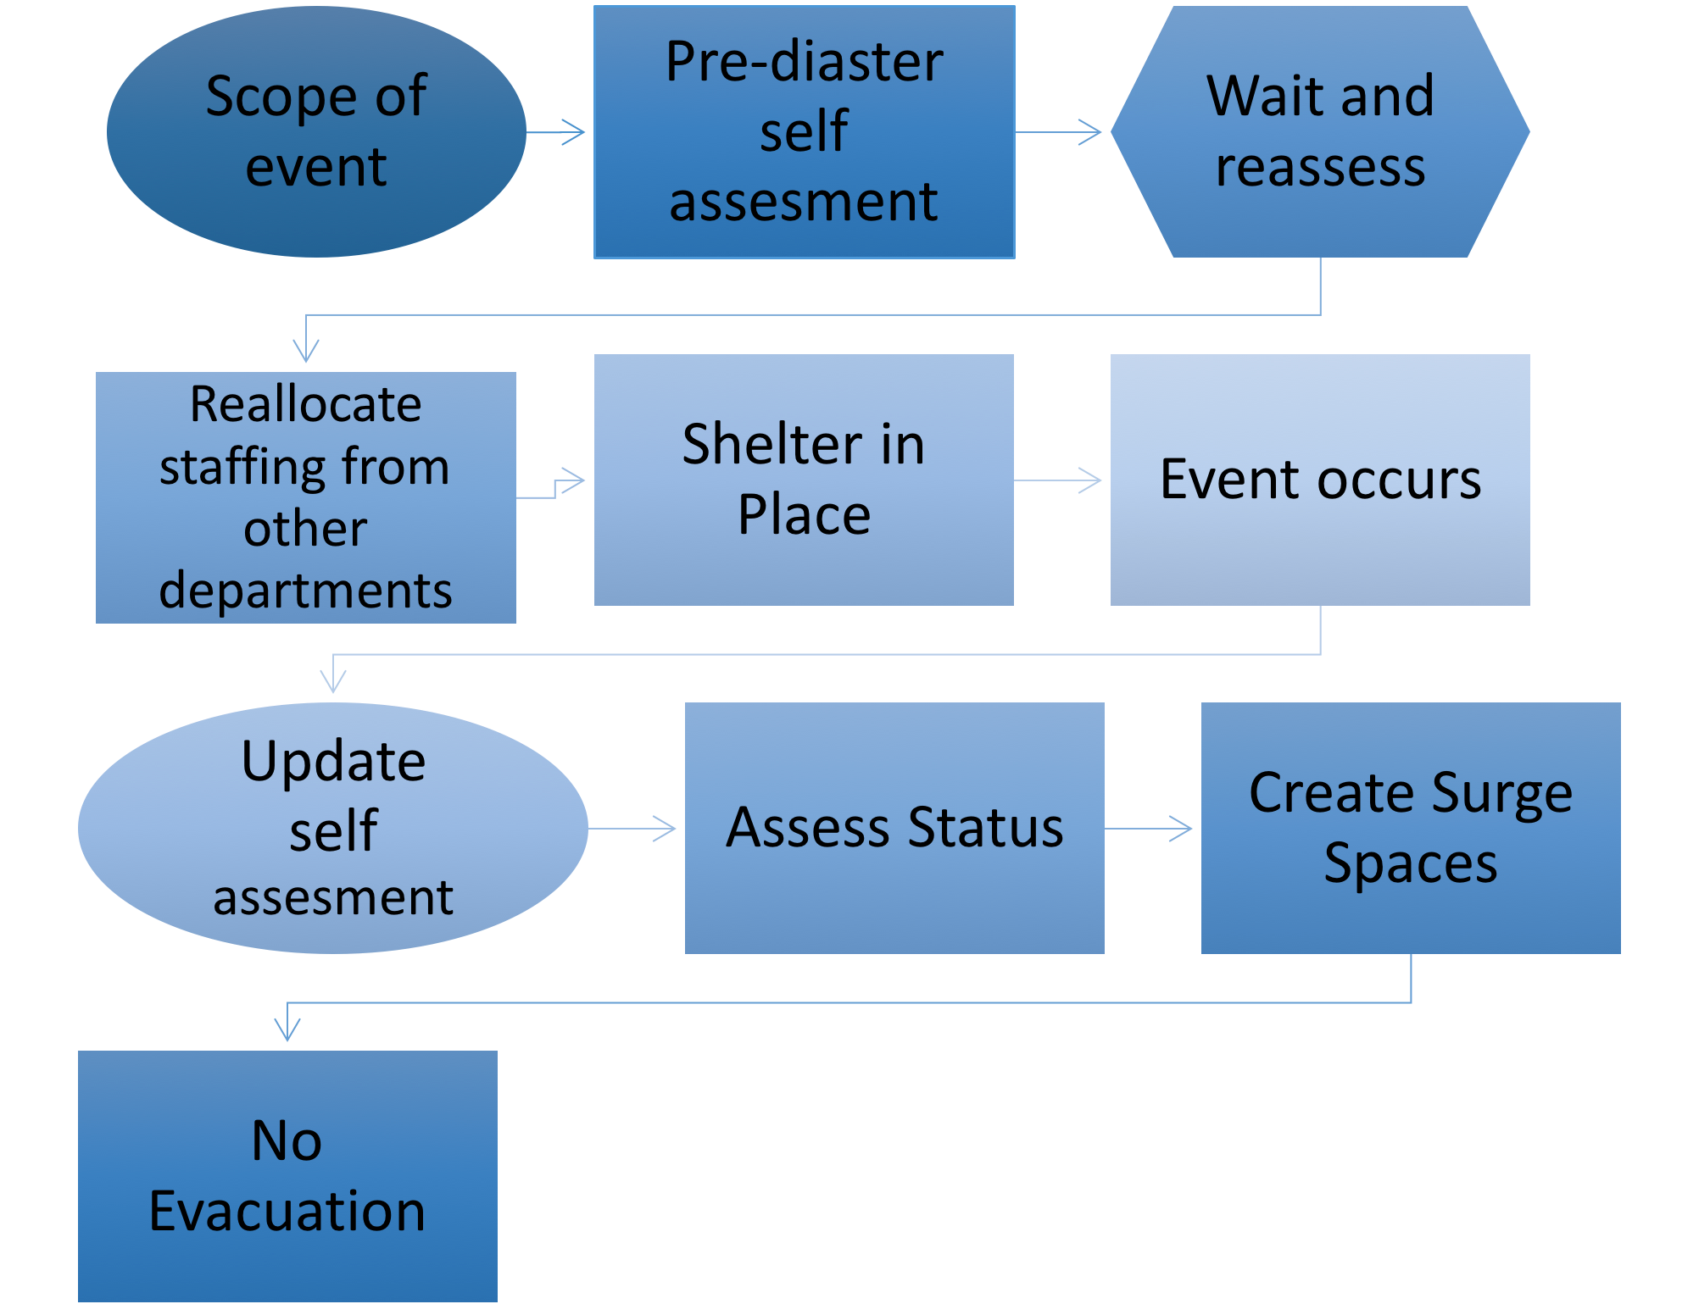

# **Hospital Emergency Management & Disaster Preparedness Committee**

|  |  |  |
| --- | --- | --- |
|  |  | Details |
| A hospital emergency management/disaster preparedness committee exists and provides leadership and governance? | * Yes * No |  |
| 1. Committee is multidisciplinary? Which disciplines are represented? | * Yes * No |  |
| 1. Open meetings are held regularly? Frequency? | * Yes * No |  |
| 1. Committee meeting minutes/action are available for review? Where? | * Yes * No |  |
| 1. Committee forwards critiques of all drills to appropriate services in a timely manner? Which services? | * Yes * No |  |
| 1. Committee is knowledgeable of hospital “system” plans that could override local plans? What are these plans? | * Yes * No |  |
| 1. Committee communicates with and/or cooperates with other hospitals in the community? Which hospitals? | * Yes * No |  |
| 1. Facility representative attends at least 75% of Local/Community Emergency Planning Committee meetings | * Yes * No |  |
| 1. Facility representative reports to governance of the hospitals on community planning, exercises and after-action reports | * Yes * No |  |
| 1. Facility participates in joint training exercises? With who? | * Yes * No |  |

**HOSPITAL COMMAND CENTER**

|  |  |
| --- | --- |
| A Hospital Command Center (HCC) is fully operational and integrated into  local/county emergency planning and operations. | * Yes * No |
| 1. In the HCC, telephone numbers are available for: |  |
| * 1. Local health department | * Yes * No |
| * 1. State health department | * Yes * No |
| * 1. Local FBI held office | * Yes * No |
| * 1. CDC Emergency Preparedness office | * Yes * No |
| * 1. Other:______________ | * Yes * No |
| 1. HCC Is equipped with: |  |
| * 1. Telephones | * Yes * No |
| * 1. Satellite phones | * Yes * No |
| * 1. Fax | * Yes * No |
| * 1. Two way radios | * Yes * No |
| * 1. Generator | * Yes * No |
| * 1. Maps of hospital | * Yes * No |
| * 1. Maps of local area | * Yes * No |
| * 1. Bullhorns | * Yes * No |
| * 1. Flashlights | * Yes * No |
| * 1. Copy of the emergency management plan | * Yes * No |
| 1. HCC is located in a secure location | * Yes * No |
| 1. An alternate HCC site exists and can be used if the primary facility is not accessible | * Yes * No |
| 1. HCC can maintain 24 hr operations for a minimum of 1 week | * Yes * No |
| 1. HCC can monitor local media | * Yes * No |
| 1. Each section chief has a designated telephone line | * Yes * No |
| 1. The ICS command staff has an adequate, predefined communications system | * Yes * No |

**MUTUAL AID AGREEMENTS**

|  |  |
| --- | --- |
| Facility has current mutual aid Memorandum of Understanding (MOUs) in place | * Yes * No |
| 1. Memorandum of understanding (MOUs) are in place with: |  |
| * 1. Law enforcement | * Yes * No |
| * 1. Fire | * Yes * No |
| * 1. Emergency medical services | * Yes * No |
| * 1. Public safety | * Yes * No |
| * 1. Military installations | * Yes * No |
| * 1. Other local and regional healthcare facilities | * Yes * No |
| * 1. Burn center | * Yes * No |
| * 1. Red Cross | * Yes * No |
| * 1. MMRS | * Yes * No |
| * 1. CERT | * Yes * No |
| * 1. Other: _______ | * Yes * No |
| 1. Memorandum of understanding (MOUs) are in place with: |  |
| * 1. Portable MRI | * Yes * No |
| * 1. Portable CT Scan | * Yes * No |
| * 1. Portable Dialysis | * Yes * No |
| * 1. Generators | * Yes * No |

# **Appendix A: HCP use of PPE**

## **Appendix B: CDC Facemask Do’s and Don’ts**

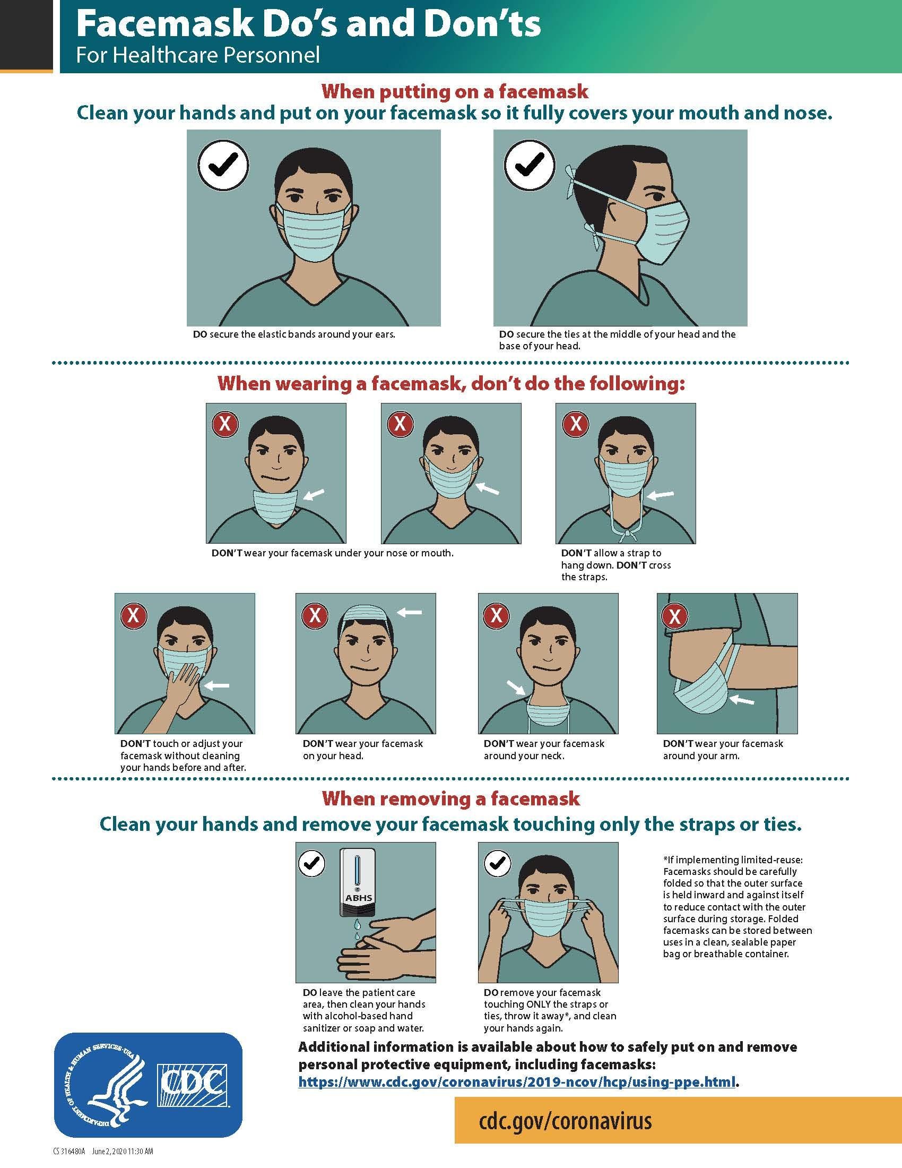

## **Appendix C: CDC Respirator On and Off**

# **Appendix D:** **Mental Health and Psychosocial Support (MHPSS) Needs**

**Take the following steps to cope with a disaster and make this information available to employees, residents, and their family members**:

* Take care of your body
  + Try to eat healthy well-balanced meals,
  + Exercise regularly
  + Try to get a good night’s rest
  + Avoid alcohol, tobacco, and other drugs.
* Connect with others
  + Share your concerns and how you are feeling with a friend or family member.
  + Maintain healthy relationships and build a strong support system.
* Take breaks
  + Make time to unwind and remind yourself that strong feelings will fade.
  + Try taking in deep breaths.
  + Try to do activities you usually enjoy.
* Stay informed
  + Watch, listen to, or read the news for updates from officials.
  + Be aware that there may be rumors during a crisis, especially on social media.
  + Always check your sources and turn to reliable sources of information like your local government authorities.
* Avoid too much exposure to news
  + Take breaks from watching, reading, or listening to news stories. It can be upsetting to hear about the crisis and see images repeatedly.
* Seek professional psychological support if needed
  + If an employee is experiencing a difficult time at work, your SNF site should provide you access to a professional psychologist or counselor
  + If a resident is exhibiting signs of stress or loneliness, your SNF site should connect them with a psychologist or counselor and try to incorporate technology to allow them to interact with friends and family
  + In the event that a resident or staff passes away from COVID-19, it is important to acknowledge grief. Allow for virtual access to connect with your SNF community to allow time to grieve and heal.

**Stress during an infectious disease outbreak can sometimes cause the following:**

* Fear and worry about your own health and the health of your loved ones, your financial situation or job, or loss of support services you rely on.
* Changes in sleep or eating patterns.
* Difficulty sleeping or concentrating.
* Worsening of chronic health problems.
* Worsening of mental health conditions.
* Increased use of [tobacco](https://www.cdc.gov/tobacco/quit_smoking/index.htm), and/or [alcohol and other substances](https://www.cdc.gov/alcohol/fact-sheets.htm).

**Get immediate help in a crisis, facilities should be sure to post these resources for all employees and residents to see:**

* Call 911
* [Disaster Distress Helpline](https://www.samhsa.gov/disaster-preparedness) 1-800-985-5990 (press 2 for Spanish), or text TalkWithUs for English or Hablanos for Spanish to 66746. Spanish speakers from Puerto Rico can text Hablanos to 1-787-339-2663.
* [National Suicide Prevention Lifeline](http://www.suicidepreventionlifeline.org/) 1-800-273-TALK (8255) for English, 1-888-628-9454 for Spanish
* [National Domestic Violence Hotline](https://www.thehotline.org/) 1-800-799-7233 or text LOVEIS to 22522
* [National Child Abuse Hotline](https://www.childhelp.org/hotline/) 1-800-4AChild (1-800-422-4453) or text 1-800-422-4453
* [The Eldercare Locator](https://eldercare.acl.gov/Public/Index.aspx)  1-800-677-1116
* [Crisis Chat](https://www.veteranscrisisline.net/get-help/chat) text: 8388255