Pandemic Preparedness: COVID- 19 Risk Mitigation in Dialysis Treatment Facilities

THIS COVID PLAN TEMPLATE WAS PREPARED FOR DIALYSIS TREATMENT FACILITIES AS A PUBLIC HEALTH SERVICE BY:

Jamillah J. Williams MPA-C, Christine Phyathep MPH-C

GPH-GU 5150 Emergency Preparedness for Healthcare Organizations
New York University School of Global Public Health

December 2020

COVID-19 Response Plan for
{Fill in name of your organization and date here}

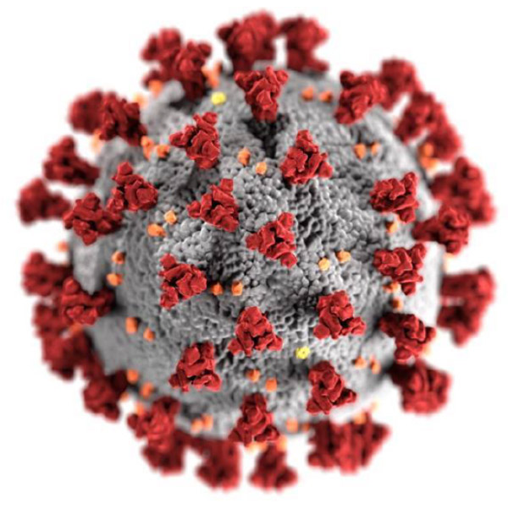

Table of Contents

Preface …………………………………...…………………………………………………………….. 4
Signature Page ………………………………………………………………………………………… 5
Mission Statement ……………………………………………………………………………………. 6
Statement of Purpose …………………………………...………………………………………….. 6
Definitions …………………………………………………………………………………………….. 6
Authorities ……………………………………………………………………………………………..7
Communications Plans…………………………………….…………………………………………..7
Mutual Aid Agreement…………………………………….……………………………………………8
Concept of Operations…………………………………………………………………………………8
Annexes:
Annex 1: Facility Profile
Annex 2: Incident Command System and Designation of Incident Commander
Annex 3: Dialysis Facility Incident Commander
Annex 4: Information Management & Telecommunication
Annex 5: Dialysis Emergency Management & Preparedness committee
Annex 6:Facility Notifications
Annex 7: Staff Notification
Annex 8: Continuity of Business Operations
Annex 9: Logistics and Emergency Facility Back- Up Plan Annex
Annex 10: Dialysis Facility Capacity
Annex 11: Facility Readiness
Annex 12:Training
Annex 13: Drills and Exercise
Annex 14: Mental Health and Psycho-Social Support
Annex 15: COVID 19 Personal Protective Equipment
Annex 16: Donning and doffing Training Assessment
Annex 17: THIRA
Annex 18: ICS Chart
Annex 19: Sheltering, Relocation and Evacuation Decision Tree
Annex 20: Sanitation Sheet
Annex 21: CDC Resources

Preface
The Corona Virus infection is particularly dangerous to those with preexisting health conditions, especially conditions that require frequent clinical care and management. In particular, dialysis patients are especially at risk of adverse outcomes associated with SARS-CoV-2 infection. Kidney International reported that patients on dialysis are at extremely high risk should they develop COVID-19, with short-term mortality of 20% or higher. The National Kidney Foundation (NKF) noted that COVID-19 dialysis patients survivors typically faced a six- week recovery process and lengthy hospital stays. People with kidney disease have depressed immune responses making them more vulnerable to infections in general. Those that take immunosuppressants, which are part of kidney transplant postoperative care, are at even greater risk. Even during the most acute phases of the COVID-19 pandemic, dialysis patients still had to receive their regularly scheduled treatments; patients who attend clinics regularly may increase their risk of exposure through their contact with others during transportation to and from centers and while at centers through contact with other patients and potentially infected staff. In an urban environment, such as New York City, exposure risk may be heightened through the use of public transportation. Physicians, nurses, and support staff are also at increased risk of exposure. In the community, control of COVID- 19 depends on social distancing, screening, contact tracing and isolation/quarantine. Controlling exposure in a high-risk patient population, such as dialysis patients, requires on-going adherence to disinfection protocols, careful screening of patients and all staff, rigorous application of infection control measures, and appropriate and consistent use of personal protective equipment (PPE). By creating a sustained culture of emergency preparedness, dialysis facilities can safely continue to provide care to these vulnerable patients, while still protecting the health and safety of all staff.

Signature Page

Chief Medical Director

Head Facility Administrator

Head of Environmental Services

Head of Patient Care Onsite

Head of Patient Care Offsite

___________________________________________
Date

Mission Statement

(Insert Your Own Mission Statement- this is an Example)

The mission of this plan is to disseminate emergency preparedness and comprehensive response efforts within Dialysis Clinical settings in order to preserve the health, safety, access and overall wellbeing of the vulnerable dialysis community during the novel COVID-19 pandemic and other infectious disease outbreaks.

Purpose

The purpose of this plan is to ensure the safety and care for dialysis patients, staff and community by providing guidance and best practices that are pragmatic and robust in reducing morbidity and mortality rates during COVID- 19 outbreaks.

Definitions & Acronyms

ASN - American Society of Nephrology
CDC - U.S. Centers for Disease Control and Prevention
COVID-19 - Novel coronavirus disease identified in 2019
CMS - Centers for Medicare & Medicaid Services
EHS - Emergency Health &amp; Safety Service
EOC - Emergency Operations Center
EM - Emergency Management Team
EMC - Emergency Management Committee
EMS - Emergency Medical Services
ESF- Emergency Support Function
ESRD - End Stage Renal Disease
GNYHA - Greater New York Hospital Association
HAI - Healthcare-associated infection
HCS - Health Commerce System
HERDS - Hospital Emergency Reporting Data System
HFD - Healthcare Facility Directory
HICS - Hospital Incident Command System
HVA - Hazard Vulnerability Analysis tool
IAP - Incident Action Plan
JCAHO - Joint Commission
KCER - Kidney Community Emergency Response Coalition
NKF- National Kidney Foundation
NYC - New York City
NYCDOHMH- NYC Department of Health and Mental Hygiene
NYS - New York State
NYSDOH - NYS Department of Health
NYEM - NYC Emergency Management
PHE - Public Health Emergency
PIO - Public Information Officer
USRDS - United States Renal Data System
WHO - World Health Organization

Authorities
- CDC
- CMS Emergency Preparedness Regulation
- JCAHO
- OSHA Regulations
- The Joint Commission- Standards for Dialysis Clinical Care
- Fire Safety Regulations

Internal Communications

The incident command will notify the public information officer to activate the dialysis center incident command system. An immediate announcement will be made if the staff's safety and patient care is an immediate threat. The goal is not only to be as transparent as possible in all activities related to managing the public health response to COVID 19 but also to keep the dialysis community safe. In the event there is a Coved 19 breakout in the dialysis center or center should be closed, staff will notify patients on where to go for hemodialysis. The team will get weekly updates by email from senior leadership on the ongoing events. Staff will follow SBAR to communicate with patients via phone text and emails. Staff should distribute emergency information on what to do if there is a COVID-19 break in the center. The data should be allocated to patients during treatment time in the following languages four most spoken languages throughout the world English, Chinese, Spanish, and Arabic.

External Communications

Dialysis centers will establish methods of communication with mutual aid partners to help facilitate response and maintain operations. The dialysis center must keep contact with the local health department when the center encounters patients with COVID-19. Emergency contact and mutual aid partners are maintained regularly. A hard copy must be kept near the incident command center. The dialysis center will work with patients and families to coordinate the patient's needs, locations, and critical debriefing. The public information officer will give media updates and daily Information to outreach partners. Public information officers will share messages in unison with media outlets. Communication efforts will use risk communication and engagement (RCCE) set by the WHO for a public health emergency.

Communicating with persons who have a disability

People who have a disability must be given the same information that is provided to the general public . Any type of information, whether it is printed, oral, or web based must be fully accessible. Appropriate accommodations should be made for a person with disability. Ex: sign language interpretation of all spoken presentations, video captioning, braille version of material, web content with screen reader capability, recorded narration describing visual materials and attention should be paid to assuring that individuals who are not fluent in English also have access to the information. Other individuals who may have access and functional needs (undocumented individuals, congregate care residents, people with cognitive or neurological impairments, prisoners, homeless, etc,) must also have full access to all pertinent information regarding dialysis treatment center emergency prepardeness plan

Mutual Aid Agreement

- Local Fire Department
- Local Police Department
- Emergency Medical Services
- Local Department of Health
- Area Hospitals (public and Private)
- Transportation companies
- Nephrologist, Physician Assistants, Nurse Practitioners
- Department of State Health Service
- Logistic companies
- American Red Cross
- National Kidney Foundation
- Pharmacies
- Renal Disaster Relief Task Force
- International society of Nephrology

CONCEPT OF OPERATIONS

(1) Assessing the Needs of the Affected Population

In an effort to be prepared for any possible emergency disasters such as the current pandemic, community needs assessments will be routinely conducted every two years to keep track of vulnerable populations and their changing needs and health problems. The first step that will be taken in the event of an emergency will be a rapid needs assessment that will be carried out by the Dialysis Center . This needs assessment will be administered in the form of surveys (available in preferred language) and will aid in enumerating needs and preferences of the most vulnerable populations during the COVID pandemic and for any future emergencies. Surveys will be conducted online to minimize contact between individuals and will be conducted at the start of the disaster event. Individuals with underlying health conditions will be labeled as “at-risk'’ along with the elderly and immunocompromised individuals. Risk communication strategies will be tailored to each population group.

(2) Matching Available Resources to the Needs

To respond appropriately to the COVID-19 pandemic and ensure delivered effectively, the following tasks will be initiated:

Medical providers throughout NYC will be equipped with appropriate personal protective equipment (PPE) and supplies to safely administer the vaccine, including to those who may be asymptomatic infected persons. Public health agencies will develop and disseminate diagnostic and treatment protocols so that treatment throughout NYC will be standardized.

Resources will be properly allocated throughout the city and areas that require more PPE and supplies will be accounted for. Public health agencies will manage cases so that individuals who have been infected or exposed can quarantine/isolate in locations that are equipped to accommodate their needs.

(3) Evaluating the Effectiveness of Dialysis Center COVID-19 Plan

Dialysis facilities are on the frontlines coordinating, responding, attending to patients As the frequency and the severity of COVID- 19 cases begins to rise, monitoring and evaluation are critical tools to help the Dialysis center improve on past, present, and future response efforts to a pandemic event. Evaluation of the department's response effort can help bring improvements and offer insight into what is needed for a successful response. The tool that can help is a tabletop, hot wash, and data collection. The goal of the response to the emergency is to protect and save human life and relieve human suffering. The dialysis center must conduct an evaluation of preparedness plan and response frequently.

Evaluation without an emergency event
Tabletop is the most common tool to use when there is no event. It allows for the assessment of responses of any given event and at different times during the event. It is a simulation of what the response would be like. Periodically, a wild card is added to the exercise to determine how quickly and effectively the group can adapt and adjust. Ex: there could be issues with power, a cyber-attack, or the data center shut down.
Evaluation after a response
Hot Wash should be held immediately after the event. One or more meetings occur after an emergency or disaster event. This is an opportunity for people in the department who responded to the event to share their thoughts, capabilities, and the management and effectiveness of the event itself. A hot wash provides data to identify opportunities for improvement, best practices, and lessons learned with recommendations for future planning, response, training, and exercise development. As improvement actions are identified and addressed, any relevant plans, policies, and procedures must be updated accordingly.

Examples of the question to ask during the hot wash
- What happened?
- What was supposed to happen?
- What should be learned?
- What needs to be improve?
- What needs to be implemented?
- Were the organizations roles and responsibilities identified?

Background
The Centers for Medicare & Medicaid Services (CMS), is dedicated to ensuring the continued health and safety of patients receiving care within Medicare participating dialysis facilities during the COVID-19 pandemic. To assist in preventing the transmission of COVID-19 within the dialysis population, CMS is reinforcing infection control guidance based upon the current Centers for Disease Control and Prevention recommendations. The following information is provided to clarify SARS-CoV-2, the virus that causes coronavirus disease 2019 (COVID-19), infection prevention and control (IPC) recommendations that are specific to outpatient hemodialysis facilities.

This section is adapted from the CDC guidance on Preparing Your Dialysis Facility for Coronavirus Disease 2019 (COVID-19), the information compliments, but does not replace, the general CDC IPC recommendations for SARS-CoV-2 available in Interim Infection Prevention and Control Recommendations for Healthcare Personnel During the Coronavirus Disease 2019 (COVID-19) Pandemic.

KEY OBJECTIVES DURING THE COVID-19 PANDEMIC: PREPARING TO MEET SURGE CAPACITY

Dialysis is a lifesaving therapy, and patients cannot postpone treatments.
Facilities can protect patients and staff from respiratory infections, including COVID-19, by adherence to the following CDC recommendations. To meet the surge capacity needs of the COVID-19 pandemic, the CDC recommends the following key Objectives for dialysis outpatient facilities; (1) Screening for COVID-19, Patient Placement, Personal Protective Equipment, Isolation, and Cleaning and Disinfection.

COVID-19 Symptoms
People with COVID-19 have had a wide range of symptoms reported – ranging from mild symptoms to severe illness. Symptoms may appear 2-14 days after exposure to the virus. People with these symptoms may have COVID-19:

- Fever or chills
- Cough
- Shortness of breath or difficulty breathing
- Fatigue
- Muscle or body aches
- Headache
- New loss of taste or smell
- Sore throat
- Congestion or runny nose
- Nausea or vomiting
- Diarrhea
- This list does not include all possible symptoms. CDC will continue to update this list as we learn more about COVID-19.

Screening for COVID-19:
Before patients arrive educate, train, and prepare dialysis staff:
- Direct staff to stay home and not report for work when they are ill. Ensure non-punitive, flexible sick leave policies exist and that staff are aware of them.
- Educate all staff about the importance of personal protective measures to prevent the spread of COVID-19, including hand hygiene, respiratory hygiene, source control, and cough etiquette.
- Make sure staff know symptoms of COVID-19, including fever, new cough, shortness of breath, sore throat, muscle aches, and tiredness.
- Create procedures to screen staff for fever and COVID-19 symptoms before they start their shift.
- Train staff to identify patients with signs and symptoms of COVID-19 before they enter the facility.
- Create procedures to triage and isolate symptomatic patients upon arrival.
- Create an emergency contact list. Ensure designated staff at the facility know how to contact your local health department.
- Reinforce training and assess staff competency with putting on, using, and taking off personal protective equipment (PPE) such as gowns, gloves, facemasks, and face shields.
For more information on PPE guidance, training and staff assessments please refer to Annex 21 , “CDC Resources”

Prepare the facility:
- Post signs at entrances with instructions to patients with fever and symptoms of COVID-19 to alert staff so they can take appropriate precautions.
- Post signs about the importance of hand hygiene, respiratory hygiene, and cough etiquette in preventing the spread of illness.
- Place supplies (e.g., tissues, alcohol-based hand sanitizer, facemasks, lined trash cans) near entrances, waiting rooms, dialysis chairs and nursing stations to make it easy for staff and patients to maintain hand and respiratory hygiene and cough etiquette.
- Waiting areas should be organized to divide patients with symptoms from patients without symptoms.
- The area for patients with symptoms should be at least 6 feet away from the area for patients without symptoms.
- Continually inventory and restock PPE, respiratory, and cough etiquette supplies. Please see annex ? for CDC strategies to optimize PPE
- Identify patients with signs and symptoms of COVID-19 before they enter the facility.
- Seek out automated options for evaluation of symptomatic patients before they leave home or long-term care facility setting to assist triage (e.g., an automated text reminding patient to call dialysis facility if they have fever and COVID-19 symptoms). Consider telephone contact with all patients before scheduled dialysis treatment (e.g., ask all patients or their caretakers to call ahead to report COVID-19 symptoms before their treatment).
- Consider flexibility in scheduling patients (e.g., you may need to move patients to a different chair or shift).

Patient Placement:
Screening and Triaging Patients at Your Dialysis Facility for COVID-19
- Ask patients and caretakers, if available, upon arrival if patient has symptoms of COVID-19 and fever.
- Place a staff member near all entrances (outdoors if weather and facility layout permit), or in the waiting room area, to ensure patients are screened for symptoms and fever before entering the treatment floor.
- All patients should be wearing a cloth face covering or facemask on arrival at the facility regardless of their symptoms. If they do not have one on arrival, provide them with a face covering.
Isolation
- Bring symptomatic patients back to an appropriate treatment area as soon as possible or take them to designated waiting area for ill patients.
- Symptomatic patients should be dialyzed in a separate room with the door closed.
- If a separate room is not available, the masked patient should be treated at a corner or end-of-row station, away from the main flow of traffic. The patient should be separated by at least 6 feet from the nearest patient (in all directions).
Hepatitis B isolation rooms should only be used for patients with COVID-19 symptoms if:
- The patient is hepatitis B surface antigen positive, OR
- The facility has no patients on the census with hepatitis B infection who would require treatment in the isolation room.
If multiple patients with COVID-19 symptoms need to be dialyzed, then cohorting patients and staff should be considered:
- If diagnosis is known, patients with different respiratory infection diagnoses should not be cohorted (e.g., COVID-19 and influenza).
- Cohorting might involve designating a section of the dialysis unit for symptomatic patients or putting all symptomatic patients on the same dialysis shift.
- Give patients the appropriate phone numbers to contact the dialysis facility and their healthcare providers if they develop COVID-19 symptoms before their next appt.

Personal Protection Equipment:
When COVID-19 Is Suspected or Confirmed
- Healthcare providers (HCP) should use appropriate PPE including
- Gown
- Gloves
- An N-95 or higher-level respirator is preferred, if available and if the facility has a respiratory protection program with fit-tested HCP. Facemasks are an acceptable alternative (https://www.cdc.gov/coronavirus/2019-ncov/hcp/ppe-strategy/index.html).
- A cloth face covering is NOT considered PPE and should not be worn by HCP when PPE is indicated
- Eye protection (e.g., goggles, a disposable face shield that covers the front and sides of the face), gloves and an isolation gown should be worn.
- Notify the health department about the patient.
- Ensure patient understands that dialysis sessions shouldn’t be missed when they are self-isolating.
- Notify transport personnel and facility that patient is returning to, if applicable (e.g., long-term care).
- Instruct patient to notify caretakers or other household members of suspected or confirmed COVID-19.
- Instruct patient to follow local public health’s recommendations on whether to self-isolate and take other steps in CDC’s recommended precautions for household members, intimate partners, and caregivers in a non-healthcare setting. Please see Annex for additional CDC guidance on recommended precautions for self-isolation in a non-healthcare setting.

Cleaning and Disinfection:
After Patients Leave
- Maintain routine cleaning and disinfection procedures for COVID-19 in dialysis settings.
- Any surface, supplies, or equipment (e.g., dialysis machine) located within 6 feet of symptomatic patients should be disinfected or discarded in addition to high-touch surfaces throughout the facility.
- Products with EPA-approved emerging viral pathogens claims are recommended for use against COVID-19.
- Refer to List N on the EPA website for EPA-registered disinfectants that have qualified under EPA’s emerging viral pathogens program for use against SARS-CoV-2.

Annex 1 Facility Profile

Name of Facility

Facility address
Facility contact name and
emergency phone number
Facility main phone number
Number of Dialysis Patient in facility
Total number # of Chairs available
Areas that can be converted as additional rooms (Ex: cafeteria, etc) and square footage
Dialysis Center staffing:
· Clinical
· Non-clinical
· Licensed practitioners
· Visitors
Nursing staff hours per patient per day

Facility is: | Check all that apply
 | ☐ As part of a medical center/medical school
 | ☐ Stand-alone, in a civilian community
 | ☐ Part of a regional hospital system
 | ☐ Part of a national hospital chain

COVID-19 In Your Facility
COVID-19 Status & Comorbidities | Number/Since start of pandemic
Number of COVID-19 positive cases to date in your facility (patients)
Number of COVID-19 positive cases to date in your facility (staff)
Suspected COVID-19 infections to date in your facility
CURRENT PATIENT CARE CAPACITY
All facilities should closely monitor their capacity for patient care. Understanding licensed bed numbers as well as surge capacity will be important if outbreak occurs. More importantly, ventilator capacity and staffed bed capacity will be essential in the event of a COVID-19 outbreak where respiratory care will be of the utmost importance.

Number of available Equipment and Staff
Number of people at Max capacity
Average staffed Chairs (average beds in use and staffed in last 6 months
Chairs with Negative Airflow (for use in respiratory isolation)
Monitored Chairs (Chairs equipped with cardiac and vital signs)
Portable Television
Personal Protective Equipment
Oxygen tanks
Pulse ox
Thermometers

ANNEX 2: INCIDENT COMMAND SYSTEM AND DESIGNATION OF INCIDENT COMMANDER
An Incident Command System (ICS) or Hospital Incident Command System (HICS) is in place. | ☐ Yes ☐ No
a. ICS is exercised at least twice annually.  Last exercised: | ☐ Yes ☐ No  ____/____/_______
b. ICS is coordinated by a Unified Command Structure coordinated when appropriate with law enforcement, fire, EMS. | ☐ Yes ☐ No
c. 1. Incident Commander is known by all staff.  2. Incident commander succession plan is in place. | ☐ Yes ☐ No
d. There is a procedure to designate an Incident Commander. | ☐ Yes ☐ No
e. Staff assigned to ICS leadership roles are oriented to their responsibilities. | ☐ Yes ☐ No
f. Staff assigned to key roles wear identifying gear during an event. | ☐ Yes ☐ No
g. All staff know where to report when the ICS is activated. | ☐ Yes ☐ No
h. Staff understands the flexibility of their positions in the ICS if leadership is unavailable. | ☐ Yes ☐ No
i. ICS or HICS is NIMS compliant? | ☐ Yes ☐ No
j. After action reports are completed after all exercises? | ☐ Yes ☐ No

ANNEX 3: Dialysis Facility Command Center
A Dialysis Command Center is fully operational and integrated into local/county emergency planning and operations. | ☐Yes ☐ No
a. In the DCC, telephone numbers are available for:  the local health department  state health department  local Police Dept.  CDC Emergency Preparedness Office  Others: | ☐ Yes ☐ No  ☐ Yes ☐ No  ☐ Yes ☐ No  ☐ Yes ☐ No  ☐ Yes ☐ No
b. NHCC is equipped with:  Telephones  Satellite phones  Fax  Two-way radios  Generator  Maps of hospital  Maps of local area  N95/KN95 masks  Surgical masks  Face Shields/eye goggles  Gowns  Gloves  Hand Sanitizer  Disinfectant Spray  Bullhorns  Flashlights  Copy of the emergency management plan  Others: | ☐ Yes ☐ No  ☐ Yes ☐ No  ☐ Yes ☐ No  ☐ Yes ☐ No  ☐ Yes ☐ No  ☐ Yes ☐ No  ☐ Yes ☐ No  ☐ Yes ☐ No  ☐ Yes ☐ No  ☐ Yes ☐ No  ☐ Yes ☐ No  ☐ Yes ☐ No  ☐ Yes ☐ No  ☐ Yes ☐ No  ☐ Yes ☐ No  ☐ Yes ☐ No  ☐ Yes ☐ No  ☐ Yes ☐ No
c. DCC is located in a secure location. | ☐ Yes ☐ No
d. An alternate DCC site exists and can be used if the primary site is inaccessible. | ☐ Yes ☐ No
e. DCC can maintain 24 hour operations for a minimum of 1 week. | ☐ Yes ☐ No
f. DCC can monitor local media. | ☐ Yes ☐ No
g. Each section chief has a designated telephone line. | ☐ Yes ☐ No
h. The ICS command staff has an adequate, pre-defined communications system. | ☐ Yes ☐ No
h. The ICS command staff has an adequate, pre-defined communications system. | ☐ Yes ☐ No

ANNEX 4: INFORMATION MANAGEMENT/TELECOMMUNICATIONS
Essential information systems and data storage have offsite storage and recovery capabilities. | ☐ Yes ☐ No
Information management staff participate in facility emergency exercises. | ☐ Yes ☐ No
System has protection from viruses and intentional attacks (hacking). | ☐Yes ☐ No
Facility has a designated public information officer (PIO). | ☐ Yes ☐ No
a. In the event of multi-agency response, media activities will be coordinated through Joint Information Center (JIC). | ☐ Yes ☐ No
b. PIO has established relationships with counterparts in Public Health and emergency management agencies. | ☐ Yes ☐ No
Staff know where and to whom media inquiries are to be referred. | ☐ Yes ☐ No
A site is designated for regular meetings with media. | ☐ Yes ☐ No
a. PIO has developed generic press releases about the facility and possible emergency conditions. | ☐ Yes ☐ No
b. PIO has established relationships with local media. | ☐ Yes ☐ No
c. The press conference location is outside the facility. | ☐ Yes ☐ No
Facility has current mutual aid Memorandum of Understanding (MOUs) in place. | ☐ Yes ☐ No
a. Memorandum of Understanding (MOUs) are in place with:  Law enforcement  Fire  Emergency medical services (EMS)  Public Safety  Military installations  Other local and regional health care facilities  Burn center  Red Cross  MMRS  CERT  Other: | ☐ Yes ☐ No  ☐ Yes ☐ No  ☐ Yes ☐ No  ☐ Yes ☐ No  ☐ Yes ☐ No  ☐ Yes ☐ No  ☐ Yes ☐ No  ☐ Yes ☐ No  ☐ Yes ☐ No  ☐ Yes ☐ No
b. Memorandum of Understanding (MOUs) are in place for:  Automated Peritoneal Dialysis(APD)  Water  Generators  Other: | ☐ Yes ☐ No  ☐ Yes ☐ No  ☐ Yes ☐ No  ☐ Yes ☐ No

ANNEX 5: Dialysis EMERGENCY MANAGEMENT/ DISASTER PREPAREDNESS COMMITTEE
A dialysis facility emergency management/disaster preparedness committee exists and provides leadership and governance. | ☐ Yes ☐ No
a. Committee is multidisciplinary. | ☐ Yes ☐ No
b. Open meetings are held regularly | ☐ Yes ☐ No  How often?
c. Committee meeting minutes/action plan are available for review. | ☐ Yes ☐ No
d. Committee forwards critiques of all drills to appropriate services in a timely manner. | ☐ Yes ☐ No
e. Committee communicates with and/or cooperates with other skilled nursing facilities/healthcare systems in the community | ☐ Yes ☐ No
f. Facility representative attends at least 75% of the Local/Community Emergency Planning Committee. meetings. | ☐ Yes ☐ No
g. Facility representative reports to governance of the skilled nursing facility on community planning, exercises and after-action reports. | ☐ Yes ☐ No
i. Facility participates in joint training exercises. | ☐ Yes ☐ No

ANNEX 6: FACILITY NOTIFICATION
Facility can send and receive emergency warning and notification information. | ☐ Yes ☐ No
a. Facility can receive warnings of imminent emergency conditions from external agencies. | ☐ Yes ☐ No
b. Facility can send warnings to external agencies. | ☐ Yes ☐ No
c. Redundant communication system is in place in the event that the primary system fails. | ☐ Yes ☐ No
ANNEX 7: STAFF NOTIFICATION
Facility can notify on-duty and off-duty staff of emergency status and recall to duty. | ☐ Yes ☐ No
a. Facility has a plan to notify on-duty and off-duty staff of emergency status. | ☐ Yes ☐ No
b. Staff notification system has been tested in the past 6 months. | ☐ Yes ☐ No
c. Facility has staff notification with up-to-date, verified phone and other contact information. | ☐ Yes ☐ No
d. Facility has either an automated call-back system or staff identified and dedicated to staff notification. | ☐ Yes ☐ No
e. Staff can receive warnings from the Digital Emergency Alert System by either voice or text messages on their wireless phones. | ☐ Yes ☐ No
f. Facility keeps a current and updated list of staff that volunteer and are likely to be deployed during an emergency (NDMS, National Guard, etc.) | ☐ Yes ☐ No
g. The EMP takes into account staff backfill issues. | ☐ Yes ☐ No
Command uses compatible radios (e.g. 800 mhz) for communications with local agencies. | ☐ Yes ☐ No
The Emergency Operations Center has a dedicated telephone trunk line. | ☐ Yes ☐ No
Two-way radio communication (walkie-talkie) is available for all units and essential personnel. | ☐ Yes ☐ No
Facility has access to communications on wheels (COWS). | ☐ Yes ☐ No
Facility has access to an amateur radio system (Ham/RACES). | ☐ Yes ☐ No
A back-up communications system is in place in the event that the primary system fails. | ☐ Yes ☐ No
If all technology-based communications fail, staff members who will serve as ‘runners’ have been identified. | ☐ Yes ☐ No

ANNEX 8: CONTINUITY OF BUSINESS OPERATIONS
1. Facility has a leadership succession plan (LSP) | ☐ Yes ☐ No
a. Facility has a continuity of operations plan (COOP). | ☐ Yes ☐ No
b. Has COOP been exercised in the last 6 months? | ☐ Yes ☐ No
c. If no, when was the last time it was exercised? | ____/____/_______
d. Facility has a business continuity plan | ☐ Yes ☐ No
e. What are the 3 priority functions of the business to be restored first? | 1.  2.  3.
f. There is a mechanism to track the use of financial resources? | ☐ Yes ☐ No

ANNEX 9: LOGISTICS AND EMERGENCY FACILITIES BACK-UP PLAN
Dialysis should ensure that power and water back-up plans are in place to continue care for patients. Water supply is the important to keep facility and dialysis machine running
Emergency Power | a. Emergency power duration is hours.
 | Emergency power generation capability is:
c. Emergency power generator is located: (physical location)
☐ At grade ☐ Above grade ☐ Below grade
 | d. Emergency power generator was last tested:
 | e. How often is it tested?
d. Do you have:
☐ None ☐ Partial Load of Operations ☐ Full Load of Operations
 | e. How long can it be run without refueling?
 | f. Does it power only Life Safety? ☐ Yes ☐ No
 | g Does it power Life Safety and full facility? ☐ Yes ☐ No
 | h. Does it power elevators? ☐ Yes ☐ No
i. Does it power the critical branches?
☐ Yes ☐ No
 | j. Load shed?
 | k. Preservation of food?
Water Supply | a. Source of facility water is: community facility
b. Secondary source of water if primary source is cutoff:

☐ Yes ☐ No
Capacity:
c. Can you attach non-potable water to your facility?

☐ Yes ☐ No
Fuel | a. Facility has days of fuel on-hand.
 | b. How does the facility get additional fuel?
 | c. How long can boilers run?
 | d. What is the amount of time (in hours) that boilers can operate w/o refueling?

ANNEX 10: Dialysis FACILITY CAPACITIES
Laboratory | Lab Bio-Safety Level: ☐ 1 ☐ 2 ☐ 3 ☐ 4
 | Laboratory volume per hour that stimulates additional/urgent staffing plan:
Ambulance/EMS | What ambulance services does the nursing home have arrangements with ?
Morgue | Is a basement available? ☐ Yes ☐ No  Does your facility have a parking lot for this purpose if needed?  ☐ Yes ☐ No
Transportation* | List types and number of vehicles facility owns/operates for patient transport (not including EMS rigs):
Oxygen Tanks, number
Portable cardiac monitors, number
Wheel chairs
Crash Cart
Portable ventilators, number
Automatic resuscitation devices, number
Total number of ventilators
Others:

ANNEX 11: FACILITY READINESS
Respiratory Protection Equipment Status | a. Percent of total clinical staff with fit-testing for N95 or N99 respirators annually:
 | b. Percent of non-clinical staff with fit-testing for N95 or N99 respirators annually:
COVID Disaster Readiness Training | a. Percent of total staff who have completed disaster response/preparedness training:
 | b. Percent of nursing staff who have completed disaster response/preparedness training:
 | c. Percent of medical staff who have completed disaster response/preparedness training:
 | d. Percent of total staff who have trained with facility’s own disaster plan:
 | e. Percent of nursing staff who have trained with facility’s own disaster plan:
 | f. Percent of medical staff who have trained with facility’s own disaster plan:

ANNEX 12: TRAINING
All staff receive orientation to the Emergency Management Plan (EMP). | ☐ Yes ☐ No
Dialysis staff complete annual training/education in CBRNE. | ☐ Yes ☐ No
a. Emergency Department staff receive at least twice-annual training in response to Chemical, Biological, Radiological, Nuclear and Explosive (CBRNE) events. | ☐ Yes ☐ No
b. All other clinicians receive annual CBRNE training. | ☐ Yes ☐ No
c. All non-clinicians receive annual CBRNE/emergency preparedness training. | ☐ Yes ☐ No
d. All clinicians receive annual blood-borne pathogens training. | ☐ Yes ☐ No
e. All clinicians maintain current Basic Life Support (BLS) registration. | ☐ Yes ☐ No
f. Percentage of total staff who have taken a NIMS course and/or are NIMS certified.

ANNEX 13: DRILLS AND EXERCISES
Facility exercises an Emergency Management Plan (EMP) at least twice per year. | ☐ Yes ☐ No
a. Exercises are conducted at least 4 months apart and no more than 8 months apart. | ☐ Yes ☐ No
b. Date of last exercise:
c. Facilities that offer emergency services include an influx of simulated patients in one exercise. | ☐ Yes ☐ No
d. Facility participates in at least one community-wide exercise per year. | ☐ Yes ☐ No
Drills/exercises take place on all shifts, on all units and include all facility departments. | ☐ Yes ☐ No
a. Contract staff is included in drills/exercises. | ☐ Yes ☐ No
Facility has conducted an exercise with casualties:  Exposed to a hazardous material  Agent requiring decontamination  Responded to an actual event within the last 12 months. | ☐ Yes ☐ No  ☐ Yes ☐ No  ☐ Yes ☐ No
At least one exercise in the last year was unannounced. | ☐ Yes ☐ No
Facility has drilled evacuation of staff and patients in the last 12 months. | ☐ Yes ☐ No
a. Exercise includes horizontal evacuation (to other units). | ☐ Yes ☐ No
b. Exercise includes vertical evacuation (to other floors). | ☐ Yes ☐ No
Annex 14 Mental Health and Psychosocial Support
Mental Health Services and Supports During COVID-19
Mental health and psychosocial considerations should be integrated into all response activities. https://www.ama-assn.org/delivering-care/public-health. The CDC provides guidance and resources to health care workers, patients, and communities with managing anxiety and stress. Add to annex. Mental Health and Coping During COVID-19 https://www.cdc.gov/coronavirus/2019-ncov/prepare/managing-stress-anxiety.html
(add a few self-care practices)
Stress during an infectious disease outbreak can sometimes cause the following:
- Fear and worry about your own health and the health of your loved ones, your financial situation or job, or loss of support services you rely on.
- Changes in sleep or eating patterns.
- Difficulty sleeping or concentrating.
- Worsening of chronic health problems.
- Worsening of mental health conditions.
- Increased use of tobacco, and/or alcohol and other substances.
Below are best Practices to help manage stress and anxiety for employees, patients, families and care-givers during a disaster:
- Take care of your body– Try to eat healthy well-balanced meals, exercise regularly, and get plenty of sleep. Avoid alcohol, tobacco, and other drugs. Connect with others– Share your concerns and how you are feeling with a friend or family member. Maintain healthy relationships, and build a strong support system.
- Take breaks– Make time to unwind and remind yourself that strong feelings will fade. Try taking in deep breaths. Try to do activities you usually enjoy.
- Stay informed– When you feel that you are missing information, you may become more stressed or nervous. Watch, listen to, or read the news for updates from officials. Be aware that there may be rumors during a crisis, especially on social media. Always check your sources and turn to reliable sources of information like your local government authorities.
- Avoid too much exposure to news– Take breaks from watching, reading, or listening to news stories. It can be upsetting to hear about the crisis and see images repeatedly. Try to do enjoyable activities and return to normal life as much as possible and check for updates between breaks.
- Seek help when needed– If distress impacts activities of your daily life for several days or weeks, talk to a clergy member, counselor, or doctor.
Get immediate help in a crisis and contact your healthcare provider if daily activities are interrupted by stress for several days. Resources below should be provided in various languages to support multi-ethnic communities and workforces; be easily accessible; and visible to all staff, patients, families and care-givers.
Call 911
- Disaster Distress Helpline 1-800-985-5990 (press 2 for Spanish), or text TalkWithUs for English or Hablanos for Spanish to 66746. Spanish speakers from Puerto Rico can text Hablanos to 1-787-339-2663.
- National Suicide Prevention Lifeline 1-800-273-TALK (8255) for English, 1-888-628-9454 for Spanish, or Lifeline Crisis Chat
- National Domestic Violence Hotline
- : 1-800-799-7233 or text LOVEIS to 22522
- National Child Abuse Hotline
- : 1-800-4AChild (1-800-422-4453) or text 1-800-422-4453
- The Eldercare Locator 1-800-677-1116
- Veteran’s Crisis Line 1-800-273-TALK (8255) or Crisis Chat or text: 8388255
Find a health care provider or treatment for substance use disorder and mental health
- SAMHSA’s National Helpline
- external icon
- : 1-800-662-HELP (4357) and TTY 1-800-487-4889
- Treatment Services Locator Website

staff must wear PPE putting patients on and off dialysis machines. Disinfect patient areas after each use.

The International Society of Nephrology has created a Renal Disaster Relief Task Force in 1989. The Renal disaster Relief Task Force has branches in The Americas, Southeast Asia, Europe, the Middle East, and Africa. After significant disasters and emergencies, the task force can offer medical personnel such as nephrologists, dialysis nurses, technicians, dialysis equipment, and medical and technical education. They also can provide psychological support.

Annex 15 COVID 19 Personal Protective Equipment (PPE)
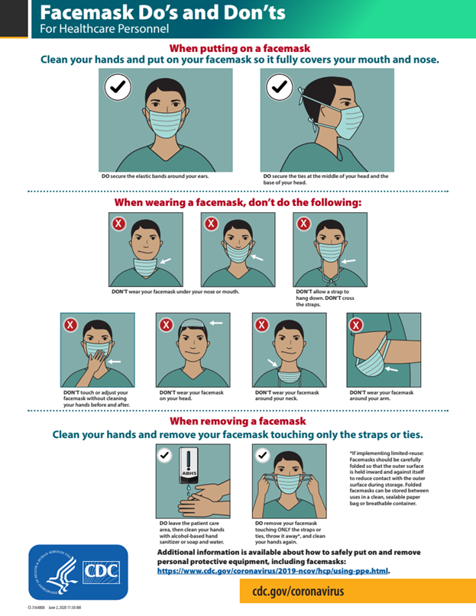

More than one donning method may be acceptable. Training and practice using your healthcare facility’s procedure is critical. Below is one example of donning.
- Identify and gather the proper PPE to don. Ensure choice of gown size is correct (based on training).
- Perform hand hygiene using hand sanitizer.
- Put on isolation gown. Tie all of the ties on the gown. Assistance may be needed by other healthcare personnel.
- Put on NIOSH-approved N95 filtering facepiece respirator or higher (use a facemask if a respirator is not available). If the respirator has a nosepiece, it should be fitted to the nose with both hands, not bent or tented. Do not pinch the nosepiece with one hand. Respirator/facemask should be extended under chin. Both your mouth and nose should be protected. Do not wear respirator/facemask under your chin or store in scrubs pocket between patients.*
  - Respirator: Respirator straps should be placed on crown of head (top strap) and base of neck (bottom strap). Perform a user seal check each time you put on the respirator.
  - Facemask: Mask ties should be secured on the crown of head (top tie) and base of neck (bottom tie). If the mask has loops, hook them appropriately around your ears.
- Put on a face shield or goggles. When wearing an N95 respirator or half facepiece elastomeric respirator, select the proper eye protection to ensure that the respirator does not interfere with the correct positioning of the eye protection, and the eye protection does not affect the fit or seal of the respirator. Face shields provide full face coverage. Goggles also provide excellent protection for eyes, but fogging is common.
- Put on gloves. Gloves should cover the cuff (wrist) of the gown.
- Healthcare personnel may now enter the patient room

How to Take Off (Doff) PPE Gear

More than one doffing method may be acceptable. Training and practice using your healthcare facility’s procedure is critical. Below is one example of doffing.
- Remove gloves. Ensure glove removal does not cause additional contamination of hands. Gloves can be removed using more than one technique (e.g., glove-in-glove or bird beak).
- Remove the gown. Untie all ties (or unsnap all buttons). Some gown ties can be broken rather than untied. Do so in a gentle manner, avoiding a forceful movement. Reach up to the shoulders and carefully pull the gown down and away from the body. Rolling the gown down is an acceptable approach. Dispose in trash receptacle. *
- Healthcare personnel may now exit the patient room.
- Perform hand hygiene.
- Remove face shield or goggles. Carefully remove face shield or goggles by grabbing the strap and pulling upwards and away from head. Do not touch the front of the face shield or goggles.
- Remove and discard respirator (or facemask if used instead of respirator). Do not touch the front of the respirator or facemask.*
  - Respirator: Remove the bottom strap by touching only the strap and bring it carefully over the head. Grasp the top strap and bring it carefully over the head, and then pull the respirator away from the face without touching the front of the respirator.
  - Facemask: Carefully untie (or unhook from the ears) and pull away from face without touching the front.
- Perform hand hygiene after removing the respirator/facemask and before putting it on again if your workplace is practicing reuse.
See Donning and Duffing checklist below:
PPE Donning Checklist for Care of COVID-19 Patients: Back Securement Isolation Gown with Mask Sequence √ #

Strategies to Optimize the Supply of PPE and Equipment during Shortages
Implication of effective surge capacity practices is a useful framework to approach decreased supply of PPE during the COVID-19 response. To help healthcare facilities plan and optimize the use of PPE in response to COVID-19, CDC has developed a Personal Protective Equipment (PPE)_Burn Rate Calculator.Personal Protective Equipment (PPE) Burn Rate Calculator excel icon[3 sheets]. The Burn Rate Calculator is now available via mobile app.

Strategies to mitigate staffing shortages
Continuity of services for the vulnerable dialysis population is essential and interruption of treatment Healthcare facilities must be prepared for potential staffing shortages and have plans and processes in place to mitigate potential barriers.The CDC provides Strategies to mitigate staffing shortages. Add to Annex https://www.cdc.gov/coronavirus/2019-ncov/hcp/mitigating-staff-shortages.html
HCP and facilities—along with their healthcare coalitions, local and state health departments, and local and state partners—should work together to develop strategies that identify and extend PPE supplies,

ANNEX 16: DONNING/DOFFING TRAINING ASSESSMENT

Initials of Staff:_________ Initials of Observer: __________Date: ___________
Staff Title (please circle one): CNA LVN RN Other
The pre-test score will be done prior to viewing any training material. A pre-test score is used to evaluate staff’s baseline knowledge prior to participating in the training.
- The post-test score will be done after viewing/practicing the training material. The post-test score will be used to compare with the pre-test score to evaluate the effectiveness of this training.
- Staff will receive 1 point for every step they are observed performing correctly and in proper order. Please put a 1 in the score column if they are correct.
- Staff will receive a zero for that step if a step is done incorrectly, in the wrong order, or has been omitted completely. Please put a zero in the score column if they are incorrect.
- Please feel free to write any comments for improvement in the comments column

# | Observed steps for donning PPE | Pre-test Score | Post-test Score | Comments
1 | Wash hands (may verbalize or stimulate hand washing)
2 | Don gown first
3 | Gown opening is to the back
4 | Ties are placed to the back and are tied in a bow not a knot
5 | Gown cuffs are pulled down to cover wrists
6 | Don gloves second
7 | Cuff of gloves cover wrist and are over the gown cuffs
 | TOTAL DONNING POINTS:
8 | Before removing gown, with one gloved hand touching only the outside of the glove, grasp the other glove at the palm and remove glove
9 | Keep dirty glove inside of gloved hand
10 | Remove 2nd glove using clean ungloved hand, enter 1-2 fingers touching only inside of gloved hand at the cuff and turning it inside out as it is removed
11 | Dispose gloves in proper waste bin
12 | Without touching the front of the gown unfasten the gown ties from the back
13 | Starting with one gown sleeve, insert 1-2 fingers inside gown cuff and pull over hand, making sure that the hand remains inside the gown sleeve
14 | Grasp other gown sleeve above the cuff and pull down glove sleeve
15 | Pull glove off while rolling it inside out and away from the body
16 | Gown does not touch body or floor when removed
17 | Touching only the inside of rolled gown dispose in proper waste bin
18 | Wash hands (may verbalize or stimulate hand washing)
19 | TOTAL DOFFING POINTS:
20 | FINAL TOTAL = (add total donning + total doffing score) | -----------/18 | -----------/18

ANNEX 17: Threat and Hazard Assessment and Risk Identification (THIRA) Example for New York, NY
In order to be prepared for a wide range of emergencies and disaster events, it is important for the CHC to periodically prepare a threat and hazard assessment and risk identification, or THIRA for short. Here is an example of a THIRA prepared for New York City area. A bank template is provided for an organization to make their own.
Organization + Area (i.e. Dialysis Center , New York City, NY)
Natural | Technological | Human-caused
Resulting from acts of nature  Example: In this area the elevation is low which puts it at greater risk of flooding. This is illustrated by event XXXX | Involves accidents or the failures of systems and structures  Example: During electrical storms the city has been known to face blackouts or power surges, this may effect out EMR and our equipment | Caused by the intentional actions of an adversary  Example: Due to the high stress nature of the facility there is a possibility of an active shooter in the facility.
Organization + Area (i.e. Dialysis Center , New York City, NY)
Natural | Technological | Human-caused
Resulting from acts of nature | Involves accidents or the failures of systems and structures | Caused by the intentional actions of an adversary
 | · | ·
Annex 18 ICS Chart
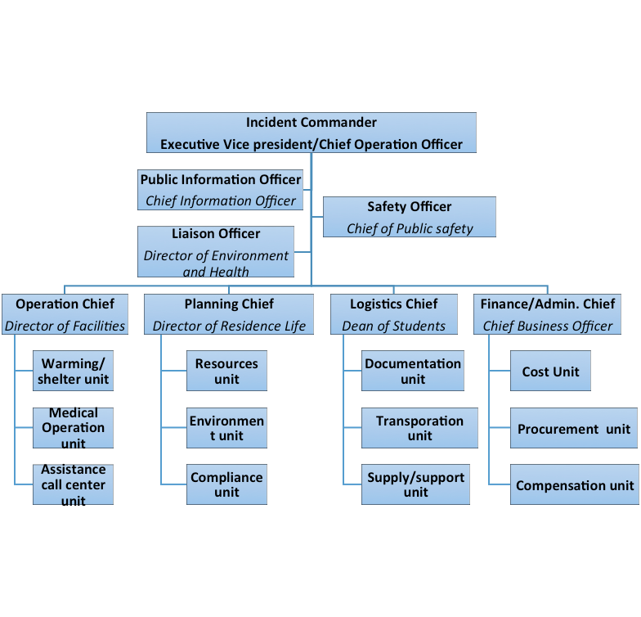

Element 19: Sheltering, Relocation and Evacuation Decision Tree
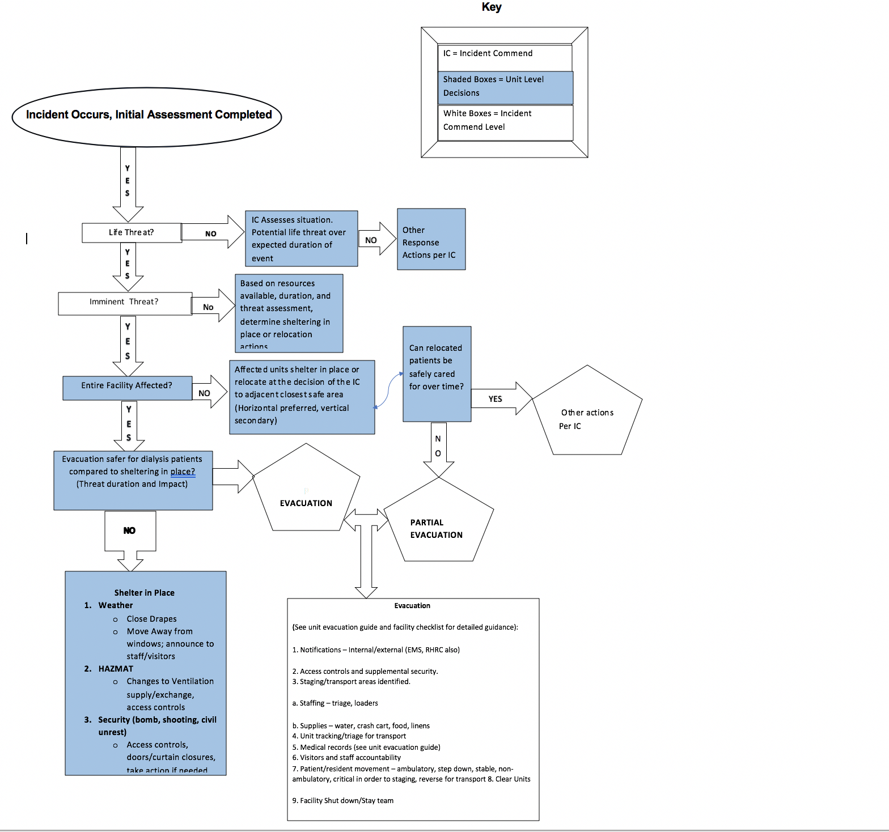

Annex 20: Sanitation Timesheet
Name | Shift Manager | Date | Time | Area sanitized
Easily forgotten items that must be sanitized regularly:
- Writing utensils
- Front desk counters
- Computer keyboards
- Faucet knobs
- Door knobs
- Chair arms
- Vending machines
- Outside of sanitizer dispensers
Things to remove from patient areas:
These items are often touched unconsciously or with little attention and can pose a risk of contamination
- Magazines or communal entertainment materials
- Coffee or drink stations in patient sections
- Pencil cups or anything the patient can touch many of accidentally
- Communal food options
- Boxes of masks – if a patient is in need of a mask present one to them from behind a screen rather than have them reaching into and potentially contaminating many masks
Keeping sanitation services safe:
- Make sure all spaces are cleaned regularly
- Always wear full PPE while cleaning
- Avoid touching your face or hair
- Take off all PPE immediately after finishing and place in and then seal the biohazard bag
- Take temperatures and check for symptoms each day and report if any symptoms arise
- If using cloth masks, wash them thoroughly between uses and do not reuse once taken off
- Have a person on standby to take your shift if there is any sign of covid 19 symptoms
- Communicate with your employer if feeling unsafe
- Try and create a solid trusted network within the center to address problems without consequences or hierarchy
Annex 21: CDC Resources: Further Guidance; Assessment Tools, Trainings, Check-list
Coronavirus Disease 2019 (COVID-19) Outpatient Dialysis Facility PreparednesAssessment Tool: https://www.cdc.gov/coronavirus/2019-ncov/downloads/COVID-19-outpatient-dialysis.pdf

Core Infection Prevention and Control Practices for Safe Healthcare Delivery in All Settings –Recommendations of the HICPAC:
https://www.cdc.gov/hicpac/recommendations/core-practices.html

Transmission Based Precautions: https://www.cdc.gov/infectioncontrol/guidelines/isolation/index.html

Glossary of terms; Contact Tracing Forms:
https://www.cdc.gov/coronavirus/2019-ncov/php/contact-tracing/contact-tracing-plan/appendix.html#contact

Additional CDC Recommendations for Dialysis Clinic:
https://www.cdc.gov/coronavirus/2019-ncov/healthcare-facilities/dialysis.html

PPE Guidance and training:
https://www.cdc.gov/coronavirus/2019-ncov/hcp/using-ppe.html

Strategies to optimize PPE:
https://www.cdc.gov/coronavirus/2019-ncov/hcp/ppe-strategy/index.html
Precautions for self-isolation: https://www.cdc.gov/coronavirus/2019-ncov/if-you-are-sick/steps-when-sick.html

Burn Rate Calculator:
https://www.cdc.gov/coronavirus/2019-ncov/hcp/ppe-strategy/burn-calculator.html

NIOSH Certified Equipment List
https://www.cdc.gov/niosh/npptl/topics/respirators/cel/

Environmental Surface Disinfection in Dialysis Facilities (Notes for Clinical Manage): https://www.cdc.gov/dialysis/pdfs/collaborative/env_notes_feb13.pdf

CDC List N Products:
https://www.epa.gov/pesticide-registration/list-n-disinfectants-coronavirus-covid-19

