**SKILLED NURSING FACILITY**

**COVID-19 Emergency Response Plan**

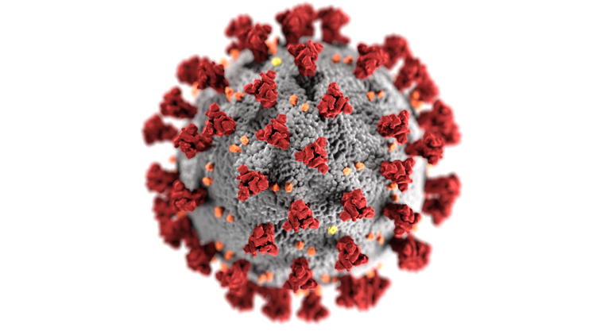

THIS COVID-19 PLAN TEMPLATE FOR SKILLED NURSING FACILITIES WAS PREPARED AS A PUBLIC HEALTH SERVICE BY

Erica Geltz MPH (Candidate), Erin Quackenbush MPH (Candidate), and Patty Medina, MPH

In Fulfillment of their Graduate Studies Course Requirements

GU-5150:Emergency Preparedness for Healthcare Organizations

NYU School of Global Public Health, New York, NY.

July, 2020

**SKILLED NURSING FACILITY**

**(Insert Your Name HERE)**

**COVID-19 Emergency Response Plan**



Today’s Date:

**TABLE OF CONTENTS**

|  |  |
| --- | --- |
|  | Page # |
| Cover Page | 2 |
| Table of Contents | 3-4 |
| Preface | 5 |
| Signature Page | 6-7 |
| Mission, Statement of Purpose, Authorities | 8 |
| Definitions | 8-10 |
| Communication Plan | 10 |
| Mutual Aid Agreement | 10-11 |
| Best Practices:  About CMS Rule  Key Objectives during the COVID-19 Pandemic   1. Prevent introduction of COVID-19 into the facility 2. Detect COVID-19 in the facility 3. Prepare to receive residents with suspected or confirmed COVID-19 4. Prepare to care for residents with suspected or confirmed COVID-19 5. Prevent the spread of COVID-19 in the facility   COVID-19 NHSN Reporting Requirements  Crisis Capacity Strategies   * 1. Staff   2. PPE   3. Gowns   4. Facemasks   5. N95   6. Gloves   7. Soap and Water   Infection prevention and control protocol to minimize risk of spread and to protect clinical and non-clinical staff   * 1. Disinfection and cleaning controls   2. Discharge | 11  11-15  16-20  21-22  22  22  22-24 |
| End-notes & References | 25-28 |
| Annexes:  Annex 1: Skilled Nursing Facility Profile  Annex 2: Incident Command System & Designation of Incident Commander  Annex 3: Skilled Nursing Facility Command Center  Annex 4: Information Management/Telecommunications  Annex 5: SNF Emergency Management/Disaster Preparedness Committee  Annex 6: Facility Notification  Annex 7: Staff Notification  Annex 8: Continuity of Business Operations  Annex 9: Logistics and Emergency Facility Back-up Plan  Annex 10: Skilled Nursing Facility Capacities  Annex 11: Facility Readiness  Annex 12: Training  Annex 13: Drills and Exercises  Annex 14: Mental Health & Psycho-social support (MHPSS) Needs  Annex 15: Donning and Doffing Guide  Annex 16: Donning and Doffing Training Assessment  Annex 17: THIRA Example & Blank Template  Annex 18: Sample Decision Tree for Evacuation vs Shelter in place  Annex 19: SNF Documentation Forms | 29-31  32  33  34  35  35  35-36  36  37  38  39  39  40  40-42  43-46  47-48  49-50  51  52-53 |

**PREFACE**

The COVID-19 pandemic revealed that most state departments of health, hospitals, and other facilities were not prepared to mitigate its spread or address the health needs of affected populations. These organizations lacked both the social capital and resources to effectively respond to the surge capacity needs for patient care. Additionally, coordinated emergency planning and response efforts were inadequate to protect the lives of our most vulnerable populations.

COVID-19 is believed to have originated in Wuhan, China, where the first reports of the disease surfaced on December 31st, 2019. Eventually, it arrived in the United States, where the first case was confirmed on January 20th, 2020.1 The first nursing home patient was transported to a local hospital in Washington State on February 19th, 2020, where the patient was later diagnosed with COVID-19.2 As of September 5, 2020, data from the Johns Hopkins COVID-19 Dashboard indicates there have been 6,269,916 million COVID-19 cases in the United States and 188,791 deaths.3 Worldwide, COVID-19 has claimed the lives of 580,038 individuals, thereby demonstrating the severity of this novel virus and the devastating impact it has on communities around the world.

The Northeastern region of the United States was severely impacted by COVID-19, with New York becoming the epicenter of the pandemic. Hospitals quickly became overwhelmed with high numbers of positive COVID-19 cases. Older populations and individuals with pre-existing medical conditions (heart disease, diabetes, obesity, asthma and other respiratory diseases) were and remain at increased risk of dying from complications associated with the virus. Residents in nursing homes are among the most vulnerable populations. Roughly, 35% of COVID-19 deaths in the United States are residents or staff from nursing homes. 4 Approximately 1.4 to 1.5 million people live in nursing homes in the United States.5 Thus, it is critical that skilled nursing facilities and other congregate settings that care for the elderly are prepared to rapidly implement emergency pandemic plans to effectively control and minimize the risk to residents, staff, and the overall population.

Skilled nursing facilities face a difficult task because in the United States the aging population is increasing at an accelerated rate, often exceeding the availability of resources that are essential to meet the health needs of the elderly. During a crisis, such as COVID-19, appropriate and timely emergency response is essential to ensure the health and safety of residents and staff. This plan is designed to ensure that skilled nursing facilities and similar facility types that serve the needs of the elderly are prepared to effectively respond to the ongoing COVID-19 pandemic.

**SIGNATURE PAGE**

The following leadership staff [fill in as appropriate for your facility] approve this policy and practices set forth in this COVID-19 Emergency Preparedness Plan

\_\_\_\_\_\_\_\_\_\_\_\_\_\_\_\_\_\_\_\_\_\_\_\_\_\_\_\_\_\_ \_\_\_\_\_\_\_\_\_\_\_\_

(Insert name of CEO or Manager of SNF) Date

\_\_\_\_\_\_\_\_\_\_\_\_\_\_\_\_\_\_\_\_\_\_\_\_\_\_\_\_\_\_\_\_\_\_\_\_ \_\_\_\_\_\_\_\_\_\_\_\_

(Insert name of Emergency Manager) Date

\_\_\_\_\_\_\_\_\_\_\_\_\_\_\_\_\_\_\_\_\_\_\_\_\_\_\_\_\_\_\_\_\_\_\_\_ \_\_\_\_\_\_\_\_\_\_\_\_

(Insert name of CMS Director) Date

\_\_\_\_\_\_\_\_\_\_\_\_\_\_\_\_\_\_\_\_\_\_\_\_\_\_\_\_\_\_\_\_\_\_\_ \_\_\_\_\_\_\_\_\_\_\_\_

(Insert name of Medical Director) Date

\_\_\_\_\_\_\_\_\_\_\_\_\_\_\_\_\_\_\_\_\_\_\_\_\_\_\_\_\_\_\_\_\_\_\_ \_\_\_\_\_\_\_\_\_\_\_\_

(Insert name of Chief Operations Officer) Date

\_\_\_\_\_\_\_\_\_\_\_\_\_\_\_\_\_\_\_\_\_\_\_\_\_\_\_\_\_\_\_\_\_\_ \_\_\_\_\_\_\_\_\_\_\_\_

(Insert name of Director of Nursing) Date

\_\_\_\_\_\_\_\_\_\_\_\_\_\_\_\_\_\_\_\_\_\_\_\_\_\_\_\_\_\_\_\_\_ \_\_\_\_\_\_\_\_\_\_\_\_

(Insert name of Director of Public Safety) Date

\_\_\_\_\_\_\_\_\_\_\_\_\_\_\_\_\_\_\_\_\_\_\_\_\_\_\_\_\_\_\_\_\_\_ \_\_\_\_\_\_\_\_\_\_\_\_

(Insert name of Facilities Manager) Date

\_\_\_\_\_\_\_\_\_\_\_\_\_\_\_\_\_\_\_\_\_\_\_\_\_\_\_\_\_\_\_\_ \_\_\_\_\_\_\_\_\_\_\_\_

(Insert name of Transportation Services) Date

\_\_\_\_\_\_\_\_\_\_\_\_\_\_\_\_\_\_\_\_\_\_\_\_\_\_\_\_\_\_\_\_\_\_ \_\_\_\_\_\_\_\_\_\_\_\_

(Insert name of Resident Services Director) Date

\_\_\_\_\_\_\_\_\_\_\_\_\_\_\_\_\_\_\_\_\_\_\_\_\_\_\_\_\_\_\_\_\_\_\_\_\_\_\_\_\_ \_\_\_\_\_\_\_\_\_\_\_\_

(Insert name of Local Department of Health Contract) Date

\_\_\_\_\_\_\_\_\_\_\_\_\_\_\_\_\_\_\_\_\_\_\_\_\_\_\_\_\_\_\_\_\_\_\_\_\_\_\_ \_\_\_\_\_\_\_\_\_\_\_\_

(Insert name of Local Fire Department Contract) Date

\_\_\_\_\_\_\_\_\_\_\_\_\_\_\_\_\_\_\_\_\_\_\_\_\_\_\_\_\_\_\_\_\_\_\_\_\_\_\_\_ \_\_\_\_\_\_\_\_\_\_\_\_

(Insert name of Local Police Department Contract) Date

\_\_\_\_\_\_\_\_\_\_\_\_\_\_\_\_\_\_\_\_\_\_\_\_\_\_\_\_\_\_\_\_\_\_\_\_\_\_\_\_ \_\_\_\_\_\_\_\_\_\_\_\_

(Insert name of Local General Hospital Contract) Date

**MISSION**

**(Please Add Your Own Mission Statement- this is an Example)**

To provide expert, compassionate care to all our nursing home residents and to ensure a safe and healthy environment for all staff and visitors. We aim to strengthen our emergency preparedness and response efforts within our skilled nursing facility in order to promote and protect the health, safety, and well-being of the population that we are proud to serve.

**STATEMENT OF PURPOSE**

The purpose of this plan is to provide guidance so that the facility may maintain the highest level of safety and care for the residents, the staff, and the community during the COVID-19 pandemic.

**AUTHORITIES**

1. CDC
2. CMS Emergency Preparedness Regulation
3. JCAHO
4. OSHA Regulations
5. The Joint Commission- Standards for Nursing Care
6. Fire Safety Regulations

**DEFINITIONS**

**ACF**: Adult care facilities

**ALF**: Assisted-living facility

**At risk population:** older adults and those with underlying medical conditions

**CARF**: Commission on Accreditation of Rehabilitation Facilities

**CDC**: Centers for Disease Control and Prevention

**CMS**: Centers for Medicare & Medicaid Services

**Congregate settings**: Examples include ALF, group homes

**COVID-19**: 2019 Novel Coronavirus (SARS-CoV-2)

**HCP**: Healthcare personnel

**ICD-9-CM**: International Classification of Diseases, 9th Revision, Clinical Modification

**JCAHO**: Joint Commission on Accreditation of Healthcare Organizations

**LTCF**: Long term care facilities

**NF**: Nursing facility

**OSHA:** Occupational Safety and Health Administration

**Pandemic:** Global outbreak

**PHE:** Public health emergency

**POC**: Plan of care

**PPE**: Personal protective equipment

**PUI**: Patient under investigation

**Respiratory Diseases:** Asthma, Acute Respiratory Distress Syndrome (ARDS), Acute Respiratory Infection (ARI), Chronic Obstructive Pulmonary Disease (COPD), etc.

**SNF**: Skilled nursing facility. An SNF is an institution or a distinct part of an institution (see §201.1), such as a skilled nursing home or rehabilitation center, which has a transfer agreement in effect with one or more participating hospitals (see §201.2 for transfer agreements and §205 for definition of a participating hospital) and which:

* + Is primarily engaged in providing skilled nursing care and related services for residents who require medical or nursing care, or rehabilitation services for the rehabilitation of injured, disabled, or sick persons, and
  + Meets the requirements for participation in §1819 of the Social Security Act and in regulation of 42 CFR part 483, subpart B
  + For Medicare purposes, the term SNF does not include any institution which is primarily for the care and treatment of mental diseases or tuberculosis. (This restriction does not apply to title XIX (Medicaid)). Also, the term SNF does not include swing bed hospitals authorized to provide and be reimbursed for SNF level services. Swing bed hospitals must meet many of the same requirements that apply to SNFs. (For more details regarding swing bed hospitals, see §201.3).6

**SOB**: Shortness of breath

**SOC**: Start of care

**Surge capacity**: the ability to manage an increase in patient volume when it exceeds the current capacity in a facility

**WHO**: World Health Organization

**COMMUNICATION PLAN**

**Internal Communication {Describe how clinical and nonclinical communications are conducted in your institution}.**

The person who is in charge of directing the COVID-19 Plan, is referred to as the Incident Commander. The person in charge will direct all facility-wide announcements regarding COVID-19.

**Facility Wide Communications**

* Facilities should utilize intercom, email, and SMS messages to alert employees and residents of information on facility- wide information and policies. Pagers and cell phones will also be utilized by staff for urgent communications.
* Staff should be kept alerted and up to date on COVID-19 diagnoses within the facility as well as any isolation or precautionary measures that need to take place regarding specific residents.

**External Communication {Describe how your institution communicates with external entities and partner institutions}**

All external communication will be directed and approved by the person in charge of the COVID-19 response. This includes appropriate communication between the facility and local Department of Health, CMS (for reporting purposes) and CDC as indicated.

Communication with residents and families is also critical. Leveraging and incorporating mental health & psycho-social support (MHPSS) must become a priority in SNF’s, especially when communicating information with at risk residents and their families.

\*Plan on expanding and adopting COVID-19 information reporting through the CDC’s National Health Safety Network (NHSN) system.7 This information will be used to support surveillance of COVID-19 locally and nationally, monitor trends in infection rates, and inform public health policies and actions.8

**MUTUAL AID AGREEMENT**

The following agencies will provide mutual aid in the event of a COVID-19 outbreak:

1. CMS
2. Local Department of Health
3. Local Hospital Facilities
4. Department of Aging
5. Office of Emergency Management (OEM)
6. Division of Emergency Management and Homeland Security
7. Emergency Medical Services (EMS)
8. Local Law Enforcement and Public Service Sectors
9. Department of Social Services
10. Agency of Human Services
11. White House Coronavirus Taskforce
12. Nursing Home Task Force

**BEST PRACTICES/RECOMMENDATIONS**

**About the CMS Rule**

The Centers for Medicare & Medicaid Services (CMS) is responsible for ensuring the health and safety of nursing home residents by enforcing the necessary requirements to maintain residents’ well-being.9 CMS inspects Medicare and Medicaid-participating facilities; in conjunction with State Survey Agencies; to ensure compliance with Federal health and safety rules and is working with CDC to provide nursing homes with clear guidance.10 CMS is committed to ensure America’s healthcare facilities are prepared to respond to COVID-19 Public Health Emergency (PHE).11

On April 19, 2020, CMS released memo QSO-20-26, “Upcoming Requirements for Notification of Confirmed COVID-19 (or COVID-19 Persons under Investigation) Among Residents and Staff in Nursing Homes,” summarizing new facility reporting requirements that would soon be released through rulemaking.12 Nursing homes are currently required to establish and maintain an infection prevention and control program designed to provide a safe, sanitary, and comfortable environment and to help prevent the development and transmission of communicable diseases and infection.13 \*Medicare Part A (Hospital Insurance) covers skilled nursing care.14

**KEY OBJECTIVES DURING THE COVID-19 PANDEMIC**

This section is adapted from guidance available from t[https://www.cdph.ca.gov/Programs/CHCQ/LCP/CDPH%20Document%20Library/AFL-20-25-Attachment-01-SNF-Checklist.pdf](https://www.cdph.ca.gov/Programs/CHCQ/LCP/CDPH Document Library/AFL-20-25-Attachment-01-SNF-Checklist.pdf)he California Department of Health, available at: and the CDC.

There are **five key objectives** during the COVID-19 pandemic for skilled nursing homes

**1) Prevent introduction of COVID-19 into the facility**

**2) Detect COVID-19 in the facility**

**3) Prepare to receive residents with suspected or confirmed COVID-19 infection**

**4) Prepare to care for residents with suspected or confirmed COVID-19 infection**

**5) Prevent the spread of COVID-19 within the facility**

**(1) Preventing Introduction into the facility**

There are two major sources of virus entry into your facility: **infected personnel and infected visitors.**

**Personnel**:

a.) The facility should require the universal use of facemasks or cloth face coverings for all staff while in the facility.

b.) The facility has provided staff with education to use facemasks or respirators as indicated. If there are shortages of facemasks, facemasks should be prioritized for direct care staff and then for residents with symptoms of COVID-19 (as supply allows).

c.) All staff are reminded to practice social distancing when in break rooms and common areas.

d.) All staff (including ancillary staff such as dietary and housekeeping and consultant personnel) should be screened at start of shift for fever and symptoms of COVID-19 (actively recording their temperature and documents they do not have fever, new or worsening cough, difficulty breathing, chills, repeated shaking with chills, muscle pain, headache, sore throat, or new loss of taste or smell). Anyone with these symptoms or fever should be given a mask and sent home.

* If they become ill with COVID-19 symptoms at work, they should alert supervisors, put on a face mask, and leave immediately to return home
* If they are home and become ill with symptoms of COVID-19, they should call supervisors, stay home and monitor symptoms
* They should seek medical advice
* They should report on ongoing condition, test results, etc. to their supervisors

The facility should have sick leave policies that are non-punitive, flexible, and consistent with public health policies that allow ill nursing facilities personnel to stay home.

**Visitors:**

Post prominent signage regarding *Visitors Policies*. https://www.cms.gov/files/document/covid-nursing-home-reopening-recommendation-faqs.pdf

Have protocol in place for your policy. Because nursing home residents are especially vulnerable, CMS does not recommend opening facilities to visitors (except for compassionate care situations) until **phase three** when:

* there have been no new, nursing home onset COVID-19 cases in the nursing home for 28 days (through phases one and two)
* the nursing home is not experiencing staff shortages
* the nursing home has adequate supplies of personal protective equipment and essential cleaning and disinfection supplies to care for residents
* the nursing home has adequate access to testing for COVID-19
* referral hospital(s) have bed capacity on wards and intensive care units

**CDC as of June 20, 2020 states that visitors with symptoms should not be permitted to enter the facility**. Any visitors that are permitted must wear a cloth face covering while in the building and restrict their visit to the resident's room or other location designated by the facility. They should also be reminded to frequently perform hand hygiene.

* If visitors are allowed: Visitors must be 18 years or older. Visitors over the age of 69 are discouraged due to the increased risks associated with COVID-19.
* Adult patients may have one support person at the bedside, including a family member, caregiver, or another person of their choice. Exceptions are made by our clinical team only when it is medically necessary for a patient’s well-being, such as for patients who have cognitive impairment, intellectual disability, or developmental delay.
* Some SNF have implemented policies to limit all nonessential visitors; in some cases, this may include volunteers.
* The facility should facilitate remote communication between the resident and visitors (for example, video-call applications on cell phones or tablets), and develop policies addressing when and how visitors might still be allowed to enter the facility (such as end of life situations).

**(2) Detecting COVID-19 in your facility**

a.) Facilities should perform surveillance to detect COVID-19. All residents and staff should follow a daily protocol for daily (or more frequent) monitoring for acute respiratory illness (fever, cough, shortness of breath). Use the CDC form to keep track of these symptoms (in staff and residents) and to report to CDC as indicated by your state. <https://www.cdc.gov/longtermcare/pdfs/LTC-Resp-OutbreakResources-P.pdf>

b.) Some facilities are conducting routine COVID-19 testing for their staff and also of their residents (from twice a week to every two weeks) depending on local conditions. The CDC form will help you to keep track of this testing.

c.) Report residents with severe respiratory infection, or three or more residents with acute respiratory illness over 72 hours, to your local public health department. Do not wait for COVID-19 results to report.

d.) Alert your local health department if you identify a resident who has COVID-19.

e.) Notify other facilities prior to transferring a resident with acute respiratory illness, including suspected or confirmed COVID-19 infection.

f.) Notify residents’ family members or the resident’s representative, if there is a COVID-19 positive staff member or resident in the facility.

**(3) Prepare to Receive residents with suspected or confirmed COVID-19 infection**

Some residents infected with COVID-19 may have a mild case and may not require medical care in an acute care facility. Other residents may be discharged from hospital with COVID-19 infection and are medically stable but are still required to have transmission-based precautions. Therefore, SNFs need to be prepared to institute the appropriate precautions to prevent spread of infection to staff and other patients.

a.) Make sure that all staff are familiar with Standard and Transmission-based precautions.

b.) Verify that your facility has the necessary PPE facemasks, N95 respirators, face shields or goggles for eye protection, gowns and gloves; place supplies in all areas where patient care is provided.

c.) Ensure the facility has adequate supply of alcohol-based hand gel and disinfection protocols and supplies to prevent spread of infection.

d.) All staff providing care to residents must be familiar with proper PPE donning and doffing procedures by demonstrating competency.

e.) Identify staff to provide dedicated care for residents with COVID-19 and ensure they are N95 respirator fit tested.

**(4) Prepare to Care for residents with suspected or confirmed COVID-19 infection**

Most SNFs do not have airborne infection isolation rooms (AIIR) for placement of residents with COVID-19 infection. Therefore, place residents with suspected or confirmed COVID-19 infection in single occupancy rooms (or cohorted in multi-occupancy rooms with other residents with confirmed COVID-19 infection), with the door closed.

a.) Symptomatic residents and exposed roommates must limit movement outside their room; if they need to leave the room, they should wear a facemask.

b.) Staff dedicated to care for residents with suspected or confirmed COVID-19 infection should use an N95 respirator wherever available (if unavailable, a facemask), eye protection (face shield or goggles), gloves, and gown. Clean and disinfect high touch surfaces and shared resident care equipment with EPA-registered, healthcare-grade disinfectants.

**(5) Prevent Spread of COVID-19 within your Facility**

a.) Cohort residents with suspected or confirmed COVID-19 infection on the same unit, wing, or building.

b.) Use single-use equipment for residents with COVID-19 infection whenever possible; otherwise, dedicate re-useable medical equipment to residents with COVID-19 infection (e.g., thermometers, stethoscopes, etc.) and clean and disinfect between use.

c.) Minimize the number of staff assigned to patient care activities for residents with COVID-19. Suspend large group activities and close communal dining areas.

d.) If possible, have dedicated staff shower and change after their shift is over to help present spread to their household and other members of the community.

e.) Post COVID-19 social distancing protocols on entry/exits and in break rooms.

f.) Install hand sanitizer dispensaries across worksites and promote Hand Hygiene.

g.) Once a COVID-19 vaccine becomes available, all employees, visitors and volunteers will be required to get vaccinated unless not indicated for medical reasons.

**CENTERS FOR MEDICARE AND MEDICAID (CMS) COVID-19 NHSN REPORTING REQUIRMENTS FOR NURSING HOMES**

CMS is requiring nursing homes to report COVID-19 facility data to the Centers for Disease Control and Prevention (CDC) and to residents, their representatives, and families of residents in facilities.15

Reports must be made at least **once every seven days**. By May 17, 2020, facilities must have submitted their first set of data. CMS will provide facilities with an initial two-week grace period to begin reporting cases in the NHSN system (which ends at 11:59 p.m. on May 24, 2020). Facilities that fail to begin reporting after the third week (by 11:59 p.m. on May 31st) will receive a warning letter reminding them to begin reporting the required information to CDC. Reporting should remain consistent with data being submitted on the same day(s) each week.

42 CFR 483.80 and CDC guidelines specify that nursing homes notify State or Local health department about residents or staff with suspected or confirmed COVID-19, residents with severe respiratory infection resulting in hospitalization or death, or ≥ 3 residents or staff with new-onset respiratory symptoms within 72 hours of each other.16

The details on reporting are available here:

<https://www.cdc.gov/nhsn/pdfs/covid19/ltcf/cms-covid19-req-508.pdf>

**Reporting must include these (link to forms below, here is the web link:** <https://www.cdc.gov/nhsn/ltc/covid19/index.html>

(i) Suspected and confirmed COVID-19 infections among residents and staff, including residents previously treated for COVID-19.

<https://www.cdc.gov/nhsn/pdfs/covid19/ltcf/57.144-res-blank-p.pdf>

(ii) Total deaths and COVID-19 deaths among residents and staff <https://www.cdc.gov/nhsn/pdfs/covid19/ltcf/57.144-res-blank-p.pdf>

(iii) Personal protective equipment and hand hygiene supplies in the facility <https://www.cdc.gov/nhsn/pdfs/covid19/ltcf/57.146-supp-blank-p.pdf>

(iv) Ventilator capacity and supplies in the facility

https://www.cdc.gov/nhsn/pdfs/covid19/ltcf/57.147-vent-blank-p.pdf

(v) Resident beds and census (see link for data collection sheets) https://www.cdc.gov/nhsn/ltc/covid19/index.html

(vi) Access to COVID-19 testing while the resident is in the facility (see link for data collection sheets) https://www.cdc.gov/nhsn/ltc/covid19/index.html

(vii) Staffing shortages: (see link for data collection sheets)

<https://www.cdc.gov/nhsn/ltc/covid19/index.html>

**CRISIS CAPACITY STRATEGIES**

**Staff**

a.) It is recommended that the resident to provider ratio be 4:1 to reduce COVID-19 transmissions and exposures.

b.) Leveraging Public health professional volunteer networks can fill the gap in the shortage of

essential SNF staff

c.) Additional sources of staffing resources

**Nursing Home Task Force**

\*The number of employees will vary based on the number of residents in a SNF.

\*\* It is recommended that the resident to provider ratio be 4:1 to reduce COVID-19 transmissions and exposures. \*\*\* Leveraging Public health professional volunteer networks can fill the gap in the shortage of essential SNF staff

**PPE Supplies**

Burn Rate calculator from CDC is available here:

<https://www.cdc.gov/coronavirus/2019-ncov/hcp/ppe-strategy/burn-calculator.html>

**Gowns**

a. Nonsterile, disposable patient isolation gowns are appropriate for use by staff when caring for clients with known or suspected COVID-19. In crisis situations, gowns may be worn by the same staff member when interacting with more than one patient known to be infected with COVID-19. If the gown becomes visibly soiled it must be removed and properly discarded.

b. Surgical gowns should be prioritized for surgical or other sterile procedures.

c. When No gowns are available, consider using washable patient gowns over scrubs, using washing lab coats, disposable aprons, or other disposable plastic covering.

**Facemask**

Extended use of facemasks is the practice of wearing the same facemask for repeated close contact encounters with several different patients, without removing the facemask between patient encounters.

* The facemask should be removed and discarded if soiled, damaged, or hard to breathe through.
* HCP must take care not to touch their facemask. If they touch or adjust their facemask, they must immediately perform hand hygiene.
* HCP should leave the patient care area if they need to remove the facemask.

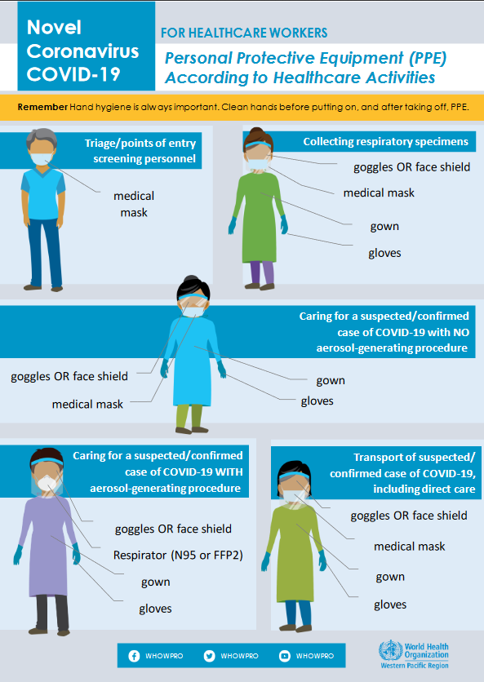

Image taken from The COVID-19 Risk Communication Package for Healthcare Facilities. WHO. Updated March 10, 2020.

**Restrict facemasks to use by HCP, rather than patients for source control.**

Have patients with symptoms of respiratory infection use tissues or other barriers to cover their mouth and nose.

**N95 Masks**

Fit testing suspension: Facilities can consider temporarily suspending annual fit testing of HCP in times of expected shortages. In March 2020, OSHA issued new [temporary guidance external icon](https://www.osha.gov/memos/2020-03-14/temporary-enforcement-guidance-healthcare-respiratory-protection-annual-fit) regarding the enforcement of OSHA’s Respiratory Protection Standard. The guidance gave OSHA field offices enforcement discretion concerning the annual fit testing requirement as long as HCP have undergone an initial fit test with the same model, style, and size. Other conditions include explaining to HCP the importance of conducting a user seal check each time the respirator is put on and conducting a fit test if there are visual changes to the employee’s physical condition.

In times of shortage, consideration can be made to use N95 respirators beyond the manufacturer-designated shelf life. However, expired respirators might not perform to the requirements for which they were certified. Over time, components such as the strap and material may degrade, which can affect the quality of the fit and seal. Because of this, use of expired respirators could be prioritized for situations where HCP are NOT exposed to pathogens, such as training and fit testing.  As expired respirators can still serve an important purpose, healthcare facilities should retain and reserve all N95 respirators during the pandemic.

**Extended use:**  Refers to the practice of wearing the same N95 respirator for repeated close contact encounters with several different patients, without removing the respirator between patient encounters. Extended use is well suited to situations wherein multiple patients with the same infectious disease diagnosis, whose care requires use of a respirator, are cohorted (e.g., housed on the same hospital unit). It can also be used for care of patients with tuberculosis, varicella, and measles, other infectious diseases where use of an N95 respirator or higher is recommended. When practicing extended use of N95 respirators, the maximum recommended extended use period is 8–12 hours. Respirators should not be worn for multiple work shifts and should not be reused after extended use. N95 respirators should be removed (doffed) and discarded before activities such as meals and restroom breaks.

**Gloves**

**Use of gloves past their manufacturer-designated shelf life for healthcare delivery:** Non-sterile disposable gloves cleared by the FDA are not required to have [expiration date labeling external icon](https://www.fda.gov/media/90612/download); however, some manufacturers choose to designate a shelf life. Facilities may consider using gloves past their manufacturer-designated shelf life for healthcare delivery. Sterile gloves past their manufacturer-designated shelf life should not be used for surgical or other sterile procedures.

Prioritize the use of non-sterile disposable gloves: Non-sterile disposable gloves should be prioritized for use during activities when gloves are recommended to protect the hands from contact with potentially hazardous substances, including blood and body fluids (e.g., wound care, aerosol **generating procedures).**

Staff should wear gloves when it can be reasonably anticipated that contact with blood or other potentially infectious materials, mucous membranes, non-intact skin, or potentially contaminated intact skin could occur.

**Consider non-healthcare glove alternatives:** In instances of severely limited or no available disposable medical gloves, non-healthcare disposable gloves (e.g., food service or industrial chemical resistance gloves) may be considered for situations where staff are not exposed to pathogens. These gloves are available in many different materials, including polyvinyl chloride, nitrile, and latex. Sizing and limitations to dexterity should be considered. Extended use of disposable medical gloves by staff refers to the practice of wearing gloves without changing them between patients or tasks. Disposable medical glove extended wear is most easily implemented when patients are cohorted, such as when caring for a group of patients with the same confirmed infectious disease diagnosis (e.g., patients with confirmed COVID-19) in a shared or adjacent location. During glove supply crisis gloves can remain on but must be sanitized between patients within the cohort to prevent cross transmission of any other pathogens from patient to patient.

Gloved hands must be cleaned following cleaning procedures described in detail below at intervals where gloves would normally be changed (e.g., when moving from a ‘dirty’ to ‘clean’ task, between patients) or hand hygiene normally performed.

Disposable medical gloves should always be discarded after:

* Visible soiling or contamination with blood, respiratory or nasal secretions, or other body fluids occurs
* Any signs of damage (e.g., holes, rips, tearing) or degradation are observed
* Maximum of four hours of continuous use
* Doffing. Previously removed gloves should not be re-donned as the risk of tearing and contamination increases. Therefore, disposable glove “re-use” should not be performed.

After removing gloves for any reason, hand hygiene should be performed with alcohol-based hand sanitizer or soap and water.

**Methods for performing hand hygiene of gloved hands for extended use of disposable medical gloves:** CDC does not recommend disinfection of disposable medical gloves as standard practice. This practice is inconsistent with general disposable glove usage, but, in times of extreme disposable medical glove shortages, this option may need to be considered.

**Alcohol-based hand sanitizer (ABHS)** is the preferred method for performing hand hygiene of gloved hands in healthcare settings when the gloves are not visibly soiled. Research has shown multiple disposable latex and nitrile glove brands maintained their integrity when treated with ABHS. [1-2] Disposable medical gloves can be disinfected for up to six (6) applications of ABHS or until the gloves become otherwise contaminated or ineffective (for one or more of the reasons stated in extended use guidance above). Follow [hand hygiene guidance](https://www.cdc.gov/handhygiene/index.html) for proper application of ABHS.

**Soap and water**

If ABHS is not available, soap and water can be used to clean donned disposable medical gloves between tasks or patients. HCP planning to wash gloves with soap and water should wear long-cuffed surgical gloves; as washing may be impractical for short cuffed gloves where water may become trapped inside the worn gloves. Disposable medical gloves can be cleaned with soap and water up to 10 times or until the gloves become otherwise contaminated or ineffective (for one or more of the reasons stated in extended use guidance above). Follow [hand hygiene guidance](https://www.cdc.gov/handhygiene/index.html) for proper soap and water hand hygiene procedures.

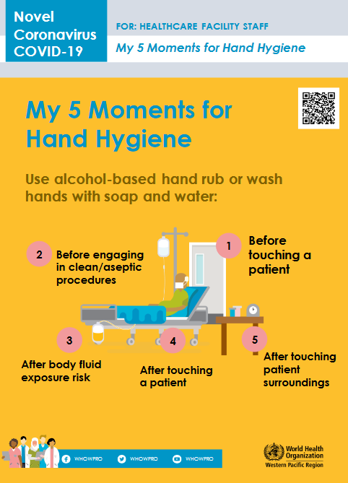

Image taken from The COVID-19 Risk Communication Package for Healthcare Facilities. WHO. Updated March 10, 2020.

**INFECTION PREVENTION AND CONTROL PROTOCOL TO MINIMIZE RISK OF SPREAD AND TO PROTECT CLINICAL AND NONCLINICAL STAFF**

From CDC available at: <https://www.cdc.gov/coronavirus/2019-ncov/hcp/nursing-homes-responding.html>

**The 4 categories of mitigation techniques**

1. Promote Behaviors that Prevents Spread
2. Maintain Healthy Environments
3. Maintain Health Operations
4. Prepare for When Someone Gets Sick

As per the **CDC June 19, 2020 Guidance**, we will implement infection prevention and control recommendation as follows:

⬜ Assign one or more individuals with training in infection control to provide On-Site Management of the IPC Program**.** This should be a full-time role for at least one person in facilities that have more than 100 residents or that provide on-site ventilator or hemodialysis services. 17

\*Smaller facilities should consider staffing/ training appropriate personnel for the IPC program based on the resident population and facility service needs identified in the [facility risk assessment](https://www.cdc.gov/longtermcare/training.html" \l "anchor_1557254909)

⬜ Provide information about [COVID-19](https://www.cdc.gov/coronavirus/2019-ncov/index.html) (including information about signs and symptoms) and strategies for [managing stress and anxiety](https://www.cdc.gov/coronavirus/2019-ncov/daily-life-coping/managing-stress-anxiety.html) in the languages that are most spoken at your SNF site.18

⬜ All staff should wear face masks or N95 respirators as appropriate.

⬜ Staff should remove masks following appropriate donning and doffing procedures (**See Annex for proper donning and filing procedures)** and then wash hands or use hand gels. use hand gel or hand washing when they leave the facility or at the end of shift or at meal times. They should wash hands/use hand gel after they reapply their used mask.

⬜ All employees should complete a daily symptom checklist.

⬜ Identify space in the facility that could be dedicated to care for residents with confirmed COVID-19 (floor, unit, or wing in the facility or a group of rooms).

⬜ Staff who are required to use PPE should receive training (when to use PPE, what PPE is necessary, how to properly don and off, how to properly dispose of PP, the limitations of PPE). Training records should be kept.

⬜ Implement or use Telehealth strategies to reduce risk of COVID-19 spread from your facility to other healthcare facilities.

⬜ Educate residents, healthcare personnel, visitors and volunteers about COVID-19, current precautions being taken in the facility, and actions they should take to protect themselves. 19

⬜ Breaks and meal times should take place in a designated area where 6 ft distances can be maintained.

⬜ Post signs at the entrance and at strategic locations reminding the wearing of face masks, frequent hand washing and/or use of hand gels in the languages most commonly used in your SNF.

⬜ Limit and monitor entry to the facility and limit visitors.

⬜ Physical distancing to the extent possible (maintain 6 ft) should be maintained at the facility.

⬜ In person group activities should be suspended.

**DISINFECTION AND CLEANING CONTROLS**

⬜ Hand washing stations or alcohol-based hand rubs should be immediately available at all entryways.

⬜ Dedicated medical equipment should be used for patient care, when possible.

⬜ Between each use, non-disposable medical equipment should be cleaned and disinfected. This should be done according to manufacturer's instructions and facility policies.

⬜ Management of laundry, food service utensils, and medical waste should be performed in accordance with routine procedures.

All facilities should closely monitor their capacity for patient care. Understanding licensed bed numbers as well as surge capacity will be important if outbreak occurs. More importantly, ventilator capacity and staffed bed capacity will be essential in the event of a COVID-19 outbreak where respiratory care will be of the utmost importance.

**DISCHARGE**

**Transfer Agreements**

An SNF must have a written transfer agreement with one or more participating hospitals (see § 205) providing for the transfer of patients between the hospital and the SNF, and for the interchange of medical and other information. If otherwise qualified SNF has attempted in good faith, but without success, to enter into a transfer agreement, this requirement may be waived by the State agency. (See 42 CFR 483.75 (n) for the detailed requirements for transfer agreements).20

**Questions to begin the Discharge Planning Process** 21

1. Is the discharge process interdisciplinary?
2. Are you providing clear and concise instructions to residents?
3. Are social services completing a post-discharge follow-up to ensure resident well-being?

**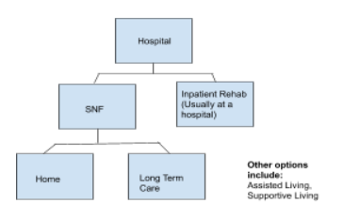**

**Discharged Planning Options**22

**Option 1: Hospital to SNF**23

* Observation vs inpatient status
* Inpatient (qualifies as a stay for a SNF to be covered)

**Option 2: SNF to Nursing Home Long Term Care** 24

|  |  |
| --- | --- |
| **SNF** | **Nursing Home Long Term Care** |
| * Time Frame: Short term * Care Received: PT, OT, Speech, Wound care * Payer: Medicare pays first or private insurance, Medicaid last resort * Location: Nursing Home (sometimes a separate wing or floor) * Goal: Return to the community | * Time Frame: Long Term * Care Received: Custodial Care (ADLs), can still get Skilled Care if it is needed but it is limited under Medicaid * Payer: Medicaid, LTC insurance, Private Pay * Location: Nursing home. You must apply to be a long-term resident |

**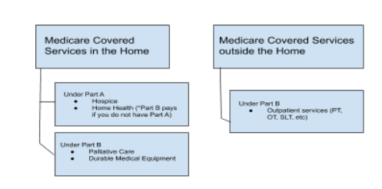**

**Option 3: Home** 25

**After a confirmed case is discharged26**

* Any facility that can convert a room to negative pressure should do so for 30-60 minutes with the door closed before staff enters the room without PPE or another patient is admitted to that room

**Community Resources and Referrals 27**

Discharge planning is NOT just about medical care. It encompasses:

* Education
* Discharge instructions
* Services: Food Pantries
* Public Benefit Programs
* Health Insurance
* Housing

**Endnotes**

1. Holshue M et al. First Case of 2019 Novel Coronavirus in the United States. N Engl J Med 2020; 382:929-936.DOI: 10.1056/NEJMoa2001191

2. Secon H. More than 60% of the US’s coronavirus deaths are linked to a Washington nursing home. Here’s what we know about the outbreak there. 2020. https://www.businessinsider.com/coronavirus-deaths-washington-nursing-home-outbreak-2020-3

3. Johns Hopkins COVID-19 Dashboard.https://coronavirus.jhu.edu/map.html

4. Yourish K et al. One Third of All US Coronavirus Deaths Are Nursing Home Residents or Workers. New York Times. 2020. <https://www.nytimes.com/interactive/2020/05/09/us/coronavirus-cases-nursing-homes-us.html>

5. Howley E K. Nursing Home Facts and Statistics. US News. <https://health.usnews.com/health-news/best-nursing-homes/articles/nursing-home-facts-and-statistics>

6. Medicare Skilled Nursing Facility Manual. https://www.cms.gov/Regulations-and-Guidance/Guidance/Transmittals/downloads/R367SNF.pdf

7. CMS. Upcoming Requirements for Notification of Confirmed COVID-19 (or COVID19 Persons under Investigation) Among Residents and Staff in Nursing Homes QSO-20-26-NH. https://www.cms.gov/files/document/qso-20-26-nh.pdf

8. CMS. Upcoming Requirements for Notification of Confirmed COVID-19 (or COVID19 Persons under Investigation) Among Residents and Staff in Nursing Homes. https://www.cms.gov/files/document/qso-20-26-nh.pdf

9. CMS. Upcoming Requirements for Notification of Confirmed COVID-19 (or COVID19 Persons under Investigation) Among Residents and Staff in Nursing Homes. https://www.cms.gov/files/document/qso-20-26-nh.pdf

10. CMS. Upcoming Requirements for Notification of Confirmed COVID-19 (or COVID19 Persons under Investigation) Among Residents and Staff in Nursing Homes. https://www.cms.gov/files/document/qso-20-26-nh.pdf

11. CMS. Interim Final Rule Updating Requirements for Notification of Confirmed and Suspected COVID-19 Cases Among Residents and Staff in Nursing Homes. https://www.cms.gov/files/document/qso-20-29-nh.pdf

12. CMS. Interim Final Rule Updating Requirements for Notification of Confirmed and Suspected COVID-19 Cases Among Residents and Staff in Nursing Homes. https://www.cms.gov/files/document/qso-20-29-nh.pdf

13. CMS. Upcoming Requirements for Notification of Confirmed COVID-19 (or COVID19 Persons under Investigation) Among Residents and Staff in Nursing Homes. https://www.cms.gov/files/document/qso-20-26-nh.pdf

14. Skilled nursing facility care. Medicare.gov. https://www.medicare.gov/coverage/skilled-nursing-facility-snf-care

15.CMS. Interim Final Rule Updating Requirements for Notification of Confirmed and Suspected COVID-19 Cases Among Residents and Staff in Nursing Homes. <https://www.cms.gov/files/document/qso-20-29-nh.pdf>

16. CMS. Upcoming Requirements for Notification of Confirmed COVID-19 (or COVID19 Persons under Investigation) Among Residents and Staff in Nursing Homes. https://www.cms.gov/files/document/qso-20-26-nh.pdf

17. CDC. Preparing for COVID-19 in Nursing Homes. https://www.cdc.gov/coronavirus/2019-ncov/hcp/long-term-care.html

18. CDC. Preparing for COVID-19 in Nursing Homes. https://www.cdc.gov/coronavirus/2019-ncov/hcp/long-term-care.html

19. CDC. Preparing for COVID-19 in Nursing Homes. https://www.cdc.gov/coronavirus/2019-ncov/hcp/long-term-care.html

20. [Medicare Skilled Nursing Facility Manual.](https://nyulangone.org/patient-family-support/visiting-hours?cid=eml_dm&em=VisitorPolicy_3.1.6&subkey=0033900002Q7d74AAB&job_id=56329) https://www.cms.gov/Regulations-and-Guidance/Guidance/Transmittals/downloads/R367SNF.pdf

21. HSAG.https://www.hsag.com/globalassets/care-coordination/snfreadmissionstoolkit508.pdf

22. Emily Gelber. Medicare and Discharge Planning. http://www.ageoptions.org/documents/MMWWebinarDischargePlanningandMedicare.pdf

23. Emily Gelber. Medicare and Discharge Planning. http://www.ageoptions.org/documents/MMWWebinarDischargePlanningandMedicare.pdf

24. Emily Gelber. Medicare and Discharge Planning. http://www.ageoptions.org/documents/MMWWebinarDischargePlanningandMedicare.pdf

25. Emily Gelber. Medicare and Discharge Planning. http://www.ageoptions.org/documents/MMWWebinarDischargePlanningandMedicare.pdf

26. 2019 Novel Coronavirus Toolkit. 2020. https://www.massgeneral.org/assets/MGH/pdf/disaster-medicine/2019-Novel-Coronavirus-(2019-nCoV)-Toolkit-version-1.29.2020.pdf

27. Emily Gelber. Medicare and Discharge Planning. <http://www.ageoptions.org/documents/MMWWebinarDischargePlanningandMedicare.pdf>

**References**

1. Best Practices and Good Ideas: A Handbook for Infection Control in Nursing Homes. <https://www1.nyc.gov/assets/doh/downloads/pdf/em/infection-control-nursing-homes.pdf>
2. CDC. Considerations for Optimizing the Supply of Powered Air-Purifying Respirators (PAPRs)https://www.cdc.gov/coronavirus/2019-ncov/hcp/ppe-strategy/powered-air-purifying-respirators-strategy.html
3. CDC.Coping with Stress. <https://www.cdc.gov/coronavirus/2019-ncov/daily-life-coping/managing-stress-anxiety.html>
4. CDC. COVID 19. Gloves. <https://www.cdc.gov/coronavirus/2019-ncov/hcp/ppe-strategy/gloves.html>
5. CDC. Infection Prevention and Control Assessment Tool for Nursing Homes Preparing for COVID-19. <https://www.cdc.gov/coronavirus/2019-ncov/downloads/hcp/assessment-tool-nursing-homes.pdf>
6. CDC. Optimize PPE Supply. https://www.cdc.gov/coronavirus/2019-ncov/hcp/ppe-strategy/index.html
7. CDC. Nursing Homes & Long-Term Care Facilities. <https://www.cdc.gov/coronavirus/2019-ncov/hcp/long-term-care.html>
8. CDC. Taking Care of Your Emotional Health. <https://emergency.cdc.gov/coping/selfcare.asp>
9. Center for Clinical Standards and Quality/Quality, Safety & Oversight Group. https://www.cms.gov/files/document/qso-20-29-nh.pdf
10. Gelber, E. Medicare and Discharge Planning. http://www.ageoptions.org/documents/MMWWebinarDischargePlanningandMedicare.pdf
11. Howledy, E. (2020). Nursing Home Facts and Statistics. Retrieved 30 July 2020, from https://health.usnews.com/health-news/best-nursing-homes/articles/nursing-home-facts-and-statistics
12. HSAG.https://www.hsag.com/globalassets/care-coordination/snfreadmissionstoolkit508.pd
13. Implement Environmental Infection Control [https://www.ahcancal.org/facility\_operations/disaster\_planning/Documents/COVID-19%20%E2%80%93%20Update%206.pdf](https://www.ahcancal.org/facility_operations/disaster_planning/Documents/COVID-19 – Update 6.pdf)
14. Medicare Skilled Nursing Facility Manual. https://www.cms.gov/Regulations-and-Guidance/Guidance/Transmittals/downloads/R367SNF.pdf
15. Nursing Home Reopening Recommendations Frequently Asked Questions. https://www.cms.gov/files/document/covid-nursing-home-reopening-recommendation-faqs.pdf
16. Secon H. More than 60% of the US’s coronavirus deaths are linked to a Washington nursing home. Here’s what we know about the outbreak there. 2020. <https://www.businessinsider.com/coronavirus-deaths-washington-nursing-home-outbreak-2020-3>
17. Spanko A. CMS Releases Nursing Home Staffing, Census Data to Help States Make PPE and Testing Decisions. Skilled Nursing News. https://skillednursingnews.com/2020/04/cms-releases-nursing-home-staffing-resident-data-to-help-states-make-ppe-testing-decisions/. Published April 24, 2020. Accessed June 8, 2020.
18. Surge Capacity Guidelines and Templates. Iowa Department of Public Health. Guidelines for Off-site Medical Care Facilities. 2006. Accessed <https://www.cidrap.umn.edu/practice/surge-capacity-guidelines-and-templates>
19. Upcoming Requirements for Notification of Confirmed COVID-19 (or COVID19 Persons under Investigation) Among Residents and Staff in Nursing Homes. <https://www.cms.gov/files/document/qso-20-26-nh.pdf>
20. Use Personal Protective Equipment (PPE) when caring for patients with confirmed or suspected COVID-19. https://www.cdc.gov/coronavirus/2019-ncov/downloads/A\_FS\_HCP\_COVID19\_PPE.pdf
21. Visiting Hours. NYU Langone. <https://nyulangone.org/patient-family-support/visiting-hours?cid=eml_dm&em=VisitorPolicy_3.1.6&subkey=0033900002Q7d74AAB&job_id=56329>
22. Yourish, K., Lai, K., & Smith, M. (2020). One-Third of All U.S. Coronavirus Deaths Are Nursing Home Residents or Workers. Retrieved 30 July 2020, from https://www.nytimes.com/interactive/2020/05/09/us/coronavirus-cases-nursing-homes-us.html
23. 2019 Novel Coronavirus Toolkit. <https://www.massgeneral.org/assets/MGH/pdf/disaster-medicine/2019-Novel-Coronavirus-(2019-nCoV)-Toolkit-version-1.29.2020.pdf>

**ANNEX 1: SKILLED NURSING FACILITY PROFILE**

|  |  |
| --- | --- |
| Skilled nursing home name |  |

|  |  |
| --- | --- |
| Facility address |  |
| Facility contact name and  emergency phone number |  |
| Facility main phone number |  |
| Number of residents in facility |  |
| Total licensed # of beds |  |
| Areas that can be converted as additional rooms (Ex: cafeteria, etc) and square footage |  |
| Skilled nursing home staffing: |  |
| * Clinical |  |
| * Non-clinical |  |
| * Licensed practitioners |  |
| Volunteers |  |
| Nursing staff hours per resident per day |  |

|  |  |
| --- | --- |
| Facility is: | Check all that apply |
|  | ☐ As part of a medical center/medical school |
|  | ☐ Stand-alone, in a civilian community |
|  | ☐ Part of a regional hospital system |
|  | ☐ Part of a national hospital chain |

|  |  |
| --- | --- |
| Specialty units | Check all that apply |
|  | ☐ Vent/trach |
|  | ☐ Dialysis |
|  | ☐ Dementia/memory |
|  | ☐ Skilled nursing |
|  | ☐ Wound Care |
|  | ☐ Intravenous injections (TPN) |
|  | ☐ Psychiatric care |
|  | ☐ Rehabilitation |
|  | ☐ Candida auris |
|  | ☐ Clostridium difficile |
|  | ☐ Other, please specify: |
| The Joint Commission’s Nursing Care Center Accreditation | ☐ Yes ☐ No |
| CARF Accreditation | ☐ Yes ☐ No |
| SNF is Medicare-certified | ☐ Yes ☐ No |
| SNF is Medicaid-certified | ☐ Yes ☐ No |

CDC. Infection Prevention and Control Assessment Tool for Nursing Homes Preparing for COVID-19.<https://www.cdc.gov/coronavirus/2019-ncov/downloads/hcp/assessment-tool-nursing-homes.pdf>

CDC. Preparing for COVID-19 in Nursing Homes.<https://www.cdc.gov/coronavirus/2019-ncov/hcp/long-term-care.html>

**COVID-19 In Your Facility**

|  |  |
| --- | --- |
| **COVID-19 Status & Comorbidities** | **Number/Since start of pandemic** |
| Number of COVID-19 positive cases to date in your facility (residents) |  |
| Number of COVID-19 positive cases to date in your facility (staff) |  |
| Suspected COVID-19 infections to date in your facility |  |

**CURRENT PATIENT CARE CAPACITY**

All facilities should closely monitor their capacity for patient care. Understanding licensed bed numbers as well as surge capacity will be important if outbreak occurs. More importantly, ventilator capacity and staffed bed capacity will be essential in the event of a COVID-19 outbreak where respiratory care will be of the utmost importance.

|  |  |  |  |
| --- | --- | --- | --- |
|  | **Ambulatory** | **Rehabilitation Center** | **Skilled Nursing Facility** |
| **Licensed bed capacity** |  |  |  |
| **Average staffed bed** (average beds in use and staffed in last 6 months |  |  |  |
| **Beds with Negative Airflow** (for use in respiratory isolation) |  |  |  |
| **Monitored beds** (Beds equipped with cardiac and vital signs) |  |  |  |
| **Ventilators** (rented or owned) |  |  |  |
| **Surge Capacity** (Number of additional beds that can be staffed & equipped w/in 12 hours) |  |  |  |
| **Oxygen tanks** |  |  |  |
| **Pulse ox** |  |  |  |
| **Thermometers** |  |  |  |

**ANNEX 2: INCIDENT COMMAND SYSTEM AND DESIGNATION OF INCIDENT COMMANDER**

|  |  |
| --- | --- |
| An Incident Command System (ICS) or Hospital Incident Command System (HICS) is in place. | ☐ Yes ☐ No |
| a. ICS is exercised at least twice annually.  Last exercised: | ☐ Yes ☐ No  \_\_\_\_/\_\_\_\_/\_\_\_\_\_\_\_ |
| b. ICS is coordinated by a Unified Command Structure coordinated when appropriate with law enforcement, fire, EMS. | ☐ Yes ☐ No |
| c. 1. Incident Commander is known by all staff.  2. Incident commander succession plan is in place. | ☐ Yes ☐ No |
| d. There is a procedure to designate an Incident Commander. | ☐ Yes ☐ No |
| e. Staff assigned to ICS leadership roles are oriented to their responsibilities. | ☐ Yes ☐ No |
| f. Staff assigned to key roles wear identifying gear during an event. | ☐ Yes ☐ No |
| g. All staff know where to report when the ICS is activated. | ☐ Yes ☐ No |
| h. Staff understands the flexibility of their positions in the ICS if leadership is unavailable. | ☐ Yes ☐ No |
| i. ICS or HICS is NIMS compliant? | ☐ Yes ☐ No |
| j. After action reports are completed after all exercises? | ☐ Yes ☐ No |

**ANNEX 3: SKILLED NURSING FACILITY COMMAND CENTER**

|  |  |
| --- | --- |
| A Nursing Home Command Center is fully operational and integrated into local/county emergency planning and operations. | ☐ Yes ☐ No |
| a. In the NHCC, telephone numbers are available for:  the local health department  state health department  local Police Dept.  CDC Emergency Preparedness Office  Others: | ☐ Yes ☐ No  ☐ Yes ☐ No  ☐ Yes ☐ No  ☐ Yes ☐ No  ☐ Yes ☐ No |
| b. NHCC is equipped with:  Telephones Satellite phones  Fax  Two-way radios  Generator  Maps of hospital  Maps of local area  N95/KN95 masks  Surgical masks  Face Shields/eye goggles  Gowns  Gloves  Hand Sanitizer  Disinfectant Spray  Bullhorns  Flashlights  Copy of the emergency management plan  Others: | ☐ Yes ☐ No  ☐ Yes ☐ No  ☐ Yes ☐ No  ☐ Yes ☐ No  ☐ Yes ☐ No  ☐ Yes ☐ No  ☐ Yes ☐ No  ☐ Yes ☐ No  ☐ Yes ☐ No  ☐ Yes ☐ No  ☐ Yes ☐ No  ☐ Yes ☐ No  ☐ Yes ☐ No  ☐ Yes ☐ No  ☐ Yes ☐ No  ☐ Yes ☐ No  ☐ Yes ☐ No  ☐ Yes ☐ No |
| c. NHCC is located in a secure location. | ☐ Yes ☐ No |
| d. An alternate NHCC site exists and can be used if the primary site is inaccessible. | ☐ Yes ☐ No |
| e. NHCC can maintain 24 hour operations for a minimum of 1 week. | ☐ Yes ☐ No |
| f. NHCC can monitor local media. | ☐ Yes ☐ No |
| g. Each section chief has a designated telephone line. | ☐ Yes ☐ No |
| h. The ICS command staff has an adequate, pre-defined communications system. | ☐ Yes ☐ No |
| h. The ICS command staff has an adequate, pre-defined communications system. | ☐ Yes ☐ No |

**ANNEX 4: INFORMATION MANAGEMENT/TELECOMMUNICATIONS**

|  |  |
| --- | --- |
| Essential information systems and data storage have offsite storage and recovery capabilities. | ☐ Yes ☐ No |
| Information management staff participate in facility emergency exercises. | ☐ Yes ☐ No |
| System has protection from viruses and intentional attacks (hacking). | ☐ Yes ☐ No |
| Facility has a designated public information officer (PIO). | ☐ Yes ☐ No |
| a. In the event of multi-agency response, media activities will be coordinated through Joint Information Center (JIC). | ☐ Yes ☐ No |
| b. PIO has established relationships with counterparts in Public Health and emergency management agencies. | ☐ Yes ☐ No |
| Staff know where and to whom media inquiries are to be referred. | ☐ Yes ☐ No |
| A site is designated for regular meetings with media. | ☐ Yes ☐ No |
| a. PIO has developed generic press releases about the facility and possible emergency conditions. | ☐ Yes ☐ No |
| b. PIO has established relationships with local media. | ☐ Yes ☐ No |
| c. The press conference location is outside the facility. | ☐ Yes ☐ No |
| Facility has current mutual aid Memorandum of Understanding (MOUs) in place. | ☐ Yes ☐ No |
| a. Memorandum of Understanding (MOUs) are in place with:  Law enforcement  Fire  Emergency medical services (EMS)  Public Safety  Military installations  Other local and regional health care facilities  Burn center  Red Cross  MMRS  CERT  Other: | ☐ Yes ☐ No  ☐ Yes ☐ No  ☐ Yes ☐ No  ☐ Yes ☐ No  ☐ Yes ☐ No  ☐ Yes ☐ No  ☐ Yes ☐ No  ☐ Yes ☐ No  ☐ Yes ☐ No  ☐ Yes ☐ No |
| b. Memorandum of Understanding (MOUs) are in place for:  Portable MRI  Portable CT  Portable Dialysis  Generators  Other: | ☐ Yes ☐ No  ☐ Yes ☐ No  ☐ Yes ☐ No  ☐ Yes ☐ No |

**ANNEX 5: SNF EMERGENCY MANAGEMENT/ DISASTER PREPAREDNESS COMMITTEE**

|  |  |
| --- | --- |
| A skilled nursing facility emergency management/disaster preparedness committee exists and provides leadership and governance. | ☐ Yes ☐ No |
| a. Committee is multidisciplinary. | ☐ Yes ☐ No |
| b. Open meetings are held regularly | ☐ Yes ☐ No  How often? |
| c. Committee meeting minutes/action plan are available for review. | ☐ Yes ☐ No |
| d. Committee forwards critiques of all drills to appropriate services in a timely manner. | ☐ Yes ☐ No |
| e. Committee communicates with and/or cooperates with other skilled nursing facilities/healthcare systems in the community | ☐ Yes ☐ No |
| f. Facility representative attends at least 75% of the Local/Community Emergency Planning Committee. meetings. | ☐ Yes ☐ No |
| g. Facility representative reports to governance of the skilled nursing facility on community planning, exercises and after-action reports. | ☐ Yes ☐ No |
| i. Facility participates in joint training exercises. | ☐ Yes ☐ No |

**ANNEX 6: FACILITY NOTIFICATION**

|  |  |
| --- | --- |
| Facility can send and receive emergency warning and notification information. | ☐ Yes ☐ No |
| a. Facility can receive warnings of imminent emergency conditions from external agencies. | ☐ Yes ☐ No |
| b. Facility can send warnings to external agencies. | ☐ Yes ☐ No |
| c. Redundant communication system is in place in the event that the primary system fails. | ☐ Yes ☐ No |

**ANNEX 7: STAFF NOTIFICATION**

|  |  |
| --- | --- |
| Facility can notify on-duty and off-duty staff of emergency status and recall to duty. | ☐ Yes ☐ No |
| a. Facility has a plan to notify on-duty and off-duty staff of emergency status. | ☐ Yes ☐ No |
| b. Staff notification system has been tested in the past 6 months. | ☐ Yes ☐ No |
| c. Facility has staff notification with up-to-date, verified phone and other contact information. | ☐ Yes ☐ No |
| d. Facility has either an automated call-back system or staff identified and dedicated to staff notification. | ☐ Yes ☐ No |
| e. Staff can receive warnings from the Digital Emergency Alert System by either voice or text messages on their wireless phones. | ☐ Yes ☐ No |
| f. Facility keeps a current and updated list of staff that volunteer and are likely to be deployed during an emergency (NDMS, National Guard, etc.) | ☐ Yes ☐ No |
| g. The EMP takes into account staff backfill issues. | ☐ Yes ☐ No |
| Command uses compatible radios (e.g. 800 mhz) for communications with local agencies. | ☐ Yes ☐ No |
| Emergency Operations Center has a dedicated telephone trunk line. | ☐ Yes ☐ No |
| Two-way radio communication (walkie-talkie) is available for all units and essential personnel. | ☐ Yes ☐ No |
| Facility has access to communications on wheels (COWS). | ☐ Yes ☐ No |
| Facility has access to an amateur radio system (Ham/RACES). | ☐ Yes ☐ No |
| A back-up communications system is in place in the event that the primary system fails. | ☐ Yes ☐ No |
| If all technology-based communications fail, staff members who will serve as ‘runners’ have been identified. | ☐ Yes ☐ No |

**ANNEX 8: CONTINUITY OF BUSINESS OPERATIONS**

|  |  |
| --- | --- |
| 1. Facility has a leadership succession plan (LSP) | ☐ Yes ☐ No |
| a. Facility has a continuity of operations plan (COOP). | ☐ Yes ☐ No |
| b. Has COOP been exercised in the last 6 months? | ☐ Yes ☐ No |
| c. If no, when was the last time it was exercised? | \_\_\_\_/\_\_\_\_/\_\_\_\_\_\_\_ |
| d. Facility has a business continuity plan | ☐ Yes ☐ No |
| e. What are the 3 priority functions of the business to be restored first? | 1.  2.  3. |
| f. There is a mechanism to track the use of financial resources? | ☐ Yes ☐ No |

**ANNEX 9: LOGISTICS AND EMERGENCY FACILITIES BACK-UP PLAN**

Skilled Nursing Facilities should ensure that power and water back-up plans are in place to continue care for patients in the case of a power outage or disruption of water supply during a COVID-19 outbreak. Power is essential for the continued care and monitoring of patients, while water is crucial to many elements including hydration, hygiene, cooking, toilets, etc.

|  |  |
| --- | --- |
| **Emergency Power** | a. Emergency power duration is hours. |
| b. Emergency power generation capability is: |
| c. Emergency power generator is located: (physical location)  ☐ At grade ☐ Above grade ☐ Below grade |
| d. Emergency power generator was last tested: |
| e. How often is it tested? |
| d. Do you have:  ☐ None ☐ Partial Load of Operations ☐ Full Load of Operations |
| e. How long can it be run without refueling? |
| f. Does it power only Life Safety? ☐ Yes ☐ No |
| g Does it power Life Safety and full facility? ☐ Yes ☐ No |
| h. Does it power elevators? ☐ Yes ☐ No |
| i. Does it power the critical branches? ☐ Yes ☐ No |
| j. Load shed? |
| k. Preservation of food? |
| **Water Supply** | a. Source of facility water is: community facility |
| b. Secondary source of water if primary source is cutoff:  ☐ Yes ☐ No  Capacity: |
| c. Can you attach non-potable water to your facility?  ☐ Yes ☐ No |
| **Fuel** | a. Facility has days of fuel on-hand. |
| b. How does the facility get additional fuel? |
| c. How long can boilers run? |
| d. What is the amount of time (in hours) that boilers can operate w/o refueling? |

**ANNEX 10: SKILLED NURSING FACILITY CAPACITIES**

|  |  |
| --- | --- |
| **Laboratory** | Lab Bio-Safety Level: ☐ 1 ☐ 2 ☐ 3 ☐ 4 |
| Laboratory volume per hour that stimulates additional/urgent staffing plan: |
| **Ambulance/EMS** | What ambulance services does the nursing home have arrangements with ? |
| **Morgue** | Is a basement available? ☐ Yes ☐ No  Does your facility have a parking lot for this purpose if needed?  ☐ Yes ☐ No |
| **Transportation\*** | List types and number of vehicles facility owns/operates for patient transport (not including EMS rigs): |
| **Oxygen Tanks, number** |  |
| **Portable cardiac monitors, number** |  |
| **Portable X-ray, number** |  |
| **Portable sonograms, number** |  |
| **Portable ventilators, number** |  |
| **Automatic resuscitation devices, number** |  |
| **Total number of ventilators** |  |
| **Average % of ventilators in use within last 6 months** |  |

**ANNEX 11: FACILITY READINESS**

Facility Readiness measures how well prepared your facility is to manage a new or ongoing COVID-19 outbreak. Understanding the level of preparedness among the staff if your facility will enable management to facilitate appropriate training where necessary.

|  |  |  |
| --- | --- | --- |
| **Respiratory Protection Equipment Status** | a. Percent of total clinical staff with fit-testing for N95 or N99 respirators annually: |  |
| b. Percent of non-clinical staff with fit-testing for N95 or N99 respirators annually: |  |
| **COVID Disaster Readiness Training** | a. Percent of total staff who have completed disaster response/preparedness training: |  |
| b. Percent of nursing staff who have completed disaster response/preparedness training: |  |
| c. Percent of medical staff who have completed disaster response/preparedness training: |  |
| d. Percent of total staff who have trained with facility’s own disaster plan: |  |
| e. Percent of nursing staff who have trained with facility’s own disaster plan: |  |
| f. Percent of medical staff who have trained with facility’s own disaster plan: |  |

**ANNEX 12: TRAINING**

|  |  |
| --- | --- |
| All staff receive orientation to the Emergency Management Plan (EMP). | ☐ Yes ☐ No |
| Nursing Facility staff complete annual training/education in CBRNE. | ☐ Yes ☐ No |
| a. Emergency Department staff receive at least twice-annual training in response to Chemical, Biological, Radiological, Nuclear and Explosive (CBRNE) events. | ☐ Yes ☐ No |
| b. All other clinicians receive annual CBRNE training. | ☐ Yes ☐ No |
| c. All non-clinicians receive annual CBRNE/emergency preparedness training. | ☐ Yes ☐ No |
| d. All clinicians receive annual blood-borne pathogens training. | ☐ Yes ☐ No |
| e. All clinicians maintain current Basic Life Support (BLS) registration. | ☐ Yes ☐ No |
| f. Percentage of total staff who have taken a NIMS course and/or are NIMS certified. |  |

**ANNEX 13: DRILLS AND EXERCISES**

|  |  |
| --- | --- |
| Facility exercises an Emergency Management Plan (EMP) at least twice per year. | ☐ Yes ☐ No |
| a. Exercises are conducted at least 4 months apart and no more than 8 months apart. | ☐ Yes ☐ No |
| b. Date of last exercise: |  |
| c. Facilities that offer emergency services include an influx of simulated patients in one exercise. | ☐ Yes ☐ No |
| d. Facility participates in at least one community-wide exercise per year. | ☐ Yes ☐ No |
| Drills/exercises take place on all shifts, on all units and include all facility departments. | ☐ Yes ☐ No |
| a. Contract staff is included in drills/exercises. | ☐ Yes ☐ No |
| Facility has conducted an exercise with casualties:  Exposed to a hazardous material  Agent requiring decontamination  Responded to an actual event within the last 12 months. | ☐ Yes ☐ No  ☐ Yes ☐ No  ☐ Yes ☐ No |
| At least one exercise in the last year was unannounced. | ☐ Yes ☐ No |
| Facility has drilled evacuation of staff and patients in the last 12 months. | ☐ Yes ☐ No |
| a. Exercise includes horizontal evacuation (to other units). | ☐ Yes ☐ No |
| b. Exercise includes vertical evacuation (to other floors). | ☐ Yes ☐ No |

**ANNEX 14: MENTAL HEALTH & PSYCHO-SOCIAL SUPPORT (MHPSS) NEEDS**

**Messages for older adults, people with underlying health conditions and their carers**

Older adults, especially in isolation and those with cognitive decline/dementia, may become

more anxious, angry, stressed, agitated and withdrawn during the outbreak or while in quarantine.

Provide practical and emotional support through informal networks (families) and health

professionals.

Share simple facts about what is going on and give clear information about how to reduce risk of

infection in words older people with/without cognitive impairment can understand. Repeat the

information whenever necessary. Instructions need to be communicated in a clear, concise,

respectful and patient way. It may also be helpful for information to be displayed in writing or

pictures. Engage family members and other support networks in providing information and helping people to practice prevention measures (e.g. handwashing, etc.).

If you have an underlying health condition, make sure to have access to any medications that

you are currently using. Activate your social contacts to provide you with assistance, if needed.

Keep regular routines and schedules as much as possible or help create new ones in a new

environment, including regular exercising, cleaning, daily chores, singing, painting or other

activities. Keep in regular contact with loved ones (e.g. via telephone, e-mail, social media or video conference).

Reference: Mental health and psycho-social considerations during the COVID-19 outbreak. WHO. March 2020.

**Take the following steps to cope with a disaster and make this information available to employees, residents, and their family members**:

1. Take care of your body
   1. Try to eat healthy well-balanced meals,
   2. Exercise regularly
   3. Try to get a good night’s rest
   4. Avoid alcohol, tobacco, and other drugs.
2. Connect with others
   1. Share your concerns and how you are feeling with a friend or family member.
   2. Maintain healthy relationships and build a strong support system.
3. Take breaks
   1. Make time to unwind and remind yourself that strong feelings will fade.
   2. Try taking in deep breaths.
   3. Try to do activities you usually enjoy.
4. Stay informed
   1. Watch, listen to, or read the news for updates from officials.
   2. Be aware that there may be rumors during a crisis, especially on social media.
   3. Always check your sources and turn to reliable sources of information like your local government authorities.
5. Avoid too much exposure to news
   1. Take breaks from watching, reading, or listening to news stories. It can be upsetting to hear about the crisis and see images repeatedly.
6. Seek professional psychological support if needed
   1. If an employee is experiencing a difficult time at work, your SNF site should provide you access to a professional psychologist or counselor
   2. If a resident is exhibiting signs of stress or loneliness, your SNF site should connect them with a psychologist or counselor and try to incorporate technology to allow them to interact with friends and family
   3. In the event that a resident or staff passes away from COVID-19, it is important to acknowledge grief. Allow for virtual access to connect with your SNF community to allow time to grieve and heal.

**Stress during an infectious disease outbreak can sometimes cause the following:**

1. Fear and worry about your own health and the health of your loved ones, your financial situation or job, or loss of support services you rely on.
2. Changes in sleep or eating patterns.
3. Difficulty sleeping or concentrating.
4. Worsening of chronic health problems.
5. Worsening of mental health conditions.
6. Increased use of [tobacco](https://www.cdc.gov/tobacco/quit_smoking/index.htm), and/or [alcohol and other substances](https://www.cdc.gov/alcohol/fact-sheets.htm).

**Get immediate help in a crisis, facilities should be sure to post these resources for all employees and residents to see:**

* Call 911
* [Disaster Distress Helpline](https://www.samhsa.gov/disaster-preparedness) 1-800-985-5990 (press 2 for Spanish), or text TalkWithUs for English or Hablanos for Spanish to 66746. Spanish speakers from Puerto Rico can text Hablanos to 1-787-339-2663.
* [National Suicide Prevention Lifeline](http://www.suicidepreventionlifeline.org/) 1-800-273-TALK (8255) for English, 1-888-628-9454 for Spanish
* [National Domestic Violence Hotline](https://www.thehotline.org/) 1-800-799-7233 or text LOVEIS to 22522
* [National Child Abuse Hotline](https://www.childhelp.org/hotline/) 1-800-4AChild (1-800-422-4453) or text 1-800-422-4453
* [The Eldercare Locator](https://eldercare.acl.gov/Public/Index.aspx)  [1-800-677-1116](https://www.veteranscrisisline.net/)
* [Crisis Chat](https://www.veteranscrisisline.net/get-help/chat) text: 8388255

Reference: Healthcare Personnel and First Responders: How to Cope with Stress and Build Resilience During the COVID-19 Pandemic. CDC. May 2020. https://www.cdc.gov/coronavirus/2019-ncov/daily-life-coping/managing-stress-anxiety.ht

**ANNEX 15: COVID-19 PERSONAL PROTECTIVE EQUIPMENT: DOFFING STEP BY STEP**

**(Edited 04/10/2020)**

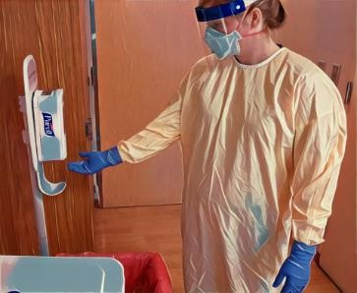**Doffing Step 1: Perform Hand Hygiene**

* Perform hand hygiene on the patient care gloves for a minimum of 20 seconds or until the hand sanitizer is dry

**Doffing Step 2: Doff Gown**

* Carefully untie the gown at the waist and neck
* Doff the gown folding the outside of the gown tightly inward into a ball to contain the contaminated side
* Once your gown is contained, separate the gown from the gloves and place gently into the linen hamper

**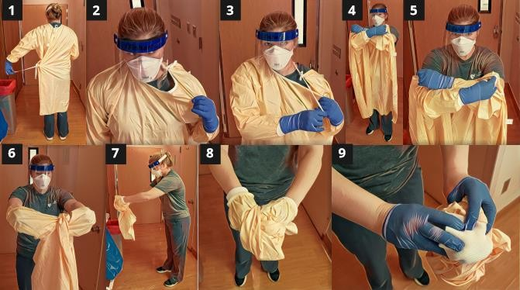**

**Doffing Step 3: Doff Gloves**

* Remove the gloves utilizing “glove in glove” technique
* Take your dominant hand and pinch the palm of the non-dominant hand and remove glove
* Ball the removed glove into the hand of the remaining glove
* Slide pointer finger of the free hand under the cuff of the remaining glove and remove
* Place gently into the waste

**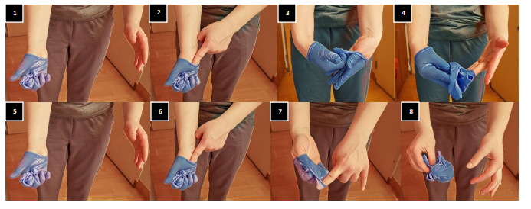**

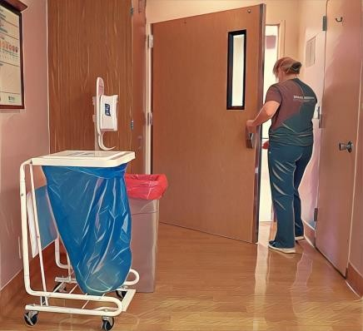**Doffing Step 4: Exit Patient Room**

* Ensure that the door closes behind you

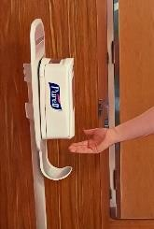**Doffing Step 5: Perform Hand Hygiene**

* Perform Hand Hygiene for a minimum of 20 seconds or until the hand sanitizer is dry

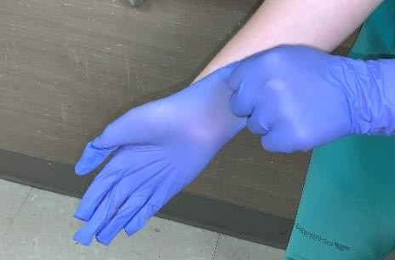

**Doffing Step 6: Don Clean Gloves**

* New gloves are donned in order to handle the disinfectant wipes safely

**Doffing Step 7: Use disinfectant wipe to clean surface for face shield or eye protection**

* Wipe a clean surface with an EPA approved disinfectant wipe
* The surface must remain wet for the appropriate wet time

**Doffing Step 8: Doff Face Shield or Eye Protection**

* To remove it, bend slightly forward and grasp the elastic headband on both sides of your head and pull it forward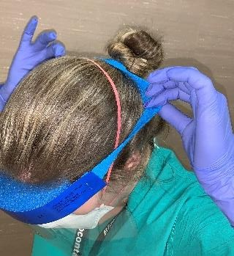

**Doffing Step 9: Disinfect Face Shield or Eye Protection**

* Once your face shield has been removed, grab a EPA approved disinfectant wipe and disinfect the surface of the Face Shield
* The surface must remain wet for the appropriate wet time
* Place clean face shield with the strap facing down and the shield facing upward

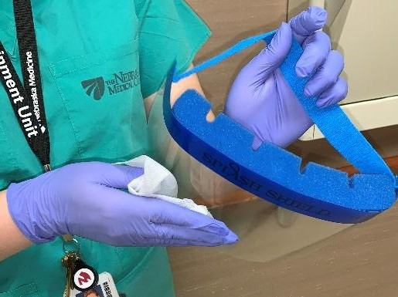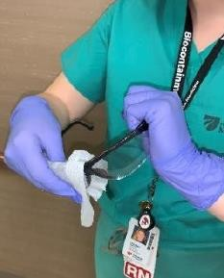

**Doffing Step 10: Perform Hand Hygiene**

* Perform Hand Hygiene on patient care gloves for a minimum of 20 seconds or until the hand sanitizer is dry

**Doffing Step 11: Doff N95 (\*Perform this step only if you are not extending the user of your N95. If you are extending the use of the N95, proceed to step 12.\*)**

* + After extended use of N95, lean near area where brown bag for UV decon is located and remove N95 one strap at a time
  + First remove the bottom strap with both hands and let dangle
  + Then remove the top strap of N95 with both hands and place gently into the trash

**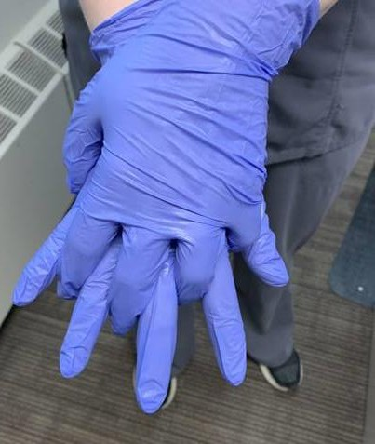**

**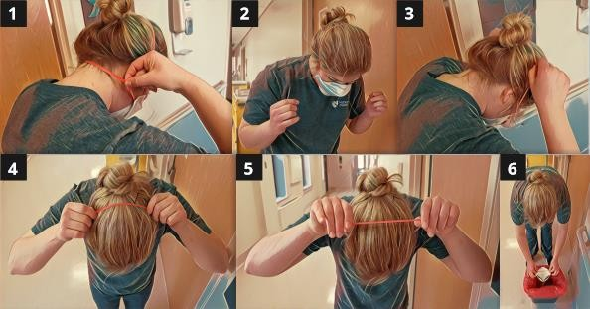**

* *(Gloves should still be on; not shown in picture)*

**Doffing Step 12: Doff Gloves**

* Remove the gloves utilizing glove in glove technique



**Doffing Step 13: Perform Hand Hygiene**

* Perform hand hygiene for a minimum of 20 seconds or until the hand sanitizer is dry

**Doffing Step 14: Place cleaned face shield in dedicated area**

* After the face shield has undergone the required wet time, place the disinfected face shield in its

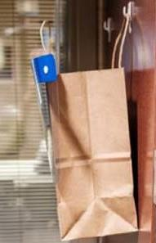

COVID-19 PPE: Doffing step by step. https://www.nebraskamed.com/sites/default/files/documents/covid-19/covid-19-personal-protective-equipment-doffing-step-by-step.pdf

**ANNEX 16: DONNING/DOFFING TRAINING ASSESSMENT**

Initials of Staff:\_\_\_\_\_\_\_\_\_ Initials of Observer: \_\_\_\_\_\_\_\_\_\_Date: \_\_\_\_\_\_\_\_\_\_\_

Staff Title (please circle one): CNA LVN RN Other

The pre-test score will be done prior to viewing any training material. A pre-test score is used to evaluate staff’s baseline knowledge prior to participating in the training.

* The post-test score will be done after viewing/practicing the training material. The post-test score will be used to compare with the pre-test score to evaluate the effectiveness of this training.
* Staff will receive 1 point for every step they are observed performing correctly and in proper order. Please put a 1 in the score column if they are correct.
* Staff will receive a zero for that step if a step is done incorrectly, in the wrong order, or has been omitted completely. Please put a zero in the score column if they are incorrect.
* Please feel free to write any comments for improvement in the comments column

|  |  |  |  |  |
| --- | --- | --- | --- | --- |
| **#** | **Observed steps for donning PPE** | **Pre-test Score** | **Post-test Score** | **Comments** |
| 1 | Wash hands (may verbalize or stimulate hand washing) |  |  |  |
| 2 | Don gown first |  |  |  |
| 3 | Gown opening is to the back |  |  |  |
| 4 | Ties are placed to the back and are tied in a bow not a knot |  |  |  |
| 5 | Gown cuffs are pulled down to cover wrists |  |  |  |
| 6 | Don gloves second |  |  |  |
| 7 | Cuff of gloves cover wrist and are over the gown cuffs |  |  |  |
|  | **TOTAL DONNING POINTS:** |  |  |  |
| 8 | Before removing gown, with one gloved hand touching only the outside of the glove, grasp the other glove at the palm and remove glove |  |  |  |
| 9 | Keep dirty glove inside of gloved hand |  |  |  |
| 10 | Remove 2nd glove using clean ungloved hand, enter 1-2 fingers touching only inside of gloved hand at the cuff and turning it inside out as it is removed |  |  |  |
| 11 | Dispose gloves in proper waste bin |  |  |  |
| 12 | Without touching the front of the gown unfasten the gown ties from the back |  |  |  |
| 13 | Starting with one gown sleeve, insert 1-2 fingers inside gown cuff and pull over hand, making sure that the hand remains inside the gown sleeve |  |  |  |
| 14 | Grasp other gown sleeve above the cuff and pull down glove sleeve |  |  |  |
| 15 | Pull glove off while rolling it inside out and away from the body |  |  |  |
| 16 | Gown does not touch body or floor when removed |  |  |  |
| 17 | Touching only the inside of rolled gown dispose in proper waste bin |  |  |  |
| 18 | Wash hands (may verbalize or stimulate hand washing) |  |  |  |
|  | **TOTAL DOFFING POINTS:** |  |  |  |
|  | **FINAL TOTAL = (add total donning + total doffing score)** | **-----------/18** | **-----------/18** |  |

**ANNEX 17: Threat and Hazard Assessment and Risk Identification (THIRA) Example for New York, NY**

**THIRA BLANK TEMPLATE**

In order to be prepared for a wide range of emergencies and disaster events, it is important for the CHC to periodically prepare a threat and hazard assessment and risk identification, or THIRA for short.  Here is an example of a THIRA prepared for New York City area. A bank template is provided for an organization to make their own.

**Organization + Area (i.e. Skilled Nursing Home, New York City, NY)**

|  |  |  |
| --- | --- | --- |
| **Natural** | **Technological** | **Human-caused** |
| **Resulting from acts of nature** | Involves accidents or the failures of systems and structures | Caused by the intentional actions of an adversary |
|  |  |  |

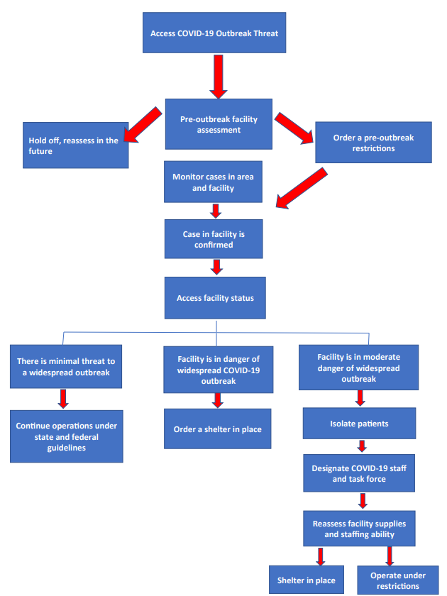**ANNEX 18: SAMPLE DECISION TREE FOR EVACUATION VS SHELTER IN PLACE**

**ANNEX 19: Skilled Nursing Facility Documentation Forms**

Surge Capacity Guidelines and Templates. Iowa Department of Public Health. Guidelines for Off-site Medical Care Facilities. 2006. Accessed <https://www.cidrap.umn.edu/practice/surge-capacity->guidelines-and-templates

|  |  |  |
| --- | --- | --- |
| **Form** | Use | Completed By |
| **Activity Log** | Documenting Activities |  |
| **Education/Discharge Instructions** | Resident instruction | Nurse |
| **Medical Equipment Request** | Request Medical Equipment | Any staff |
| **Incident Action Plan** | Incident management planning | Planning Officer |
| **Message Form** | Documentation of communication | Risk Communicator |
| **Inventory Tracking Form** | Tracking equipment and supplies | Any staff |
| **Pharmacy Request Form** | Request pharmaceuticals | Nurse |
| **Resident Treatment Summary Report** | Summary of residents treated |  |
| **Facility System Status Report** | Overview of facility | Safety officer |
| **Transportation Log** | Document resident transported | Transportation Unit Officer |
| **Treatment Log** | Detailed information on resident receiving care |  |
| **Volunteer Registration/Credentialing** | Used to log volunteers |  |

**Example of Inventory Tracking Form**

|  |  |  |  |  |
| --- | --- | --- | --- | --- |
| **Optimizing PPE Inventory/Stockpile** | **Quantity** | **Cost** | **Need** | **Supplies Provided by:** |
| Eye Protection   * Goggles * Reusable face shields |  |  |  |  |
| Face Masks |  |  |  |  |
| N95 Respirators  \*Fit test required |  |  |  |  |
| Powered Air Purifying Respirators (PAPRs)  \*Fit test required with certain face pieces  \*Seal check |  |  |  |  |
| Elastomeric respirators  \*Fit test required |  |  |  |  |
| Gloves  Performance Standard:   * NFPA 1999-2018 (single use emergency medical gloves) * ANSI/ADA 76-2005 |  |  |  |  |
| Isolation gowns |  |  |  |  |
| Ventilators |  |  |  |  |
| Alcohol-based hand sanitizer (ABHS) |  |  |  |  |
| Disinfectant supplies |  |  |  |  |