COVID-19 Contact Tracing for Immigrant Populations
New York City Department of Health and Mental Hygiene
New York, New York

THIS DISASTER PLAN WAS PREPARED AS A PUBLIC HEALTH SERVICE BY:

Reyna Bhandari
Eric Rochman
John Vasilios Andreo

And in partial fulfillment of course requirements for:

Management of Public Health Disasters
GPH-GU 5270
New York University School of Global Public Health

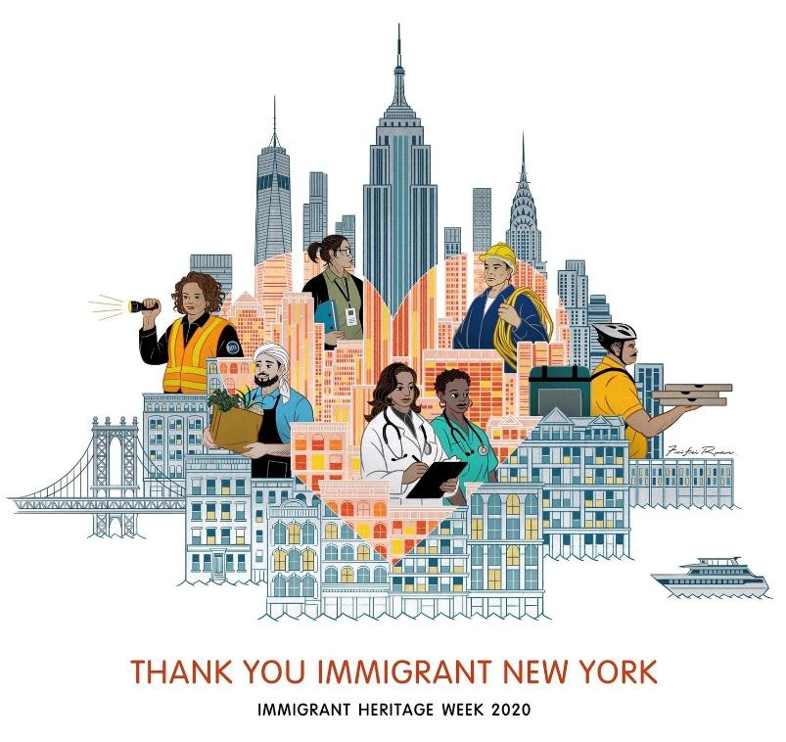

Table of Contents
Preface 3
Signature Page 4
Mission 5
Statement of Purpose 5
Legal and Statutory Authorities 5
Definitions 6
Mutual Aid Agreement 8
Concept of Operations 9
I. Assessing Population Needs 9
II. Matching Available Resources to Needs of Immigrant Communities 9
III. Evaluating the Effectiveness of the Response 11
Annex 1- THIRA 13
Annex 2- ICS Chart 15
Annex 3- Community Training 16
References 18

Preface
COVID-19 Contact Tracing for Immigrant Populations

COVID-19 is a novel coronavirus that was first identified in Wuhan, China where the outbreak began in December 2019. This infectious disease is spread primarily from person to person through respiratory droplets or aerosolized particles released when an infected person speaks, coughs, or sneezes. The symptoms of COVID-19 that most commonly occur include fatigue, fever, and dry cough, while many other less common symptoms have been documented, such as loss of taste or smell, headache, sore throat, and aches and pains. The virus has spread throughout the world, with the World Health Organization declaring COVID-19 a pandemic on March 11th, 2020. While a majority of individuals recover from the disease without needing treatment at a hospital, approximately 1 out of every 5 individuals who become infected with COVID-19 become seriously ill and will develop severe respiratory symptoms.¹

A central piece in the prevention of community spread and the identification of individuals who were potentially exposed to those infected by COVID-19 is a comprehensive contact tracing program. Contract tracing, as defined by the CDC, is the identification, monitoring, and support of a confirmed or probable case’s close contacts who have been exposed to, and possibly infected with, the virus.² The CDC provides support to local health departments in the establishment of contact tracing programs through the development and distribution of various resources, guidance, and training.

While these resources are useful in the fundamental planning of a contact tracing program, it does not provide a one size fits all solution. This is specifically the case with New York City, which is home to a diverse immigrant population with varying immigration statuses. The 2019 Annual Report from the Mayor’s Office of Immigrant Affairs (MOIA) estimates that New York City is home to 3.1 million immigrants, comprising 37% of the city’s population.³ Of this population, 37.3% are foreign-born, with undocumented immigrants comprising 5.7% of the foreign-born population. Significant disparities in access to health care and other essential services exist for the immigrant population, creating an even greater challenge in reaching these populations with contact tracing efforts.

To establish a successful contact tracing program that meets the needs of all New Yorkers, the New York City Department of Health and Mental Hygiene (NYC DOHMH) will work with the New York City Health and Hospitals Test and Trace Corps to ensure that its efforts to reach the immigrant population take into account cultural and linguistic differences, while using various methods of communication and outreach to connect to and support individuals who have been possibly infected with COVID-19. While this plan has been developed in response to the COVID-19 pandemic, it is meant to establish a comprehensive contact tracing program that applies to the management of future infectious disease outbreaks in New York City. By partnering with local stakeholders and organizations in the community, as well as training individuals from the various immigrant communities in supporting and carrying out contact tracing activities, we can ensure that even the city’s most vulnerable New Yorkers are receiving the help and support they need.

Signature Page

The following individuals from the New York City Department of Health and Mental Hygiene, the New York City Office of Emergency Management, New York City Health and Hospital Corporation, and the Mayor’s Office of Immigrant Affairs have reviewed and approved this plan focusing on COVID-19 Contact Tracing for Immigrant Populations. In support of this plan, the undersigned have agreed to a collaborative interagency approach and will provide all necessary resources at their disposal to ensure the established plan is successful in its implementation and operations.

REVIEWED AND APPROVED BY:

_______________________________________________ ___________
Dave A. Chokshi, MD, MSc Date
Commissioner, NYC DOHMH

_______________________________________________ ___________
Beth Maldin, MPH Date
Deputy Commissioner Emerg. Preparedness & Response

_______________________________________________ ___________
Deanne Criswell Date
Commissioner, NYC OEM

_______________________________________________ ___________
Mitchell Katz, MD Date
President and CEO, NYC Health + Hospitals

_______________________________________________ ___________
Bitta Mostofi Date
Commissioner, NYC MOIA

Mission
The mission of the New York City Department of Health and Mental Hygiene is to protect and promote the health of all New Yorkers.⁴ While the Department of Health strives to address the various health issues faced by New Yorkers, we are focusing our resources and attention on the COVID-19 response, making it our central priority. We have developed three priority areas specific to the COVID-19 response:

- Prevent or rapidly address a resurgence in COVID-19 infections.
- Plan and prepare to vaccinate New Yorkers for influenza and then COVID-19, partnering with New York City communities to inform effective local strategies.
- Address “parallel pandemics” related to COVID-19, including other infections (such as tuberculosis) or chronic diseases (such as heart disease), mental health, overdose, racism, and social and economic instability.

At the heart of our prevention and identification efforts is our commitment to the planning and implementation of a comprehensive contact tracing program that ensures all populations, including New York's most vulnerable and hard to reach population, are aware of any potential past exposures and are provided accurate and timely information as well as free COVID-19 testing to prevent further community spread.

Statement of Purpose
New York City is home to 3.1 million immigrants of varying nationalities and cultural backgrounds. To execute an effective contract tracing program, the Department of Health and Mental Hygiene will componentize its program specifically to identify and serve immigrant populations, which may prove difficult otherwise. The purpose of this plan is to establish the framework for the New York City Department of Health and Mental Hygiene and New York City Health and Hospital Corporation to ensure the execution of its contract tracing program component for immigrant and diverse populations in the event of a pandemic. The objective of this plan is to identify and delegate essential responsibilities and authorities to the necessary working groups and staff members for effective and efficient execution.

Legal and Statutory Authorities
The New York City Department of Health and Mental Hygiene is under the direction of Dave A. Chokshi, MD. The department and its functions were established under Chapter 22 of the New York City Charter.⁵ Section 556 provides the agency board authority to engage in all operations related to the public health of the city:

“Functions, powers and duties of the department. Except as otherwise provided by law, the department shall have jurisdiction to regulate all matters affecting health in the city of New York and to perform all those functions and operations performed by the city that relate to the health of the people of the city, including but not limited to the mental health, mental retardation, alcoholism and substance abuse-related needs of the people of the city.”
And more specifically Section 556. Article C. Clause 2. gives the agency broad authority to execute a track and trace program in the realm of public health Citywide:
“Supervise the reporting and control of communicable and chronic diseases and conditions hazardous to life and health; exercise control over and supervise the abatement of nuisances affecting or likely to affect the public health”

Definitions
COVID-19 - COVID-19 refers to a novel strain from the coronavirus family, also known as SARS-CoV-2.

Contact Tracing - is the process of identification of persons who may have come into contact with an infected person and subsequent collection of further information about these contacts.

Case Investigation - is part of the process of supporting patients with suspected or confirmed infection. In case investigation, public health staff works with a patient to help them recall everyone with whom they have had close contact during the timeframe while they may have been infectious.

Self Quarantine - Recommended two-week self-isolation for persons diagnosed with COVID-19 or showing symptoms of COVID-19.

COVID Hotspot - area of elevated incidence or prevalence, higher transmission efficiency or risk, or higher probability of disease emergence.

NYC DOH - New York City Department of Health and Mental Hygiene is responsible for addressing the public health of the city.

NYC H+H - New York City Health and Hospital Corporation is New York City’s public health care system.

NYC Test and Trace Corp - is a group of doctors, public health professionals, and community advocates working to provide COVID-19 testing and contact tracing under the direction of New York City Health + Hospitals.

NYC OEM - The New York City Office of Emergency Management is the agency responsible for coordinating citywide emergency planning and response for all types and scales of emergencies.

NYC MOIA - The New York City Mayor’s Office of Immigrant Affairs advocates for policies and programs that increase justice, equity, and empowerment for immigrant communities living in the city.

Communication Plans
Internal Communication
COVID-19 has disproportionately affected minorities and marginalized communities, making immigrant populations no exception. When there is a positive COVID-19 case, the DOH must be notified immediately so that they can work with the NYC Test and Trace Corps to begin adequate contact tracing. There will be a chain of command initiated at the DOH office so that the information is conveyed to the right personnel and that contact tracing can commence. Databases will be updated, and a designated task force will ensure that this information is communicated to other agencies, such as the CDC, OEM, and MOIA. If the positive case leads to a small outbreak, the DOH will send out a memo and alert local hospitals, healthcare clinics, and schools within the community of a potential spread of COVID-19.
External Communication
Contact tracing in immigrant communities has been unsuccessful up until now due to several reasons. These will be addressed by:
- Developing a caller ID for all contact tracers so that individuals will see “NYS DOH Contact Tracing” pop up on their phones and be more inclined to pick up rather than an unknown number.
- For individuals who are difficult to locate, contact tracers will be asked to flag them and use alternative methods of communication, such as mailing letters and text messaging which will be supported by advertising campaigns in various languages alerting the public of the purpose of this type of contact.
- Specialized contact tracers will be recruited to communicate with immigrant communities and who will have the necessary language skills to communicate
- Governor Cuomo will be briefed on making a public statement about emphasizing the need for individuals to disclose this information to contact tracers as well as making it mandatory for restaurants, businesses, stores to collect visitor's personal information.
- A specialized script will be designed for contact tracers to avoid individuals ending the call before disclosing important information. Contact tracers will also have the script translated into several different languages and will be made up of native speakers to better meet the needs of immigrant populations.
- If previous efforts are still not successful, contact tracers will be trained to wear PPE and visit homes in immigrant neighborhoods to interview them in person.

Mutual Aid Agreement
There will be a mutual aid agreement between the NYC DOH, NYC OEM, NYC H+H, and NYC MOIA. All agencies as well as hospitals, healthcare clinics, and volunteer organizations will be mobilized should further aid be needed. NYC Health + Hospitals, NYU Langone, Mt. Sinai Hospital, and New York Presbyterian are the primary community health entities that will be involved with providing aid. NYC may also choose to rely on additional aid from surrounding cities that have been trained to deploy their resources to the greater metropolitan area. If an outbreak escalates, the federal response will be initiated through FEMA.

Concept of Operations

I. Assessing Population Needs
To design and operate an effective contact tracing program targeting New York City (NYC) immigrant populations, it is essential for DOH to understand and address their needs and preferences. An effective program is one in which the active participation of community members is high. NYC has many different immigrant communities with various languages, cultural values and norms, and varying degrees of trust in governmental agencies. Cultural differences in NYC help to make the city vibrant and robust, but these differences must be understood and respected for emergency public health measures to be successful. Numerous cultural and language barriers can make the implementation of public health measures challenging. To overcome potential barriers, DOH will develop and implement an educational campaign directed towards different immigrant communities. Key to the success of this program will be the recruitment and extensive training of appropriate and qualified staff.
To help overcome the lack of trust, DOH will engage in educating the city’s different immigrant communities about what contact tracing is, the importance of participating, and why contact tracing is an effective way to control the COVID pandemic. Collaborating with faith and religious-based organizations to help develop and amplify messaging will be an essential aspect of the program. Those who are undocumented or who may lack the proper work authorization documents might be contacted through organizations with whom they have an ongoing and trusted relationship. This education campaign will be necessary to ensure that immigrant populations understand what contact tracing is and how to participate and to also build the trust between DOH and the different communities to help encourage community participation. The trust between the different immigrant groups and DOH contact tracers will be essential if this component of contact tracing is to have high rates of participation. Many immigrant communities may be hesitant to participate in contact tracing for several reasons. They may not understand what contact tracing is and the benefits of participating or they may be distrustful of government/authorities due to their immigration status or previous experiences with government services in the US or their home countries. Launching an effective, culturally competent outreach and educational campaign to introduce contact tracing to immigrant groups and by providing opportunities to answer their questions and concerns will help to increase participation in the contact tracing program. The objective is to communicate the role that contact tracing plays in keeping themselves, their families, and their communities healthy, and also, how contact tracing can help to eradicate the spread of the disease. A successful contact tracing program requires the full participation of all community members.

II. Matching Available Resources to Needs of Immigrant Communities
To rapidly implement a contact tracing program in response to a pandemic, NYC DOHMH needs to have the most up-to-date data on the various immigrant populations and culturally distinct groups contained within the city. Being able to rapidly identify and describe immigrant populations will ensure that NYC DOHMH has the appropriate resources to meet the needs of those populations. For example, if 50% of the immigrant population is known to be Spanish speaking, 20% Arabic, 10% Chinese, and 20% other, DOH can plan to recruit field workers who are fluent in these languages, and also this provides guidance for the development and launch of media and outreach campaigns relative to the target populations.
For NYC DOHMH to obtain the most up-to-date and accurate statistics and data on the city’s immigrant populations, they will make a formal request to the Mayor’s Office of Immigrant Affairs (MOIA). MOIA is mandated to provide the city with the latest immigrant statistics and they are the most reliable source of this information. Guided by the data obtained from MOIA, the NYC DOHMH can design a contact tracing program proportionate and reflective of the immigrant demographics of the city.
Language can be a crucial barrier that will need to be addressed if a contact tracing program is to be effective. English is not the primary language of many immigrant groups, and for our contact tracing program to be effective, it will be essential for NYC DOHMH staff to be able to communicate with the language of choice of the various immigrant groups throughout the city. Once NYC DOHMH receives the necessary data from MOIA, they will begin to recruit and train case investigators and contact tracers who have the necessary language skills and cultural backgrounds to contact and interact with specific immigrant populations. Recruitment will be based on the population statistics as provided by MOIA. Based on these data, NYC DOHMH will establish hiring targets for individuals with specific language skills and recruit contact tracers and case investigators towards those targets. All contact tracers and case investigators will also be fluent in English as a primary or secondary language. If a staff member for a specific language is not being utilized because of low infection rates in that specific language community then they will be reallocated to work on contact tracing for English speakers. If an immigrant or immigrant group requiring specific language communication skills is needed, a contact tracer hired for that language skill will automatically be placed on that case so that their language and communication skills can immediately be useful to the program. All contact tracers and case investigators will receive the same basic training as only (English only) recruits, but they will also receive specialized training geared towards communicating with immigrant populations due to some of the sensitivities and strategies that might be needed for this specialized work.
The program will partner with MOIA to help identify strategic partnerships to introduce contact tracing and building trust between NYC DOHMH and various immigrant communities. NYC DOHMH will create a special immigrant outreach task force within NYC DOHMH to identify and manage those partnerships alongside MOIA and other municipal agencies. Faith-based organizations, immigrant specific nonprofits and advocacy groups, and local elected community officials are examples of some of the organizations that will be contacted by the taskforce. Because these community organizations have deep roots and trust within specific communities, partnerships will be leveraged to have contact tracing introduced and supported by these organizations. These partnerships are essential in assuring high rates of participation.
A broad media strategy on the importance of contact tracing, how it works, and why it is effective in combating COVID or any pandemic is necessary. A wide range of communication channels will be utilized, including social media, traditional print, TV, and radio, and posting announcements within the communities. An essential strategy to build trust between the contact tracing program and the various communities will be to emphasize that sensitive information such as work authorization will not be requested and personal information will not be disclosed to any authorities other than DOH or healthcare services. The goal of this strategy is to build trust between the communities and the program to ensure and increase participation. Additionally, providing positive cases with support in which contacts are provided with education, information, and necessary resources and support to help them understand their risk, what they should do to separate themselves from others who are not exposed, and how to monitor themselves for illness. Also, they will be informed of the possibility that they could spread the infection to others even if they do not feel ill. Lastly, nearby testing facilities will be listed that are free of charge.
PPE distribution and training for contact tracers must be provided to protect them from exposure. Regular supplies of PPE (masks, gloves, etc.) will be provided to contact tracers conducting in-person surveillance as well as the provision of training on proper use and disposal of PPE to prevent improper disposal.

III. Evaluating the Effectiveness of the Response
An important aspect of any successful contact tracing program is an ongoing evaluation and risk assessment program so that operations can be adjusted as needed. Due to the ever-changing dynamics of any novel bio-event, it is critical to executing a robust surveillance program to identify hotspot areas and trends to identify potential surges in a geographically defined area. Information from surveillance efforts will be critical to ensuring that tracing efforts are adequate and are having an impact on the target populations. A citywide tracking system of cases that incorporates real-time date from the NYC DOHMH, NYC H+H, and the other area hospital networks will allow the NYC Test and Trace Corps to deploy a rapid response to areas where increases in cases are occurring and to evaluate the current efforts and their effectiveness in maintaining cases at a low level within the immigrant populations. This real-time data collection will also provide the opportunity to compare case levels within and between immigrant populations and geographic areas to determine what barriers may be impacting the ability to effectively trace individuals who have been exposed or have tested positive.
An additional indicator that will provide insight into the effectiveness of contract tracing efforts among immigrant populations is by tracking the number of tests conducted in geographic areas that have the highest concentration of immigrant populations and calculating the percent of positive tests for these groups. The NYC DOHMH can collect and analyze this information as an indicator of a potential increase in exposures within certain populations. Regular analysis of this data matched to the geographic focus areas of the Test and Trace Corps will indicate the effectiveness of efforts to conduct contact tracing to decrease the positivity rate within immigrant communities.
The contact tracers working in the field play an important role in the evaluation of the effectiveness of the overall tracing efforts through the collection of daily information focusing on their success rate in establishing contact with their intended targets. This is a key evaluation metric. The collection of basic demographic information of the individuals they are interacting with can be anonymized and aggregated, allowing for trends in both successful and unsuccessful attempts to indicate which immigrant populations are less receptive to the tracing efforts. In identifying immigrant populations that are found to be less receptive, the NYC DOHMH can reevaluate their approach in their targeted outreach and communication plans and develop additional strategies to engage with the specific immigrant groups to increase the success rate of the contact tracing efforts. Also, by identifying the immigrant groups that have a high success rate of contact, the NYC DOHMH can partner with the MOIA to identify potential similarities in cultural characteristics among the different immigrant populations so that the successful efforts can be replicated in targeting additional immigrant groups.
Epidemiological data can also play a role in measuring the effectiveness of contact tracing efforts for the immigrant population. NYC DOHMH will use incidence and prevalence rates of COVID-19 in the different immigrant groups to see how they compare to rates amongst the general population as well as other immigrant groups to gauge the effectiveness of contact tracing efforts in decreasing the spread of the disease. This information will prove useful in increasing contact tracing efforts in communities with increased incidence and prevalence of COVID-19 and to ensure that immigrant populations in surrounding geographic areas are also getting the attention and resources they need to prevent an increase in cases.
Through the use of real-time data and continual sharing of information among the different institutions involved, the contact tracing operations will be able to conduct ongoing evaluation of their efforts and the effectiveness in their ability to decrease the spread of COVID-19 in the immigrant populations. This information will also be used after the conclusion of the pandemic in the creation of after-action reports to inform the key stakeholders in the response of what methods and strategies were successful and what areas require improvement in the response to similar future events. This will allow for continued planning to ensure that the resources and operational plans will consider the various lessons learned in the contact tracing efforts to immigrant communities during the COVID-19 pandemic.

Annex 1- THIRA
Threat and Hazards Identification and Risk Assessment Table:
Department of Health, New York City

Natural | Technological | Human-caused
Resulting from acts of nature | Involves accidents or the failures of systems and structures | Caused by the intentional actions of an adversary
- Disease Outbreak- infectious diseases that are present and/or emerging are regularly monitored. Depending on the mode of transmission, infectious diseases have the potential to spread rapidly throughout densely populated and highly trafficked areas of NYC. Infectious diseases with high morbidity and mortality rates can overwhelm healthcare facilities and create significant surges in patients seeking treatment. When necessary, NYC will coordinate with the Centers for Disease Control and Prevention and the state Department of Health to mitigate the impact of infectious diseases on the population and control cases to decrease widespread outbreaks.  - Drought- while there are several classifications of drought, the most common to affect NYC is a meteorological drought, which is caused by a change in the normal pattern of precipitation. A drought of this type has a slow onset and often takes a minimum of three months to develop, and may last for several years. Droughts occurring in upstate regions of NYC can have a major impact on the water supply on a city-wide basis as its water comes from three sources in upstate New York. Droughts can lead to decreased availability and quality of potable water and can comprise sanitation and hygiene resulting in an increased likelihood of disease and illness.  - Extreme Cold- events of extreme cold involves a temperature at or below 32°F for extended periods, usually occurring between December and March.¹ While temperatures during extreme cold events tend to be similar across all areas of the city, neighborhoods with less density and asphalt maybe a few degrees colder. Extreme cold can have serious health implications, as exposure to cold temperatures for an extended period causes the body to lose heat faster than it can generate it. A drop in the body’s internal temperature can result in hypothermia and can exacerbate chronic heart and lung conditions. Specific populations are more vulnerable to extreme cold events, including the homeless and the elderly. | - Bridge/Tunnel Collapse- deterioration of bridges and tunnels over time due to climatic events and regular use can cause structural failures resulting in collapse. Failures of one or several bridges/tunnels due to structural deficiencies could result in severe injuries and casualties and would have major implications for transportation throughout the region causing major congestion and gridlock. Regular inspection and maintenance of bridges/tunnels are critical to ensuring structural integrity, greatly decreasing the potential for failures.  - Train Derailment- subway and commuter trains are at risk of derailment as a result of weakening joints, erosion, and unstable rails.¹ Hazardous weather conditions such as high winds can tip and derail train cars operating above ground. Extreme heat and cold can cause tracks to expand and contract, making rails unstable. Aging infrastructure and logistic difficulties with maintaining train tracks pose challenges to mitigating the causes of derailment. Train derailment can lead to serious injuries and causalities and major disruptions to the transit system, which disproportionately affects low-income populations who rely heavily on public transportation.  - Wastewater Treatment Failure- A total of 1.3 billion gallons of wastewater is treated in NYC daily by 14 treatment plants before relating to local waterways.¹ Wastewater treatment plans are usually located near waterfront areas, thereby making them more susceptible to failure as a result of extreme weather-related events. As a result of a combined sewer system that collects sanitary waste and stormwater, during periods of heavy rain and snow, wastewater treatment plants can become overwhelmed, resulting in the release of unprocessed sewage into local waterways. Public exposure to contaminated water resulting from wastewater treatment plain failures can create unsafe sanitary conditions. | - Cyber-Attack Against Infrastructure- cyber-attacks on critical infrastructure such as the power grid or public transportation systems could have wide-ranging, city-wide effects that disrupt essential services. Accessibility of computer systems responsible for controlling and regulating infrastructure through cyber attacks can occur from anywhere in the world through the internet. Disruption to infrastructure through cyber attacks can incite panic and fear in the general public and could potentially cause physical damage when related to the disruption of transportation-related systems.  - Biological Attack- intentional biological attacks, specifically in the most densely populated areas of NYC, have the highest risk of spreading among the population. Potential targets for biological attacks include tourist attractions, public transit hubs, entertainment venues, as well as financial centers, and government offices. Exposure to biological agents can occur through inhalation, contact with contaminated surfaces, contact between infected individuals, or ingestion of contaminated food or water. Populations with an increased risk if exposed include children, individuals with compromised immune systems or preexisting conditions, and the elderly.

References:
- NYC Office of Emergency Management, NYC’s Risk Landscape: A Guide to Hazard Mitigation, 2014.
- NYC Office of Emergency Management, 2017 NYC Hazard Mitigation Plan Annex, 2017.

Annex 2- ICS Chart
New York City Department of Health and Mental Hygiene
Incident Command Center: Epidemic
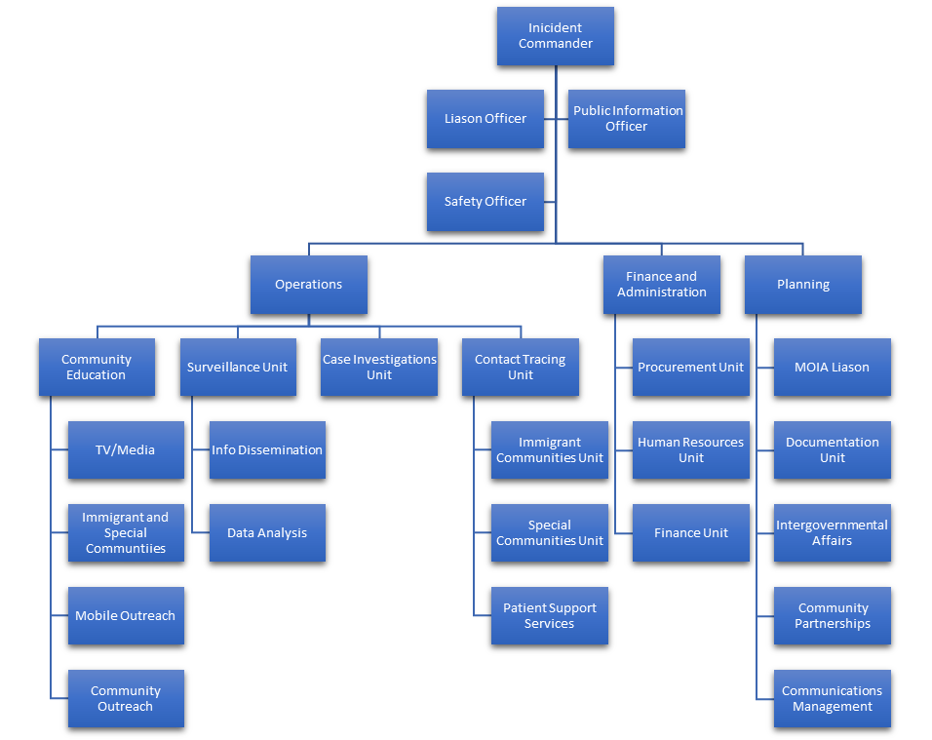

Annex 3- Community Training
Training Seminar Title: What do I do if I am contacted by a Contact Tracer?
Objectives of the Training Seminar | Educate community members on the importance of contact tracing, what it entails, and how they can be best prepared to actively participate in these efforts if required.
Estimated Length of Training | 1 hour — training to be offered biweekly
Target Audience and max size of the audience | Community members from immigrant communities in the surrounding area. Choose several zip codes to focus on implementing a training seminar, engage with the community to inform them of upcoming training, and hold training in a widely known community public space. Max audience: depending on the capacity of location - est. 50-100 people.  The training would also be provided in several additional formats to accommodate the participants and increase participation. An online asynchronous interactive training module would be created to allow for self-guided learning. In-person training would also be live-streamed and recorded to allow for participants to join and watch from any location. Both options would be available publicly on the DOHMH website and would be regularly announced in communications sent to community and faith-based organizations.
Session Facilitators | Contact tracers through NYC Health + Hospitals would be good facilitators of the session since they will be able to answer any questions, concerns, uncertainties, or misinformation amongst the community.
Session Goals and Intended Outcomes for Participants | - Understanding the importance of contact tracing and why participation is an effective form of decreasing the spread of COVID and other contagious diseases  - Understand the importance of adhering to public measures such as social distancing, the use of masks and other PPE where appropriate, and hand washing  - Understanding that cooperation with public health authority will not impact their immigrant status  - Understand the importance of getting tested and quarantining if contacted by contact tracers to avoid having further peoples infected.  - Understand the importance of giving accurate and timely information to contact tracers so they can notify anyone they came into contact with as soon as possible.  - Identify the closest healthcare center where they can get tested and stress that NYC Health + Hospitals provided services to anyone regardless of their immigration status.  - Actively seek out testing at the first sign of symptoms or if they came into contact with anyone who tested positive.  - Recognize what COVID-19 symptoms are and encourage them to keep taking their temperature regularly.
Strategies to increase community uptake of mitigation | - Hand out pamphlets with important information about symptoms of COVID-19, contact tracer phone numbers to look out for, nearest health center to get tested, and who to call if you want to self-report a positive case.  - Provide masks, thermometers, and hand sanitizer at community training sessions as an incentive to attend.  - Attach business cards of contact tracers in the package along with information for the nearest health facility.

References
1. Coronavirus Disease 2019 Q&As. World Health Organization 2020; https://www.who.int/emergencies/diseases/novel-coronavirus-2019/question-and-answers-hub/q-a-detail/coronavirus-disease-covid-19. Accessed October 3rd, 2020.
2. Contact Tracing FAQs: Information for Health Departments. Centers for Disease Control and Prevention 2020; https://www.cdc.gov/coronavirus/2019-ncov/php/contact-tracing-faq.html. Accessed October 3rd, 2020.
3. NYC Mayor's Office of Immigrant Affairs 2019 Annual Report. New York City Mayor's Office of Immigrant Affairs 2020; https://www1.nyc.gov/assets/immigrants/downloads/pdf/MOIA-Annual-Report-for-2019.pdf. Accessed October 3rd, 2020.
4. Our Core Values, Mission, Vision and Strategy 2020-20201. NYC Health 2020; https://www1.nyc.gov/assets/doh/downloads/pdf/public/doh-values-mission-vision-strategy.pdf. Accessed October 3rd, 2020.
5. New York City Charter. 2020; https://nyccharter.readthedocs.io/c22/. Accessed October 3rd, 2020.

