HOSPITAL
COVID-19 Emergency Response Plan

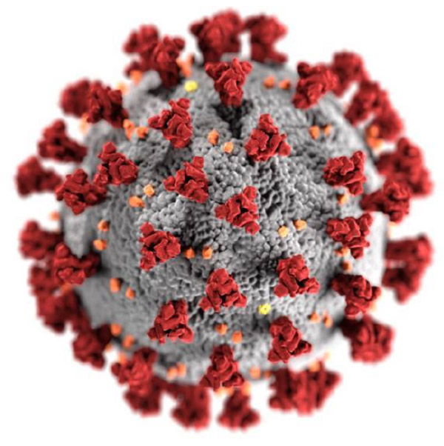

THIS COVID-19 PLAN TEMPLATE AND SELF ASSESSMENT DOCUMENT
FOR ACUTE CARE HOSPITALS WAS PREPARED AS A PUBLIC HEALTH SERVICE BY
Felix Ansah, Zelda Wanstok, Daniel Okpare, Leslie Hernandez & Noor Jamal
In Fulfillment of their Graduate Studies Course Requirements
GU-5150: Emergency Preparedness for Healthcare Organizations
NYU School of Global Public Health, New York, NY.
July, 2020

NAME OF HOSPITAL
[Enter hospital title here]
[Enter hospital city and state here]

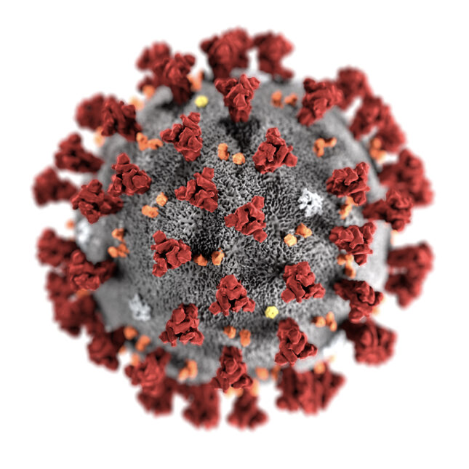

[Enter date of plan here]

Table of Contents

Element # and Topic | Page(s) #
1: Cover Page, Table of Contents | 1-2
2: Preface, Signature Page | 4-5
3: Mission Statement, Scope and Objectives | 6
4: Authorities, Definitions | 7-8
5: Communication Plans, Mutual Aid Agreements | 9-10
6: Threat and Hazard Assessment and Risk Identification (THIRA) | 10-11
7: Facility Profile Document | 12-13
8: Patient Care Capacity | 14
9: Other Healthcare Facility Resources | 15
10: Back-Up Plan Document | 16
11: Facilities Readiness Document | 17
12: Continuity of Business Document | 17-18
13: Designation of the Incident Commander and Succession Plan | 18
14: Location of the Command Center | 19
15: Emergency Management Committee Document | 20
16: Training Plan | 21-22
17: Emergency Communications Document | 22-25
18: Decision Tree for Determining Evacuation vs Shelter-in-Place | 26
19: Mutual Aid Agreement (Response Sponsors) | 27
20: Mental Health | 28-29
References | 30

Preface
The first documented case of COVID-19 in the United States (US) was reported on January 20; the patient was a man returning from a trip to Wuhan, China.² By January 30, 2020, WHO declared the outbreak a Public Health Emergency of International Concern.^{1,2} During the subsequent weeks, additional cases of COVID-19 were increasingly recognized throughout the world, and several countries began restricting travel and instituting quarantine or shelter-in-place measures. On March 11, WHO declared COVID-19 a pandemic because of the rapid rise in cases outside of China.¹ By March 26, the US reported the highest number of cases in the world, with over 80,000 confirmed cases and 1,000 deaths.² Although much of the US then followed stringent shelter-in-place and social distancing measures, the healthcare system was severely challenged by the large and rapidly growing number of COVID-19 patients requiring hospitalization.
As early as March 20, 2020, in New York State (NYS), then the epicenter of the pandemic in the US, 18% of the COVID-19 patients required hospitalization. This surge of gravely ill patients severely taxed the entire health care infrastructure in NYS and especially in New York City (NYC) where cases were most prevalent.
As of XX [ date], NYC is now in Phase XX. Many hotspots around the US are experiencing a surge of cases, and NAME OF FACILITY needs to be well prepared for another wave of COVID-19 patients.Therefore, it is timely to have a best practice COVID-19 Plan in place in order to be well prepended for any eventuality. The highest level of protection is needed in terms of infection control precautions, screening of patients and staff, disinfection, and protection and safety of staff and visitors is an important priority, especially given that cancer patients are at higher risk of adverse outcomes if they are infected with the coronavirus agent. This Plan serves as a guide to best practices in the management of COVID-19 in a large, level hospital.

Letter of Approval/Signature Page
I have reviewed and supported the implementation of this Emergency Operations Plan for a potential disaster at Memorial Sloan Kettering Cancer Center.

Emergency Management Officer Date

Executive Vice President, Chief Medical Officer Date

Senior Vice President Date

Chief of Staff Date

Chief of Emergency Medicine Date

Mission Statement
(THIS IS AN EXAMPLE) To lead in the prevention, diagnosis, treatment, and cure of cancer through programs of excellence in research, education, outreach, and cost-effective patient care.²

Purpose
The purpose of the hospital plan is to initiate, coordinate and sustain an effective local response to the current epidemic crisis. The objective is to train hospital staff and clerical health departments to take initiative and implement preventive methods during COVID-19 emergency. After the plan is put into effect and practiced by the hospital, it can provide a basis for coordinating disease protective actions and steps to a speedy recovery.

Specific Plan Objectives
The disaster plan is the guidance document which helps to organize the activities to initiate, manage, and recover from patient surges of COVID-19.

The objective of this disaster plan is to guide the organization during the COVID-19 pandemic by the following:
- Defining the parameters for implementing the plan and providing timely information regarding the number of suspected and known patient cases in the hospital as well as infection rates among staff.
- Defining roles and establishing responsibilities of the hospital staff and departments within the organization to respond to the pandemic.
- Ensuring the effective operationalization of HICS.
- Assuring adequate surge capacity to meet needs at a minimum of 30% surge in new COVID-19 cases (staff, supplies, space and equipment).
- Ensuring staff safety and health including mental health.
- Ensuring that the needs of vulnerable populations (children, pregnant women, elderly, disabled, non-English speaking, homeless, etc.) are addressed appropriately and with compassion.
- Identifying primary/alternative emergency communication systems.
- Establishing communication processes for public and patient information.
- Identifying appropriate policies for admission, transfer and discharge of patients.
- Managing surge and alternate care processes.
- Effectively Managing morgue operations to address surge in decedents
- Communication with local and state government authorities and mutual aid partners.
- Finding and using relevant community resources, including family assistance programs.
- Providing resources to response partners, including community organizations
- Recovery process for operations of the hospital.
Authorities, Codes, Policies
A multidisciplinary Emergency Management Committee (EMC) administers the Emergency Management Program. EMC reports to the Executive Safety Committee. The MSK Director of Emergency Management and the Enterprise Resiliency Manager facilitates the program related activities and the EMC guides them. The Director also monitors compliance of the program and represents the Center for all local, regional, and state integrated activities regarding to the planning.¹
Implementations of the disaster plan (planned/unplanned), evaluations, and proposed improvements are reported to the President and to the Boards of Managers and Overseers for review and recommendations.¹
Executive Vice President/Hospital Administrator, Administrator-on-Call or Nursing Supervisor can activate Hospital Incident Command System (HICS) or Hospital Command Center (HCC). The Incident Commander will deactivate HICS depending on the evaluation of necessary services.¹
The Senior Vice President/Hospital Administrator or designee will evaluate the incident for deciding on the level of HICS activation, personnel requirement, and the need for activating HCC. The operator will be contacted at 212- 639-6000 or ext. 6000 to page/activate select HICS positions or the entire HICS team depending on the direction of the I/C or designee. A request may be made to HICS personnel for: Monitoring email for an incident briefing and further instructions, attending a conference call/an in-person meeting at a specified location, reporting to the Command Center.¹
HICS members, who are not activated for the incident, will be informed about the limited activation of HICS and will be prepared to guide the management of the incidence from their regular work locations or as directed.¹
This plan follows The Joint Commission requirements. The EMC follows the priorities of the Center’s Hazard Vulnerability Analysis (HVA) for developing specific emergency response plans to address four phases of emergency management: mitigation, preparedness, response, and recovery. The Center conducts HVA annually for facility-based and community-based hazard risk assessment using an all-hazard approach. Also, NYC Emergency Management (NYCEM) develops a NYC Hazard Mitigation Plan every five years with annual updates (the most recent plan was developed in 2014). The process of developing it is similar to HVA. Considering the state’s mitigation plan, the NYS Standard Multi-Hazard Mitigation Plan is updated by the Department of Homeland Security and Emergency Services with assistance from collaborating agencies and interested stakeholders. Furthermore, the City Department of Health and Mental Hygiene (DOHMH) developed an HVA process focusing on public health in 2011-2012. The top five priorities of them was coastal storm, pandemic influenza, extreme heat, flooding, aerosolized anthrax, and radiological dispersal device.¹
Hospital guideline protocols and policies are enacted through the federal, state, and county city laws under the Planning Section Chief. The Emergency Manager role also consists of serving as an Incident Commander where the Chief of Emergency Medicine directs the medical branch.
During an emergency or disasters, personnel are required to follow CDC and FEMA guidelines. Employees are mandated to look out for patients safety and well-being. Patients need immediate transfer to neighboring hospitals if the surge capacity increases. All patients are monitored and employees are informed and reminded about their roles and responsibilities. Employees are also required to recognize safety and preventive measures to reduce disease in the community.
Any employee who may not understand their role must ask his superior to clarify, and if they do not know how to do their task safely, they should not perform the task until such time that they fully understand appropriate safe practices.

Definitions/ Acronyms
Acuity (patient): the level of severity of an illness; high acuity being very ill and low acuity being in a relatively normal state of health
COVID-19: coronavirus disease / 2019 novel coronavirus
Disaster: a natural or man-made event that overwhelms local resources
ED: emergency department
EMS: emergency medical services
HICS: hospital incident command system
ICU: intensive care unit
MCI: mass casualty
MOU: memorandum of understanding
PACU: post-anesthesia care unit
PPE: personal protective equipment
Saturation: a higher volume or acuity of patients than the hospital can manage due to either lack of physical space or lack of patient-care resources
SDU: step down unit; level of care between ICU and ward
Surge: a volume of patients that cannot be safely and effectively cared for by a hospital or emergency medical service
Trauma: injuries or illness caused by outward forces on the human body; a surgical subspecialty requiring specialized care
Volume: number of patients, regardless of acuity
Ward: basic level of acute care
Agency Communication Plans
Internal Communications
In a disaster event, emergency information is coordinated via a technology system speaker designated as a “Code Blue” intercom to hospital staff. A catastrophe is also reported to the healthcare hospital wide network email. Expense notifications and pages are usually scheduled messages written during the crisis, and the email contains detailed information about the incident and hospital response.
External Communications
During internal communication, the Logistics Chief assigned supervisor and team associate with the local healthcare system and the ambulance provider to disclose information about new patient transfer and to mitigate an overwhelming working capability.
In addition, the Memorial Sloan Kettering Cancer Center prioritizes a risk-free social media platform ensuring the safety of the community and staff personnel.
Pre-Arranged Agreements & Mutual Aid Agreements
All pre-arranged and mutual aid agreements utilize care capacity provision by ensuring safety to patients and staff personnel. Operational Section Chiefs collaborate in planning and coordinating a COVID-19 disaster response.
In order to address and manage the disaster, it is imperative that staff workers co-join the local ambulance provider, local police, and the fire department. All-weather and intensive care referrals are available 24 hours a day according to specific guidelines. When the hospital building exceeds capacity, patients are transferred to other local institutions. Availability referral within the Memorial Sloan Kettering Center network includes:
- New York – Presbyterian David H. Koch Center, Manhattan, NY
- Hospital for Special Surgery, Manhattan, NY
- Lenox Hill Hospital, Manhattan, NY
- Gracie Square Hospital, Manhattan, NY
Also, pre-arranged agreements with out of network hospitals incorporate:
- Bellevue Hospital Center, Manhattan, NY
- Mount Sinai Hospital, Manhattan, NY
- Weill Cornell Medical Center, Manhattan, NY
- NYU Langone Medical Center, Manhattan, NY
- Rockefeller Institute Hospital, Manhattan, NY
The new COVID-19 mutual aid assistance agreement co-exist with other institutions related to:
- Emergency Medical Services (EMS)
- Department of Health
- Emergency Management Agencies
- Centers for Disease Control and Prevention
- Local volunteer organizations if and as needed

Sample Threat and Hazards Assessment Table:

Hospital Name, City
[Use as a reference point in creating or editing your facility’s THIRA]
Natural | Technological | Human-caused
Resulting from acts of nature | Involves accidents or the failures of systems and structures | Caused by the intentional actions of an adversary
- Epidemic/Pandemic: Communicable disease spreads quickly in densely populated cities, and the ongoing COVID-19 pandemic has exemplified New York’s vulnerability; the city has sustained 204,000 confirmed cases and 16,410 deaths as of 6/1/20.⁷  - Hurricane: As a hospital situated on the United States’ eastern coast (and within an urban context), Hospitals are vulnerable to hurricanes and hurricane-related damage. New York has a long history of being affected by hurricanes.⁸  - Flood: In addition to hurricane damage, flooding is a serious concern in many areas of New York. Hurricane Sandy, for example, caused widespread damage, including extended MTA train issues.^{9,10} Further, the boroughs of New York are situated between active rivers and were constructed before modern floodproofing. Another hazard is that many patients have low mobility in an evacuation.  - Winter storm: Winter storms can often cause power outages and/or prevent patients and workers from reaching hospitals for services and their work.  - Heat wave: Though hospitals have heat protection and backup generators, heat waves are dangerous for elderly populations and people physically weakened due to cancer treatment.¹¹ | - Hazardous materials release: Many precautions surround hazardous material disposal in the hospital environment, but New York is home to many different material processing and dump sites.¹² Should any releases happen, the hospital is potentially within the range of effect from some sites.  - Power failure: Though hospitals are built with backup generators and emergency power failure plans, extended blackouts are serious threats to immunocompromised patients, research property, food services, and other vital functions within a hospital.  - Train derailment: Any delay or halt of train traffic in New York immediately impacts providers, administrators, environmental services and other crucial roles in the day-to-day operations of a hospital. Both short- and long-term train issues can impact the quality and timelines of care many cancer patients need on a regular basis, including chemotherapy.  - Infrastructure collapse: Many patients commute to Manhattan or nearby satellite sites to seek treatment, and any interruption of commonly used bridges or tunnels could delay care or affect the ability of some workers to be physically present for their shifts.  - Urban conflagration: Fires can spread quickly in urban environments, and hospitals are particularly vulnerable when situated in residential communities or when buildings are very close together. | - Cyber incident: Patient data is protected information, but hospitals are vulnerable to cyber-attacks or acts of cyber terrorism. Though hospitals have the appropriate cautionary measures in place, protected health information (PHI) or intellectual property (IP) are particularly valuable.¹³  - Explosives attack: Whether threats or actually carried out, New York is often a target of explosive attacks. Recent attacks or threats have included Times Square, bus terminals, and train stations.¹⁴ Hospitals in Manhattan are in busy and densely populated areas and are potentially vulnerable to explosives attacks.  - Acts of violence: Acts of violence are common in New York, and the workplace is no exception.¹⁵ Though hospitals have robust plans to counteract violent trespassers (e.g., “Code Silver” and other codes and precautions), there is always a possibility a violent act could occur at the hospital.¹⁶  - Arson/Fire: Hospitals contain flammable and hazardous materials that must be protected from patients, staff, and visitors to maintain safe operating conditions.¹⁶ Purposeful and accidental fires pose serious threats due to their ability to spread rapidly within a hospital and the overall lack of mobility some patients have.

Threat and Hazard Assessment and Risk Identification (THIRA)

Organization + Area (i.e. Community Health Center, New York City, NY)
Natural | Technological | Human-caused
Resulting from acts of nature | Involves accidents or the failures of systems and structures | Caused by the intentional actions of an adversary

Facility Profile Document
Hospital Name | Total # of Licensed Beds (per NDMS)
(Insert Hospital Name Here) | (Insert Total # of beds here)

Hospital Information
Facility Address | (insert address here)
Facility is located: | (check the corresponding box)  □ As a part of a medical center/medical school  □ Stand-alone  □ Part of a regional hospital system  □ Part of a national hospital chain  □ Military
JCAHO Accreditation | □ Yes Year of Accreditation: _____________  □ No
Facility Phone # | (insert phone number here)
Facility Fax # | (insert fax number here)
Facility Email | (insert email here)
Facility Online Website | (insert online website URL here)

Hospital Staffing
Clinical | (insert # of clinical personnel here)
Non Clinical | (insert # of non clinical personnel here)
Licensed Practitioners | (insert # of licensed practitioners here)
Residents (if teaching hospital) | (insert # of residents here IF a teaching hospital)
TOTAL HOSPITAL STAFF | (insert total # of staff here)

Non-hospital based (Satellite) Clinics and Staffing
# of Clinics | (insert # of clinics here)
Clinic Staff | (insert # of clinic staff here)
Full Time Staff | (insert # of full time staff here)
Contract Staff | (insert # of contract staff here)

Facility is a National Disaster Medical System (NDMS) member | □ Yes  □ No
If yes, site of Federal Coordinating Center (FCC): | (insert name and address of FCC if applicable)

Facility is located in a Metropolitan Medical Response System Region | □ Yes  □ No  □ Don’t know

Facility has an on-site heliport/helipad | □ Yes  □ No
Capacity of helipad: | Weight: ____________  Number of pads: ___________  (N/A if no heliport/helipad)
Lighted: | □ Yes □ No
Access: | (insert how heliport/helipad is accessed here)
Support: | (insert support information for heliport/helipad here)
How is it coordinated?
Temporary heliport/helipad? | □ Yes  □ No
Landing zone is maintained by:
Crash response provided by:
Hospital response team | □ Yes □ No
Local Fire Department | □ Yes Fire Department Address: ________________________  □ No

Base Plan Element 8: Current Patient Care Capacity

 | LICENSED  BED CAPACITY | AVERAGE STAFFED BEDS  (Average beds actually in use and staffed in last 6 months) | BEDS WITH NEGATIVE AIR FLOW  (For use in respiratory isolation) | MONITORED BEDS  (Beds equipped with cardiac and vital signs monitors) | VENTILATORS (Number of ventilators in each unit)  Owned or rented | SURGE CAPACITY  (Number of additional beds that can be staffed & equipped w/in 12 hours) | Negative Pressure  Beds/  Isolation
Ambulatory
Behavioral Health
Burn
Emergency Department
Intensive Care, Medical
Intensive Care, Neonatal
Intensive Care, Pediatric
Intensive Care, Stepdown
Intensive Care, Surgical
Medical-Surgical
Nursery
Obstetric (Ante/post-partum, labor, delivery)
Operating Room
Pediatrics
Post Anesthesia Care
Skilled Nursing Facility Care

Base Plan Element # 9: Other Hospital Capacities

Laboratory | Lab Biosafety Level: ☐1 ☐2 ☐3 ☐4
 | Laboratory volume per hour that stimulates additional/urgent staffing plan:
Trauma Level Designation: | ☐ I ☐ II ☐ III ☐ IV ☐ V (check one)  Certified by ☐ ACS ☐ State
Ambulance/EMS | Does the hospital lease or own ambulances?  Ground or air?
Morgue | Capacity:
Transportation* | List types and number of vehicles facility owns/operates for patient transport (not including EMS rigs):
Portable cardiac monitors
Portable X-ray
Portable sonograms
Portable ventilators
Inclusive of disposable
Automatic resuscitation devices
Total number of ventilators
Average % of ventilators in use within last 6 months
Radiation therapy

Base Plan Element # 10: Logistics and Facilities & Back-Up Plan

Emergency Power | a. Emergency power duration is ___ hours.
 | b. Emergency power generation capability is:
c. Emergency power generator is located: (physical location)
☐ At grade ☐ Above grade ☐ Below grade
 | d. Emergency power generator was last tested:
 | e. How often is it tested?
 | d. Do you have: ☐ None ☐ Partial Load of Operations ☐ Full Load of Operations
 | e. How long can it be run without refueling?
 | f. Does it power only Life Safety? ☐ Yes ☐ No
 | g Does it power Life Safety and full facility? ☐ Yes ☐ No
 | h. Does it power elevators? ☐ Yes ☐ No
 | i. Does it power the critical branches? ☐ Yes ☐ No
 | j. Load shed?
 | k. Preservation of food?
Water Supply | a. Source of facility water is: ☐community ☐ facility
 | b. Secondary source of water if primary source is cut off: ☐ Yes ☐ No Capacity:
 | c. Can you attach non-potable water to your facility? ☐ Yes ☐ No
Fuel | a. Facility has __ days of fuel on-hand.
 | b. How does the facility get additional fuel?
 | c. How long can boilers run?
 | d. What is the amount of time (in hours) that boilers can operate w/o refueling?

Base Plan Element # 11: Facility Readiness

Respiratory Protection Equipment Status | a. Percent of total clinical staff with fit-testing for N95 or N99 respirators annually:
 | b. Percent of non clinical staff with fit-testing for N95 or N99 respirators annually:
 | c. Quantity of powered air purifying respirators:
Disaster Readiness Training | a. Percent of total staff who have completed disaster response/preparedness training:
 | b. Percent of medical staff who have completed disaster response/preparedness training:
 | c. Percent of nursing staff who have completed disaster response/preparedness training:
 | d. Percent of total staff who have trained with facility’s own disaster plan:
 | e. Percent of medical staff who have trained with facility’s own disaster plan:
 | f. Percent of nursing staff who have trained with facility’s own disaster plan:

Base Plan Element # 12: Continuity of Business Operations

1. Facility has a leadership succession plan (LSP)
☐ Yes ☐ No
a. Facility has a continuity of operations plan (COOP). ☐ Yes ☐ No
b. Has COOP been exercised in the last 6 months? ☐ Yes ☐ No
c. If no, when was the last time it was exercised?
d. Facility has a business continuity plan ☐ Yes ☐ No
e. What are the 3 priority functions restored first?

f. Is there a mechanism to track the use of financial resources?
☐ Yes ☐ No

Base Plan Element # 13: Incident Command System and Designation of Incident Commander

2. An Incident Command System (ICS) or Hospital Incident Command System (HICS) is in place. ☐ Yes ☐ No
a. ICS is exercised at least twice annually. ☐ Yes ☐ No
Last exercised:
b. ICS is coordinated by a Unified Command Structure coordinated when appropriate with law enforcement, fire, EMS. ☐ Yes ☐ No
1. Incident Commander is known by all staff.
☐ Yes ☐ No
2. Incident commander succession plan is in place.
☐ Yes ☐ No
d. There is a procedure to designate an Incident Commander. ☐ Yes ☐ No
e. Staff assigned to ICS leadership roles are oriented to their responsibilities. ☐Yes ☐ No
f. Staff assigned to key roles wear identifying gear during an event. ☐ Yes ☐ No
g. All staff know where to report when the ICS is activated. ☐ Yes ☐ No
h. Staff understands the flexibility of their positions in the ICS if leadership is unavailable.
☐ Yes ☐ No
i. ICS or HICS is NIMS compliant? ☐Yes ☐No
j. After action reports are completed after all exercises? ☐ Yes ☐ No

Base Plan Element # 14: Hospital Command Center

3. A Hospital Command Center (HCC) is fully operational and integrated into local/county emergency planning and operations. ☐ Yes ☐ No
a. In the HCC, telephone numbers are available for:
the local health department ☐ Yes ☐ No
state health department ☐ Yes ☐ No
local FBI field office ☐ Yes ☐ No
CDC Emergency Preparedness Office ☐ Yes ☐ No
Others
b. HCC is equipped with:
Telephones ☐ Yes ☐ No
Satellite phones ☐ Yes ☐ No
Fax ☐ Yes ☐ No
Two-way radios ☐ Yes ☐ No
Generator ☐ Yes ☐ No
Maps of hospital ☐ Yes ☐ No
Maps of local area ☐ Yes ☐ No
Bullhorns ☐ Yes ☐ No
Flashlights ☐ Yes ☐ No
Copy of the emergency management plan
☐ Yes ☐ No Other
c. HCC is located in a secure location. ☐ Yes ☐ No
d. An alternate HCC site exists and can be used if the primary site is inaccessible. ☐ Yes ☐ No
e. HCC can maintain 24 hour operations for a minimum of 1 week. ☐ Yes ☐ No
f. HCC can monitor local media. ☐ Yes ☐ No
g. Each section chief has a designated telephone line.
☐ Yes ☐ No
h. The ICS command staff has an adequate, pre-defined communications system. ☐ Yes ☐ No

Base Plan Element # 15: Hospital Emergency Management/Disaster Preparedness Committee

6. A hospital emergency management/disaster preparedness committee exists and provides leadership and governance. ☐ Yes ☐ No
a. Committee is multidisciplinary. ☐ Yes ☐ No
b. Open meetings are held regularly ☐ Yes ☐ No How often?
c. Committee meeting minutes/action plan are available for review. ☐ Yes ☐ No
d. Committee forwards critiques of all drills to appropriate services in a timely manner.
☐ Yes ☐ No
e. Committee is knowledgeable of hospital “system” plans that could override local plans. ☐ Yes ☐ No
f. Committee communicates with and/or cooperates with other hospitals in the community ☐ Yes ☐ No
g. Facility representative attends at least 75% of Local/Community Emergency Planning Committee meetings ☐ Yes ☐ No
h. Facility representative reports to governance of the hospital on community planning, exercises and after-action reports. ☐ Yes ☐ No
i. Facility participates in joint training exercises. ☐ Yes ☐ No

Base Plan Element # 16: Section 8 - Training, Drills, and Exercise

DRILLS AND EXERCISES
94. Facility exercises
Emergency Management Plan (EMP) at least twice per year. ☐ Yes ☐ No
a. Exercises are conducted at least 4 months apart and no more than 8 months apart.
☐ Yes ☐ No
b. Date of last exercise:
c. Facilities that offer emergency services include an influx of simulated patients in one exercise. ☐ Yes ☐ No
d. Facility participates in at least one community-wide exercise per year.
☐ Yes ☐ No
95. Drills/exercises take place on all shifts, on all units and include all facility departments.
☐ Yes ☐ No
a. Contract staff is included in drills/exercises. ☐ Yes ☐ No
96. Facility has conducted an exercise with casualties:
Exposed to a hazardous material
☐ Yes ☐ No
Agent requiring decontamination
☐ Yes ☐ No
Responded to an actual event within the last 12 months. ☐ Yes ☐ No
97. All ED personnel participate in at least twice-annual mass casualty exercises.
☐ Yes ☐ No
98. At least one exercise in the last year was unannounced. ☐ Yes ☐ No
99. Facility has drilled evacuation of staff and patients in the last 12 months.
☐ Yes ☐ No
a. Exercise includes horizontal evacuation (to other units). ☐ Yes ☐ No
b. Exercise includes vertical evacuation (to other floors). ☐ Yes ☐ No

Base Plan Element # 17: Section 6 - Communications, Warning, and Notification

STAFF NOTIFICATION
76. Facility can notify on-duty and off-duty staff of emergency status and recall to duty.
☐ Yes ☐ No
a. Facility has a plan to notify on-duty and off-duty staff of emergency status.
☐ Yes ☐ No
b. Staff notification system has been tested in the past 6 months. ☐ Yes ☐ No
c. Facility has staff notification with up-to-date, verified phone and other contact information. ☐ Yes ☐ No
d. Facility has either an automated call-back system or staff identified and dedicated to staff notification. ☐ Yes ☐ No
e. Staff can receive warnings from the Digital Emergency Alert System by either voice or text messages on their wireless phones.
☐ Yes ☐ No

f. Facility keeps a current and updated list of staff that volunteer and are likely to be deployed during an emergency (NDMS, National Guard, etc.) ☐ Yes ☐ No
g. The EMP takes into account staff backfill issues. ☐ Yes ☐ No

COMMUNICATIONS
77. Command uses compatible radios (e.g. 800 mhz) for communications with local agencies. ☐ Yes ☐ No

78. The Emergency Operations Center has a dedicated telephone trunk line.
☐ Yes ☐ No

79. Two-way radio communication (walkie-talkie) is available for all units and essential personnel. ☐ Yes ☐ No

80. Facility has access to communications on wheels (COWS). ☐ Yes ☐ No

80. Facility has access to communications on wheels (COWS). ☐ Yes ☐ No

82. A back-up communications system is in place in the event that the primary system fails. ☐ Yes ☐ No

83. If all technology-based communications fail, staff members who will serve as ‘runners’ have been identified.
☐ Yes ☐ No

INFORMATION MANAGEMENT/ TELECOMMUNICATIONS
84. Essential information systems and data storage have offsite storage and recovery capabilities. ☐ Yes ☐ No

85. Information management staff participate in facility emergency exercises.
☐ Yes ☐ No

86. System has protection from viruses and intentional attacks (hacking). ☐ Yes ☐ No

PUBLIC INFORMATION AND MEDIA RELATIONS
87. Facility has a designated public information officer (PIO). ☐Yes ☐ No
a. In the event of multi-agency response, media activities will be coordinated through Joint Information Center (JIC). ☐ Yes ☐ No
b. PIO has established relationships with counterparts in Public Health and emergency management agencies. ☐ Yes ☐ No
88. Staff know where and to whom media inquiries are to be referred.
☐ Yes ☐ No
89. A site is designated for regular meetings with media. ☐ Yes ☐ No
a. PIO has developed generic press releases about the facility and possible emergency conditions. ☐ Yes ☐ No
b. PIO has established relationships with local media. ☐ Yes ☐ No
c. The press conference location is outside the facility. ☐ Yes ☐ No

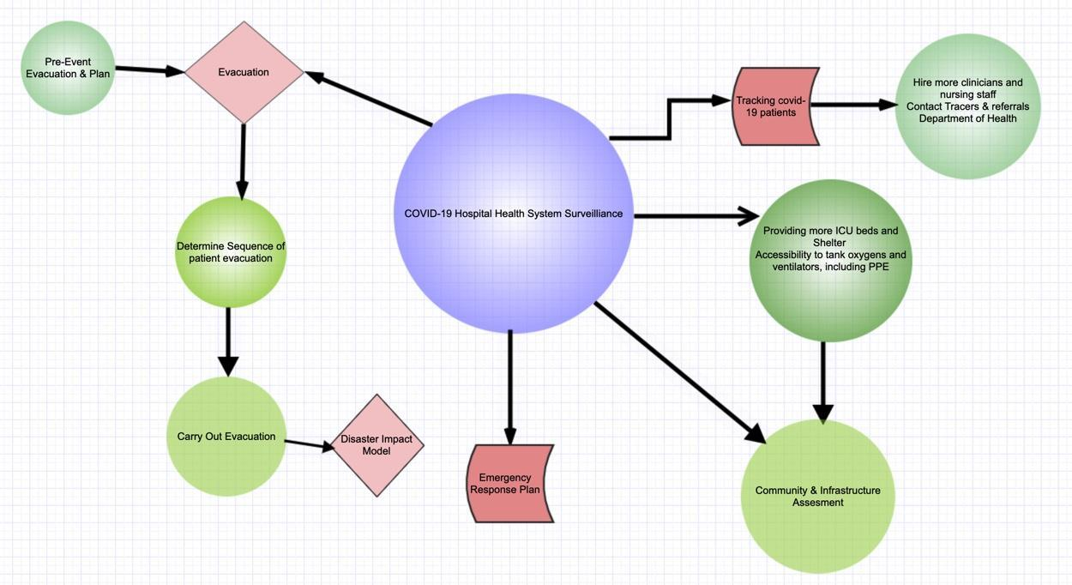
Base Plan Element #18: Decision Tree for Determining Evacuations vs. Shelter in Place

Base Plan Element # 19: Mutual Aid Agreements (Response Partners)

5. Facility has current mutual aid Memorandum of Understanding (MOUs) in place.
☐ Yes ☐ No
a. Memorandum of Understanding (MOUs) are in place with:
Law enforcement ☐ Yes ☐ No
Fire ☐ Yes ☐ No
Emergency medical services (EMS) ☐ Yes ☐ No
Public Safety ☐ Yes ☐ No Military installations ☐ Yes ☐ No
Other local and regional health care facilities
☐ Yes ☐ No
Burn center ☐ Yes ☐ No
Red Cross ☐ Yes ☐ No
MMRS ☐ Yes ☐ No
CERT ☐ Yes ☐ No
Other ☐ Yes ☐ No
b. Memorandum of Understanding (MOUs) are in place for:
Portable MRI ☐ Yes ☐ No
Portable CT ☐ Yes ☐ No
Portable Dialysis ☐ Yes ☐ No
Generators ☐ Yes ☐ No

Mental Health

Take the following steps to cope with a disaster and make this information available to employees, residents, and their family members:
- Take care of your body
  - Try to eat healthy well-balanced meals,
  - Exercise regularly
  - Try to get a good night’s rest
  - Avoid alcohol, tobacco, and other drugs.
- Connect with others
  - Share your concerns and how you are feeling with a friend or family member.
  - Maintain healthy relationships and build a strong support system.
- Take breaks
  - Make time to unwind and remind yourself that strong feelings will fade.
  - Try taking in deep breaths.
  - Try to do activities you usually enjoy.
- Stay informed
  - Watch, listen to, or read the news for updates from officials.
  - Be aware that there may be rumors during a crisis, especially on social media.
  - Always check your sources and turn to reliable sources of information like your local government authorities.
- Avoid too much exposure to news
  - Take breaks from watching, reading, or listening to news stories. It can be upsetting to hear about the crisis and see images repeatedly.
- Seek professional psychological support if needed
  - If an employee is experiencing a difficult time at work, your SNF site should provide you access to a professional psychologist or counselor
  - If a resident is exhibiting signs of stress or loneliness, your SNF site should connect them with a psychologist or counselor and try to incorporate technology to allow them to interact with friends and family
  - In the event that a resident or staff passes away from COVID-19, it is important to acknowledge grief. Allow for virtual access to connect with your SNF community to allow time to grieve and heal.
Stress during an infectious disease outbreak can sometimes cause the following:
- Fear and worry about your own health and the health of your loved ones, your financial situation or job, or loss of support services you rely on.
- Changes in sleep or eating patterns.
- Difficulty sleeping or concentrating.
- Worsening of chronic health problems.
- Worsening of mental health conditions.
- Increased use of tobacco, and/or alcohol and other substances.

Get immediate help in a crisis, facilities should be sure to post these resources for all employees and residents to see:
- Call 911
- Disaster Distress Helpline 1-800-985-5990 (press 2 for Spanish), or text TalkWithUs for English or Hablanos for Spanish to 66746. Spanish speakers from Puerto Rico can text Hablanos to 1-787-339-2663.
- National Suicide Prevention Lifeline 1-800-273-TALK (8255) for English, 1-888-628-9454 for Spanish
- National Domestic Violence Hotline 1-800-799-7233 or text LOVEIS to 22522
- National Child Abuse Hotline 1-800-4AChild (1-800-422-4453) or text 1-800-422-4453
- The Eldercare Locator 1-800-677-1116
- Crisis Chat text: 8388255

References

Emergency Management. (2015, December 15). Retrieved June 8, 2020, from https://www.numc.edu/our-services/emergency-management/

Emergency Management/Preparedness Division. (n.d.). Retrieved June 8, 2020, from https://www.co.benton.or.us/preparedness

Emergency Medicine. (2016, April 29). Retrieved June 8, 2020, from https://www.numc.edu/education/graduate-medical-education/residency-fellowship-programs/emergency-medicine/

Our History. (2016, May 18). Retrieved from https://www.numc.edu/about/our-history/

Mental Health Resources: https://www.cdc.gov/coronavirus/2019-ncov/daily-life-coping/managing-stress-anxiety.html

https://emergency.cdc.gov/coping/selfcare.asp

