Community Health Center COVID-19 Emergency Response Plan
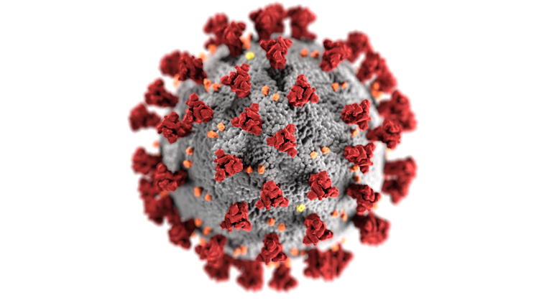

THIS COVID-19 PLAN TEMPLATE FOR COMMUNITY HEALTH CENTERS WAS PREPARED AS A PUBLIC HEALTH SERVICE BY

David Ray Garcia, Mounika Nekkanti, Anya Snyder, Gene Yeh

GPH-GU 5150 Emergency Preparedness for Healthcare Organizations

New York University School of Global Public Health

July, 2020

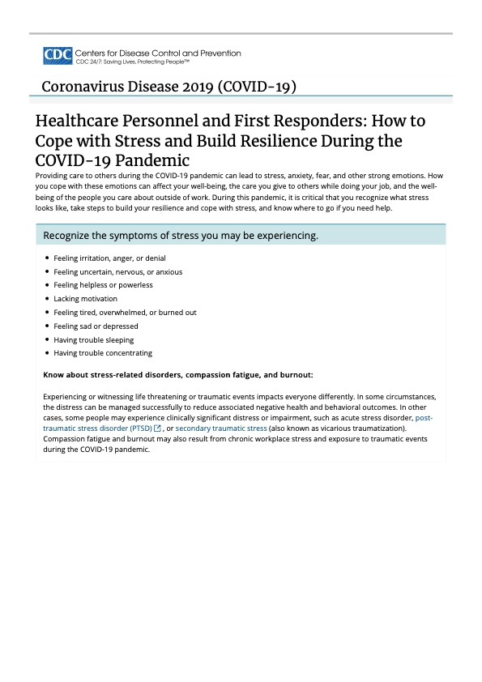

COVID-19 Response Plan for
{Insert name of your organization here}

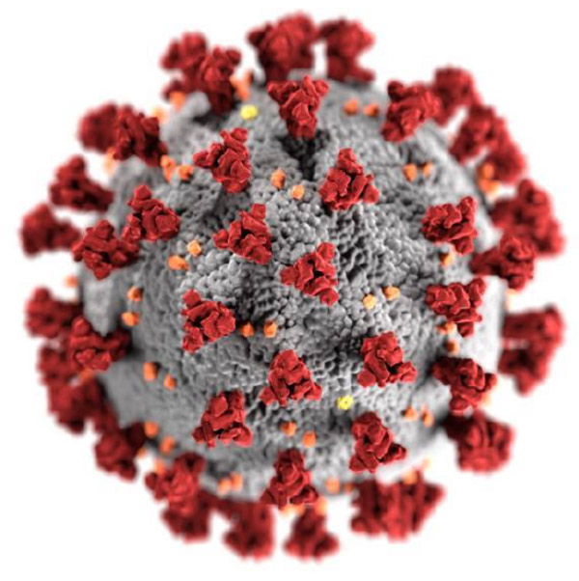

Table of Contents

Preface…………………………………………………………………………………………...4
Signature Page………………………………………………………………………………….6
Mission Statement, Statement of Purpose…………………………………………………...7
Authorities, Definitions & Acronyms…………………………………………………………..8
Communications Plans, Mutual Aid Agreements……………………………………......9-11
Best Practices/Recommendations…………………………………………..…………...12-20
References……………………………………………………………………………………..21

Annexes
Annex 1: Incident Command Organizational Chart
Annex 2: Facility Profile Document
Annex 3: Patient Care Capacity
Annex 4: Other Healthcare Facility Resources
Annex 5: Back-Up Plan Document
Annex 6: Facilities Readiness Document
Annex 7: Continuity of Business Document
Annex 8: Emergency Management Committee Document
Annex 9: Training Plan
Annex 10: Emergency Communications Document
Annex 11: Mental Health & Psychosocial Support (MPSS) Needs
Annex 12: Donning and Doffing Guide PPE Guide
Annex 13: Facemask Do’s & Dont’s
Annex 14: Donning and Doffing Respirators
Annex 15: THIRA Example and Blank Template

Preface

According to the World Health Organization (WHO), COVID-19 virus is an infectious disease that is caused by a new type of coronavirus.¹ COVID-19 is primarily spread through droplets of saliva or nasal discharge from coughs and sneezing. As of this writing (July, 2020) there is no specific vaccine or treatment for COVID-19, however most infected people will experience mild to moderate respiratory illness and recover without special treatment.² According to what is known about the virus, the Centers for Disease Control and Prevention (CDC) suggested strategies for the public to prevent the spread of COVID-19, such as interrogating its transmission route, washing hands often, avoiding close contact (social distancing), covering mouth and nose with personal protective equipment (PPE) or other forms of face covers, clean and disinfect frequently touched surfaces, etc.³ Guidelines and decision tools were published for the general public, workplaces, communities, faith-based organizations, health departments and more, as well as guidance for healthcare facilities.^{2,4} People that are most at risk of developing serious illness include older people, as well as people with underlying medical conditions such as cardiovascular disease, diabetes, respiratory disease, and cancer.

Community health centers (CHCs) provide care to a large number of medically underserved populations, such as those who lack health insurance, low-income and homeless families, communities of color, and many others.⁵ Many individuals in this population rely solely on community health centers to receive routine essential care.⁵ As primary care providers and trusted members of their communities, CHCs need to be prepared to respond to emergency and disaster situations, as they may be relied upon for medical care and other support services. During an emergency, people want to receive care from their normal provider, and for many, that provider is their CHCs.⁵ Therefore, making sure the community as well as the underserved populations regularly receives quality care is important for CHCs.

Suggestions on the quality and quantity of PPE, disinfection protocols, appropriate hand-washing, limited capacity of certain areas are recommended and can aid in a CHC’s decision making for emergencies.⁶ Although these resources are quite helpful and play a critical role in decision making, it is also important to keep in mind that these resources may be barriers for the community when seeking adequate care. For example, if the capacity of people staying in a certain workplace is limited as according to the guidelines, numbers of employees (such as on-site health providers) may be reduced as well as number of patients receiving services.

Therefore, alternative ways of providing health care services will have to be put into consideration in order to keep up the same quality of services provided.⁷ Overall, the main goal of a CHC during emergencies and disasters is to make sure that the community regularly receives good quality healthcare services.

This Best Practices plan provides guidance to a wide range of community health centers and tools that can be adapted as needed for their own special circumstance in order to 1) maintain critical functioning and 2) respond to the COVID-19 crisis. This plan has been developed to provide guidance that aims to assist community health centers to adapt and operate effectively or adjust the way of delivering healthcare services during a COVID-19 crisis so that they may continue their critical role in serving vulnerable populations and ultimately reducing health disparities.

Signature Page
{please add your own key roles as needed}

Organization CEO/Executive Director date

____________________________________________________________________
Organization Medical Director date

____________________________________________________________________
Organization Emergency Management Officer date

____________________________________________________________________
Organization Public Safety Officer date

Mission Statement
{Insert your organization here and adapt the mission statement to your discretion} mission is to improve the health of people and families in the community and to provide access to affordable, quality healthcare especially to uninsured persons. Our goal is to offer quality health care and related services to a diverse population, regardless of ability to pay. Our mission is to promote healthy lifestyles, disease prevention and early treatment through culturally sensitive care.

Statement of Purpose
The purpose of this plan is to provide community health centers with a disaster plan to utilize in its response efforts to the COVID-19 pandemic.

Authorities
The Joint Commission for ambulatory health care accreditation and Patient-Centered Medical Home Recognition
The Accreditation Association for Ambulatory Health Care for ambulatory health care accreditation and Patient-Centered Medical Home recognition
The National Committee for Quality Assurance for Patient-Centered Medical Home recognition
The National Association of Community Health Centers (NACHC) serves as the leading national advocacy organization in support of community-based health centers
U.S. Centers for Medicare & Medicaid Services (CMS) is the US federal agency which conducts all Medicare and Medicaid related services as well as provides oversight on Emergency Preparedness for participating organizations

Definitions & Acronyms
CHC - Community health center
COVID-19 - An infectious form of the coronavirus spread through respiratory droplets
Disaster - An event, natural or man-made, that overwhelms local resources
ED - Emergency department
EMS - Emergency medical services
FQHC - Federally qualified health center
ICS - Incident command system
Pandemic - A disease that is prevalent throughout a country or the world
PCMH - Patient-centered medical home
PPE - Personal protective equipment
Surge - A large volume of patients that cannot safely be cared for by a healthcare organization
THIRA -Threat and hazard assessment and risk identification
Volume - A number of patients, with varying levels of acuity

Communications Plans

INTERNAL COMMUNICATION
Facility-wide communication:

Under the guidance of key personnel in charge of the facility or their designee (also referred to as the incident commander), the activation of the disaster response plan will be communicated within the facility through overhead announcements to alert staff of the emergency. In addition, a facility-wide communication will be established through email, landlines, and facility cellular devices. All staff should have prior instruction to limit their own cellular communication strictly for critical safety concerns only. If landlines and cellular networks fail, the CHC will use runners to communicate to staff. All staff should report to their supervisors and follow detailed instruction (as well as the protection of clients and visitors) as per their response plan.

EXTERNAL COMMUNICATION
Communications with first responders and other local authorities:

Once the CHC has been made aware of the emergency, the designated point person will immediately communicate with external authorities and first responders.

Communication with other healthcare organizations & agencies:

Key public health agencies and organizations such as the local Department of Health, The National Association of Community Health Centers (NACHC) and the U.S. Centers for Medicare & Medicaid Services (CMS) will be notified (if needed) by the CHC Director or designee to facilitate sharing information, coordinate resource requests and patient-centered emergency response guidance.

Patient information communication:
Patient transfer may be necessary when the medical needs of the patient cannot be met at the facility. In such a case, electronic transfer forms and discharge summaries will be sent to both the patients and the healthcare facility/ alternate care site that the patients are being transferred to, to avoid any health complications. The transport and relocation process of the patients will be arranged by the Logistics section chief and participating mutual aid partners, communication will be maintained throughout. Moreover, the transfer of patient records will follow the HIPAA privacy rules and applicable State privacy laws to respect patient privacy. 24-hour emergency phone lines and other forms of telehealth communication should be established to regulate the influx of new patients to the facility.

Media and public communication:

The CHC Director or designee will be responsible for all forms of public information and external communications in case of an emergency involving the facility. This person is responsible for effectively communicating to the public about the emergency and how the emergency will impact the center’s operations. This might be accomplished through press releases, town hall forums and news articles while informal communication would occur via social media platforms.

Supply chain vendor communication:

Communications must be ongoing with all partners, providers, contractors, consultants, vendors and service providers to arrange for the resources necessary during (and after) the emergency.To ensure smooth and effective service provisions during such emergency or disaster events, Memoranda of Understandings will be referred to. The personnel at the CHC in charge of procurement will be responsible for communicating to the supply chain vendors.

Mutual Aid Agreements

It is recommended that the CHC identify key organizations or entities for the purposes of mutual aid agreements.This is a mutual responsibility. It is also recommended that mutual aid agreements also note the key individuals within the organizations so that communications during times of crisis are facilitated.

The following agencies will provide mutual aid to {insert name of organization here and key contact(s)} in the event of a disaster: some examples are provided below

- Other local Community Health Centers
- Local Community Health Centers Association
- Hospitals and other healthcare facilities

Best Practices

Patient Safety
Patient as well as worker safety must be the top priority of any community health center operating during the COVID-19 response. Notably, it is crucial that CHC administrators and staff consider visitor’s and family members’ safety in addition to patient safety. Beginning from the adaptive phase of the response to provision of services, the following provides a list of best practices for CHCs to ensure patient safety during their response efforts.

Non-essential services such as routine dental and eye care, routine wellness checks, pediatric vaccinations, newborn and early childhood care, as well as follow up services may need to be immediately rescheduled (depending on local conditions and phase that locality I currently in) in order to prepare for a change of scope in service provision.⁶ Telehealth visits can and should take the place of in-person visits for these services where evaluation and referral to partner clinics can be conducted.⁷

Appropriate signage regarding entry and exits points, face coverings, hand hygiene, cough etiquette, and physical distancing protocols should be displayed on large, easy to read posters (CDC example). Signage should be posted in multiple languages.

Patient’s may have one visitor, however visitor’s should not be allowed into examination rooms and should be encouraged to remain outside of the facility or in their vehicles. Exceptions may be made to support severely ill/elderly/children patients.

Patients requiring in-person services should either a) make an appointment if non-COVID related or b) call ahead of time if experiencing symptoms to allow staff to appropriately prepare for arrival. Upon entering, waiting rooms must be partitioned to allow for 6 feet physical distancing. If absolutely necessary, visitors entering the facility should remain with the patient as if one unit. Waiting rooms should be separated based on symptomatology.

Face coverings must be required upon entry for all persons and CHCs should provide supplies to patients and visitors if feasible. Additionally, alcohol based hand rub containing at least 70% isopropyl alcohol should be provided throughout the facility.⁸

To avoid overcrowding, patients should be instructed to wait outside of the facility or in vehicles until called upon. If feasible, entry and exit points should be separate in order to reduce patient exposure.

Patient screening begins with temperature readings and symptom checklist at home before traveling to the facility. Febrile patients & those experiencing COVID related symptoms should speak with a provider by phone or telemed to discuss next steps. Symptomatic patients requiring in person triage and/or testing should be provided with specific instruction unique to the CHC prior to entry of the facility. An intake triage station equipped with a staff member, masks to patients and family designated to accompany them (and this person should undergo the same screening protocol) non-contact thermometers, as well as questionnaires about signs and symptoms should be stationed preferably outside of each entry or just inside the doorway to avoid exposure to those in the waiting room.⁶ Patients should be sent to appropriate areas of waiting room or referred for critical care services.

Worker Safety
The United States Department of Labor and the Occupational Safety and Health Administration (OSHA) has released guidance on preparing workplaces for the coronavirus disease 2019 (COVID-19).⁷ This guidance suggests that workplaces that have planned for influenza pandemics update their plans to include protection from the unique characteristics of the SARS-CoV-2, such as risks and sources of exposure, as well as routes of transmission. OSHA stresses that workplaces should prepare in advance to prevent the sequelae from a failed response stemming from inadequate resources and training for pandemic conditions.The focus of this guidance entails engineering, administrative, and workplace controls, as well as the use of personal protective equipment (PPE). In light of rapidly changing knowledge regarding COVID-19 that continues to become available, the OSHA COVID-19 webpage should be monitored periodically for updates: www.osha.gov/covid-19.

Symptoms of COVID-19
OSHA provides basic knowledge regarding infection with SARS-CoV-2, the virus that cause COVID-19, where symptoms can range from mild to severe or fatal, and include fever, cough, and difficulty breathing, as well as non-respiratory symptoms.⁷ There are also instances where individuals may experience no symptoms, which are known as asymptomatic cases, or symptoms may be delayed between two to fourteen days after exposure.

Spread of COVID-19
Guidance from OSHA describes that the spread of SARS-CoV-2 mainly occurs between close contact, i.e. within six feet, with respiratory droplets produced from coughs or sneezes from an infected individual, which land in the mouth, nose, or are inhaled into the lungs of a susceptible individual.⁷ There is also a risk of transmission when an individual comes into contact with contaminated surfaces and then touches their mouth, nose, or eyes. The Centers for Disease Control and Prevention (CDC) provides updated information regarding the transmission of the coronavirus: www.cdc.gov/coronavirus/2019-ncov/about/transmission.html.

Outbreaks and the Workplace
According to OSHA guidance, widespread person-to-person transmission in the community can affect workplace operations through absenteeism, alterations in patterns of commerce, and interruptions in supply chains.⁷ Absenteeism may result from a worker’s illness with coronavirus, but may also occur when family members become ill, there is a lack of childcare, or there is fear of exposure from the workplace. Commerce is likely to be affected, as demand for supplies necessary for infection prevention increases, such as N-95 respirators, gowns, disinfectants, and hand sanitizing solutions. Supply chain shipments may experience delays or cancel orders without notification.

Risk Reduction in the Workplace
OSHA recommends that all facilities develop an infectious disease preparedness and response plan against COVID-19, if not already available.⁷ Guidance should be incorporated from federal, state, local, tribal, or territorial health organizations when available. Plans should address the levels of risk that are associated with different workers or sites, if a multi-site facility. Considerations should account for workers who come in contact with the general public, as well as other coworkers. There is also a concern for health workers that must make home visits in the community or with mobile sites. Plans should also account for workers with individual risk factors, such as older age, chronic medical conditions, immunocompromise, or pregnancy, and methods of mitigating risk in these individuals. Contingency plans should also be in place to account for absenteeism, for example planning for operations with a reduced workforce, cross-training workers to different positions, and being able to operate during a surge. Planning for an environment that allows for social distancing is also important, such as implementing staggered work shifts, flexible work hours, limiting services, or providing remote services.

Basic Prevention Measures
Guidance from OSHA recommends the promotion of frequent and thorough hand washing for all workers and visitors, with either soap and running water or alcohol-based hand sanitizing solution containing a minimum of 60% alcohol.⁷ Hand hygiene information for healthcare professionals can also be found on the CDC’s website (https://www.cdc.gov/handhygiene/providers/index.html). Cleaning and disinfecting of surfaces in the work environment should be done regularly with Environmental Protection Agency (EPA)-approved disinfectants that are labeled to be effective against SARS-CoV-2, with special considerations regarding necessary concentration of solution, contact time, and any needed PPE. Workers should also be encouraged to use respiratory etiquette, such as covering coughs and sneezes and staying home when feeling sick. When possible, shared workspaces should also be limited, such as desks, offices, phones, or equipment.

Infection Policies
Isolation of potentially infectious individuals is a critical step in protecting workers and visitors.⁷ Workers should be trained on how to implement isolation measures, such as which rooms can serve as isolation rooms until sick individuals can be removed from the worksite. Suspected individuals with COVID-19 should be isolated separately from individuals with confirmed cases, to prevent further transmission. Personnel allowed in isolation areas should be restricted as much as possible. Face masks, such as procedure masks or surgical masks, should be available to all visitors not already wearing one in order to limit the spread of respiratory droplets, and should cover the nose and mouth.These should not be confused with PPE needed for employees, such as respirators which require fit testing. Employees should also be trained to self-monitor for signs and symptoms of COVID-19 and how to report these symptoms to supervisors.

Workplace Controls
A hierarchy of controls is a framework used in occupational safety to control workplace hazards.⁷ The ideal way to control hazards is to remove them from the work environment, rather than workers having to reduce their exposures, however during COVID-19 it is not possible to eliminate hazards. In this case, the most effective measures for protection, according to OSHA, include engineering controls, administrative controls, safe work practices, and PPE. Engineering controls reduce exposures without relying on worker behavior and are considered the most cost-effective solutions to implement. OSHA recommendations include high-efficiency air filtration, increased ventilation rates, physical barriers, such as sneeze guards, windows for customer service, and negative pressure ventilation in rooms where procedures are performed that generate aerosols or for patient isolation. Recommendations for administrative controls include encouraging symptomatic workers to remain at home, utilization of remote work to minimize contact, alternating days to reduce the number of staff, discontinuing non-essential travel, providing emergency communication plans or forums for workers’ concerns, providing COVID-19 training on risk factors and protective behaviors, and most importantly providing easy to understand training on the appropriate usage of PPE and correct techniques for donning and doffing. Safe work practices include a work environment that promotes personal hygiene through the availability of tissues, contact-free trash cans, hand soap and running water, 60% alcohol rubs, handwashing signs in restrooms, and disinfectants and disposable towels to sanitize workstations. OSHA recommends appropriate PPE such as gloves, eye wear, face shields, masks, or respirators. These should be selected based on the levels of risk to the worker and should be properly fitted and refitted, as necessary. PPE must be used consistently and properly, and if reused it should be inspected, maintained, and replaced if damaged. In order to avoid contamination, PPE must be properly removed and disposed of, and if reused it should be properly cleaned and stored. Detailed information on types of respirators, fit testing, and training can be found at:
- www.osha.gov/laws-regs/regulations/standardnumber/1910/1910.134
- www.cdc.gov/coronavirus/2019-ncov/hcp/respirators-strategy
- www.osha.gov/SLTC/etools/respiratory
- www.cdc.gov/niosh/topics/respirators
- www.osha.gov/SLTC/respiratoryprotection
- www.cdc.gov/niosh/docs/2005-100/default.html

Levels of Exposure
OSHA categorizes risk exposure into four levels, very high, high, medium, and lower risk.⁷ Though most American working conditions are considered lower or medium exposure risk, healthcare workers, including medical, postmortem, or laboratory personnel carry a high or very high exposure risk to COVID-19. Very high exposure risk involves duties such as procedures that are aerosol-generating, handling COVID-19 specimens, or performing autopsies. High exposure risk includes these same types of workers, but there is no exposure to aerosol-generating procedures. This includes entering patients’ rooms, transporting patients, or preparing bodies for burial or cremation. Medium exposure risk involves working with people who may be infected with SARS-CoV-2, but are not known or suspected to be infected, and there is frequent contact that is less than six feet apart with others. Lower exposure risk workers carry out functions where there is minimal contact with the public or coworkers.

Protecting Workers
OSHA describes the various ways to protect workers based on their levels of exposure risk.⁷ Workers in the lower risk exposure group should be encouraged to monitor public health communications regarding COVID-19, with websites such as www.cdc.gov/coronavirus/2019-ncov. Medium risk exposure workers should be provided with physical barriers, such as clear plastic guards, if appropriate. There should also be masks on hand for people who are suspected to be ill, as well as signs that inform about the symptoms of COVID-19. Public access to the worksite should be limited, as well as minimizing face-to-face contact with the use of windows and telecommunication. Medium exposure risk workers will need some combination of PPE, which employers should determine in their hazard assessment of the types of exposures in the workplace.

Areas classified as high or very high exposure risk should implement engineering controls, such as appropriate air-handling systems as described by the CDC, www.cdc.gov/mmwr/preview/mmwrhtml/rr5210a1.htm. Administrative controls for workers should include medical monitoring of staff, ongoing job-specific education and training on COVID-19 transmission, and psychiatric mental health support for the burden of stress. Community or field workers should have 60% alcohol-based hand rubs for decontamination in the field. PPE is essential for high and very high exposure risk workers and includes gloves, gowns, eyewear, and masks or respirators. Respirators are recommended when in contact within six feet of patients who are suspected or known to be infected with COVID-19. Workers in laboratories, morgues, or mortuaries will need appropriate gowning that is fluid resistant and large enough to cover areas that require protection from blood, fluids, or chemicals. Similarly, workers that are in charge of the disposal of contaminated PPE and infectious waste must also be trained and provided with appropriate PPE. OSHA provides specific guidance on PPE (www.osha.gov/covid-19) and the CDC describes healthcare-associated infections (www.cdc.gov/hai) on their websites. Detailed donning and doffing techniques are described by the CDC (https://www.cdc.gov/coronavirus/2019-ncov/hcp/using-ppe.html) and infographics are available in the Annex of this document.

For patients, administrative controls should include placing patients with COVID-19 in single rooms when available, or cohorting them together when space is limited. There should be signage requesting that patients and family immediately report respiratory illnesses upon arrival and don disposable face masks.

Mental Health
According to CDC guidance, strong emotions such as fear and anxiety during a pandemic can be overwhelming for workers in the work setting and those working from home.⁸ Coping with these emotions can affect stress and well-being, and there are concerns regarding worker burnout. Steps should be outlined to recognize workers experiencing stress and policies should be created to help build resilience and stress management, as well as outlining where to access mental health resources in the workplace. Workers should be able to talk openly with coworkers, supervisors, employers, and unions on how the pandemic is affecting the workplace and how to identify solutions. Updated information on coping with stress for workers can be found on the CDC’s website: https://www.cdc.gov/coronavirus/2019-ncov/hcp/mental-health-healthcare.html

OSHA Resources
The following are OSHA’s resources designed to help reduce the number and severity of workplace injuries and illnesses.⁸

- Compliance assistance specialists
  - Visit www.osha.gov/complianceassistance/cas or call 1-800- 321-OSHA (6742) to contact your local OSHA office.
- No-cost on-site consultations
  - For more information or to find the local On-Site Consultation office in your state, visit www.osha.gov/consultation, or call 1-800-321-OSHA (6742).
- Cooperative programs
  - To find out more visit www.osha.gov/cooperativeprograms.
- Occupational safety and health training
  - For more information on training courses, visit www.osha.gov/otiec.
- Educational materials
  - All OSHA publications are free at www.osha.gov/publications and www.osha.gov/ebooks. You can also call 1-800-321-OSHA (6742) to order publications.
  - QuickTakes, OSHA’s free, twice-monthly online newsletter with the latest news about OSHA initiatives and products to assist in finding and preventing workplace hazards. To sign up, visit www.osha.gov/quicktakes.

References:
- World Health Organization. Coronavirus. Published 2020. Accessed June 14, 2020.https://www.who.int/health-topics/coronavirus#tab=tab_1
- Healthcare Facilities: Managing Operations During the COVID-19 Pandemic. Centers for Disease Control and Prevention. https://www.cdc.gov/coronavirus/2019-ncov/hcp/guidance-hcf.html Published June 28, 2020. Accessed July 7, 2020.
- How to Protect Yourself & Others. (2020, April 24). Retrieved June 09, 2020, from https://www.cdc.gov/coronavirus/2019-ncov/prevent-getting-sick/prevention.html
- COVID-19 Guidance: Agriculture Workers and Employers. (2020, May 05). Retrieved June 09, 2020, from https://www.cdc.gov/coronavirus/2019-ncov/community/guidance-business-response.html
- Ablah, E., Tinius, A. M., Horn, L., Williams, C., & Gebbie, K. M. (2008). Community Health Centers and Emergency Preparedness: An Assessment of Competencies and Training Needs. Journal of Community Health, 33(4), 241-247. doi:10.1007/s10900-008-9093-9
- Screening and Triage at Intake. Centers for Disease Control and Prevention.https://www.cdc.gov/coronavirus/2019-ncov/hcp/dialysis/screening.html. Published April 14, 2020. Accessed July 7, 2020.
- United States Department of Labor Occupational Safety and Health Administration. Guidance on Preparing Workplaces for COVID-19. Published online 2020. https://www.osha.gov/Publications/OSHA3990.pdf
- CDC. Coping with Stress for Workers. Centers for Disease Control and Prevention. Published April 30, 2020. Accessed July 12, 2020. https://www.cdc.gov/coronavirus/2019-ncov/community/mental-health-non-healthcare.html

Annex 1

Annex 2

Annex 3

Annex 4

Annex 5
Annex 6

Annex 7

Annex 8

Annex 9

Annex 10

Annex 11
Annex 12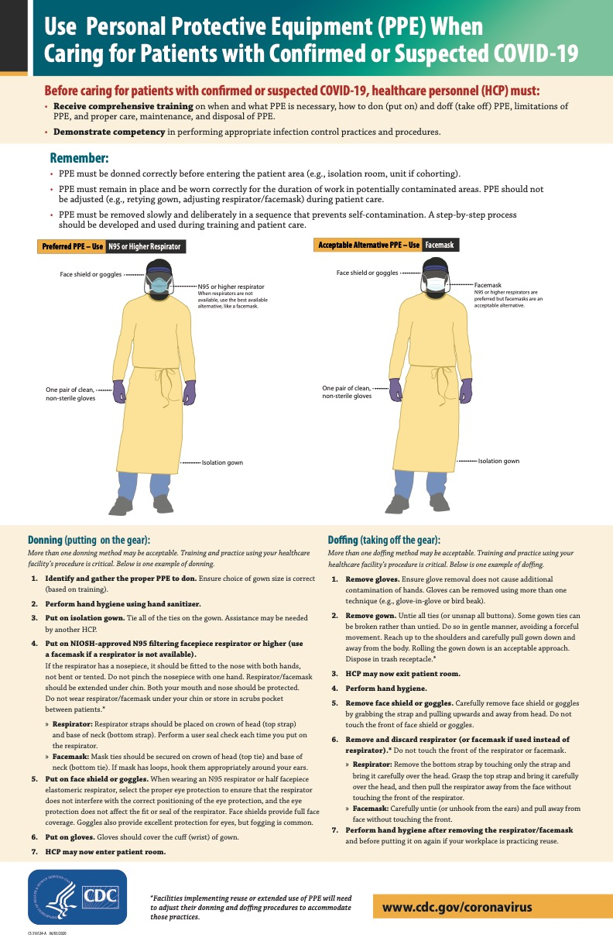

Annex 13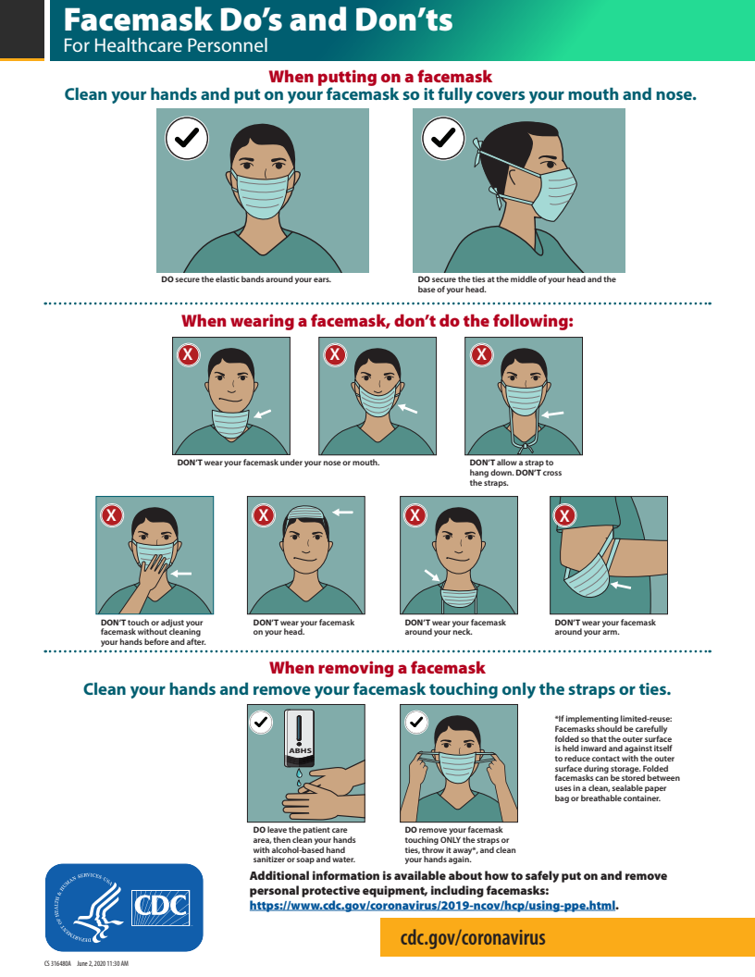

Annex 14
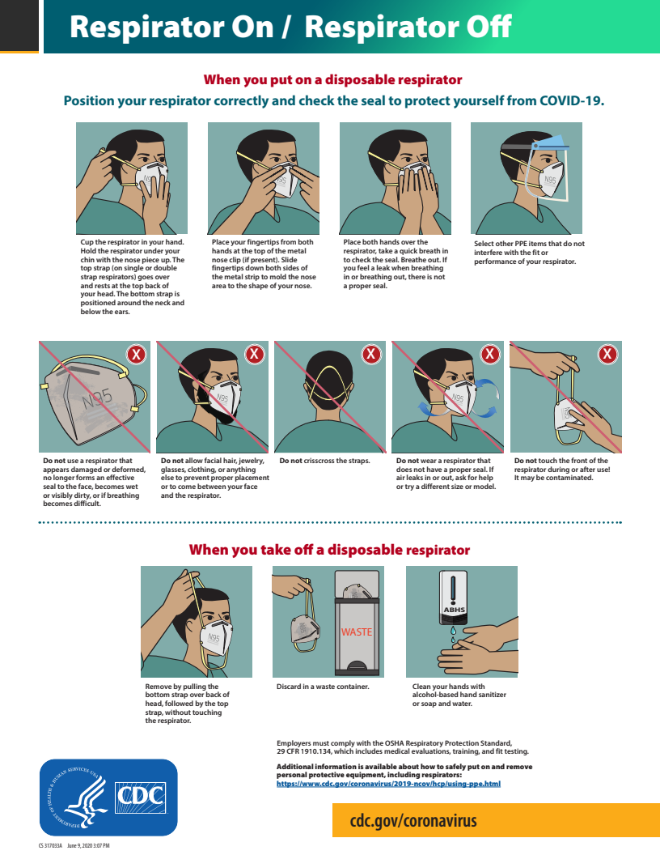
Annex 15
In order to be prepared for a wide range of emergencies and disaster events, it is important for the CHC to periodically prepare a Threat and Hazard Assessment and Risk Identification, or THIRA for short. Here is an example of a THIRA prepared for the New York City area. A blank template is provided below.

Threat and Hazards Assessment Table: Community Health Center

(New York City, NY)
Natural | Technological | Human-caused
Resulting from acts of nature | Involves accidents or the failures of systems and structures | Caused by the intentional actions of an adversary
Epidemic – With a population of almost 9 million people as well as containing two of the largest hubs for international travel New York City is the most densely populated city in the country & consequentially a perfect breeding ground for emerging and reemerging infectious disease outbreaks. New York City has experienced pandemics such as the 1918 Influenza Pandemic which killed approximately 30,000 people. Community health centers (CHCs) provide primary care to vulnerable populations and are at high risk of catastrophe during epidemics due to influx of patients, constrained resources, and organizational limitations.  Flood – Due to its geographic location adjacent to the Atlantic Ocean and various waterways, New York City has experienced devastating historical flooding. As climate change worsens, sea levels rise CHCs will be at high risk of damages from coastal flooding.  Winter storms – Nor’Easters are common in New York City and most threatening between September-April and bring storms with high winds originating in Southern regions and moving northeast along the East Coast. Category 1 winter storms are those in which 4 to 10 inches of snow accumulate threatening transportation, public infrastructure, and public safety. | Power failure – Power outages due to significant winds from severe storms can disrupt power supply in New York City. Utility services may be responding to an influx of outages and may not have the capacity to restore power to a CHC within a timely manner. CHCs may lose control of HVAC systems, refrigeration, important radiographical scanning devices, acute care ventilator support, elevator usage, and communication equipment.  Radiological release – Radiation exposure in community health center settings can be disastrous due to a lack of warning as well as the invisible nature of radiological release. Health care workers particularly are at risk of radiation exposure from various imaging procedures as prolonged and frequent exposure is required by many job titles. Increasing reliance on technology will continue to pose threats to employees and patients. Health impacts can be deterministic (outcomes experienced only when a certain threshold exposure level is reached) or stochastic (outcomes experienced regardless of exposure level & appear later).  Hazardous materials release – Health care settings are a primary source of hazardous materials release due to reliance on chemicals for medication administration, imaging procedures, cleaning procedures, and sterilization. Additionally, infrastructure collapse or damage to equipment also poses a threat to employees and patients via dust and asbestos. | Cyber incident – With the vast amount of personal identification information as well as billing and insurance within digital communication servers, health care settings are vulnerable to the threat of cyber security attacks. Even with implementation of cyber security tools, technological advance has allowed cyber attackers to bypass certain firewall protections and access patient information. From 2012-2013 the number of cyber security attacks in health care settings increased by 1375.  Workplace violence – It is essentially not possible to work remotely in a health care setting. Thus, employees, patients, and staff are vulnerable to external active shooter situations as well as disgruntled and violent patients. In settings such as community health centers, which often exist in low-income, urban centers violence in the workplace is doubly hazardous. The number of incidents of workplace violence is four times greater in health care settings than in the private sector.  Terrorism – Due to their direct proximity to densely populated urban neighborhoods, CHCs are targets for acts of terrorism. Historically, hostage situations have been known to be common within healthcare settings. The constant shuttling of people and equipment back and forth as well as the chaotic and fast-paced environment are intriguing to those wishing to engage in acts of terrorism.

Threat and Hazard Assessment and Risk Identification (THIRA)

Organization + Area (i.e. Community Health Center, New York City, NY)
Natural | Technological | Human-caused
Resulting from acts of nature | Involves accidents or the failures of systems and structures | Caused by the intentional actions of an adversary

