Emergency Isolation & Housing in Hotels During COVID-19
New York City Emergency Management
New York, New York

GPH-GU 5270 Management of Public Health Disasters
Akshitha Dondapati
Cole Swartz
Abner Wong

December 7th, 2020
Table of Contents

Preface 3
Committee Approval 4
Authorities 6
Definition 7
Communications Plan 8
Mutual Aid Agreement 9
CONOPS 10
Preliminary Circumstance Matrix 11
Surge Capacity 12
Local Public Health Agency Roles and Responsibilities 12
Annex 1: Threat and Hazards Assessment Table: New York, NY (NYC) 16
Annex 2: ICS Chart 18
Annex 3: Training Seminar 19
Appendix 1 20
Works Cited 21

Preface
The COVID-19 pandemic, caused by severe acute respiratory syndrome coronavirus 2 (SARS-CoV-2), causes symptoms that includes dry cough, fever, pneumonia, and death. There have been well over a quarter of a million deaths in the United States thus far, with the numbers not showing any signs of slowing down. Because the pathogen has a basic reproduction number (R₀) of ~2, upon discovering a COVID positive patient, containing the spread of the virus through isolation could prevent thousands of people from infection.

New York City is one of the most densely populated cities in the world and close quarter living arrangement is common throughout the city. This makes isolation and/or quarantine at home difficult. In such situations, hospitals are unlikely to have the capacity to isolate positive patients, with priorities going to those who have the most serious and/or severe conditions. Hotels could provide an alternative to home isolation/quarantine. Guests would be able to fulfill their quarantine/isolation requirements in a safe, respectful, and controlled environment.

This disaster plan is created by the New York City Emergency Management and New York City Health + Hospitals for the purpose of establishing the roles and responsibilities of the agency and related parties with regards to isolation and quarantine in hotels within the city. It is not made to replace current procedures and protocols but used as a supporting document.

Committee Approval
New York City Emergency Management (NYCEM) & New York City Health + Hospitals
The following list of signatures documents each member of the Board of Supervisors’ concurrence and receipt of the NYCEM and NYC H+H COVID-19 Evacuation and Isolation plan. As needed, revisions will be submitted to New York City Emergency Management Emergency and New York City Health + Hospitals.
________________________________ _________________
Deanne Criswell, Commissioner NYCEM Date

________________________________ _________________
Andrew D'Amora, First Deputy Commissioner NYCEM Date

________________________________ _________________
Jenna Peters, Chief of Staff NYCEM Date

________________________________ _________________
Craig Bonney, Deputy Chief Operating Officer NYCEM Date

________________________________ _________________
Theodore G. Long, Executive Director Test and Trace Corps NYC H+H Date

________________________________ _________________
John Ulberg, Chief Financial Officer NYC H+H Date

________________________________ _________________
Adrian M. Gonzalez, Deputy Director of Take Care NYC H+H Date

________________________________ _________________
Amanda Johnson, Senior Director of Care Models NYC H+H Date

________________________________ _________________
Neil Vora, Director of Tracing NYC H+H Date
Mission Statement and Purpose
The mission of NYCEM is to help New Yorkers before, during, and after emergencies through preparedness, education, and response. The agency is responsible for coordinating citywide emergency planning and response for all types and scales of emergencies.

The mission of NYC H+H is to extend equally to all New Yorkers, regardless of their ability to pay, comprehensive health services of the highest quality in an atmosphere of humane care, dignity, and respect. To promote and protect, as both innovator and advocate, the health, welfare, and safety of the people of the City of New York. To join with other health workers and with communities in a partnership which will enable each of our institutions to promote and protect health in its fullest sense – the total physical, mental and social well-being of the people.

The purpose of this plan is to ensure that NYCEM and NYC H+H is able to effectively maintain the health of the New York City community during the COVID-19 crisis. The management and mitigation of the spread of COVID-19 is important to NYCEM and NYC H+H and this plan is to ensure that isolation of potential and confirmed cases of COVID-19 is safe, reasonable, and respectful of the New York City community.

Authorities
NYC has adapted CIMS ICS. NYCEM and NYC H+H ensure that in an emergency management situation, this command system is implemented. Under this management system, NYPD will be the Primary Agency (Incident Commander) at CBRN / Haz-Mat incidents. If NYPD determines there is no actual or suspected criminal activity or terrorism, a Unified Command will be implemented. For chemical incidents, DEP will make a final assessment of the hazard, and direct all mitigation efforts. For biological or radiological incidents, DOHMH will make a final assessment of the hazard. In situations where chain of command must be adjusted, NYCEM will authorize authority of intercity agencies.
Executive Orders for Quarantine and Isolation:
- EO #202.44
- EO #202.36
- EO #202.32
- EO #202.18
- EO #202.16
- EO #202.15
- EO #202.14
- EO #202.11
- EO #202.10
- EO #202.8
- EO #202.7
- EO #202.5
- EO #202.1
- EO #202
Adapted from: https://www1.nyc.gov/assets/em/downloads/pdf/Appendix_cims_charts.pdf

Definition
AWS - Advance Warning System

CDC - Centres for Disease Control and Prevention

CIMS - Citywide Incident Management System

DCAS - New York City Department of Citywide Administrative Services
DOB - Department of Buildings
DOE - Department of Education
DOH - Department of Health
DOHMH - Department of Health and Mental Hygiene
DOITT - New York City Department of Information Technology and Telecommunications
FEMA - Federal Emergency Management Agency
HPD - New York City Department of Housing Preservation and Development
MTA - Metropolitan Transportation Authority
NIMS - National Incident Management System
NYC H+H - New York City Health and Hospitals Corporation
NYCEM - New York City Emergency Management
NYPD - New York Police Department

NYFD - New York Fire Department

OMB - Mayor's Office of Management & Budget

R0 - Basic reproduction number

SARS-CoV-2 - Severe acute respiratory syndrome coronavirus 2

WEA - Wireless Emergency Alerts

Communications Plan
Internal Communications
The responsibility of onsite communications falls under NYCEM. Once a declaration for a state of emergency has been established, all NYCEM employees will shift to their state of emergency roles and duties. The employees that are on call will be responsible for the interagency and interoffice communications during their respective shifts. The physical location of an agency directory will be at the NYCEM headquarters, and a digital version will be on a shared document in the agency’s cloud software. Communications will primarily be through email and phone calls. Cell phone usage will be encouraged for those who are on site at the isolation sites. Phone communication towers are assumed to be functional during this disaster, as cleared by DOITT. Alternative forms of communications between NYCEM personnel and other agencies include, but are not limited to, landline telephones, voicemail, and text messaging. All Internal communications are required to be labeled “For Internal Use only”. All communications and sensitive documents will follow EITS guidelines for proper naming and storage in preparation for possible audits.

External Communications
A list of internal and external managers will be included in a copy of the internal directory located in the NYCEM headquarters and in the shared document. The responsibility of external communications is determined by CIMS. This system is based on and an extension of the NIMS Incident Command System. The NYC H+H assumes responsibility for public health orders, clinical guidance and risk communications. The responsibility of telecommunications falls under the responsibility of both the DOITT and the company Verizon. Dissemination of emergency information can be done through NYC’s three alert systems: Notify NYC, Advance Warning System (AWS), and Wireless Emergency Alerts (WEA). Communications systems are assumed to be functional during this disaster. Contact with hospitals within the vicinity of the isolation sites will be kept daily. DCAS will be the first line of communication for hotel procurement.

Mutual Aid Agreement
In the event of an emergency, NYCEM will coordinate response and recovery efforts with outstanding mutual aid agreements in the capacities below. All mutual aid assistance will be formally requested. Mutual aid may be requested from local, state, regional, and/or national agencies. These agencies may be publicly or privately owned.
Local:
- DOH, DOE, DOB, OMB, DOHMH, NYPD, NYFD, HPD, DOIT, DCAS,
- CURB, MTA, Citibike,
- Langone, Bellevue, NYC H+H
- All NYC + Boroughs hotels
- Yankee Stadium
Interstate/National:
- NJ Transit, Long Island Transit, UBER, LYFT
- CDC, FEMA

CONOPS
Organizational Structure
The organizational structure that is utilized by NYCEM is an adaptation of the Incident Command System. It is called the Citywide Incident Management System (CIMS). A unified command system is used for most emergency situations that do not have a criminal or terrorism aspect.
This system has been directly adapted from: 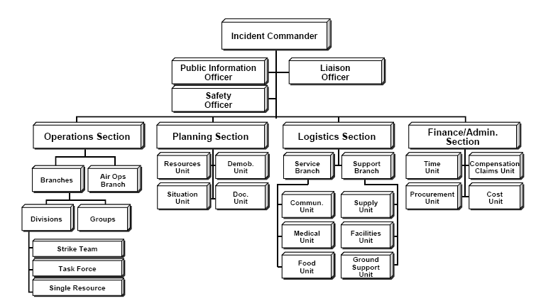
Example of CIMS:
https://www1.nyc.gov/assets/em/downloads/pdf/Appendix_cims_charts.pdf

Overall Approach
A separate adapted ICS structure will be adapted for the COVID-19 pandemic response as needed through the Emergency Support Function 8. Overall, the CONOPS will allow NYC to assess the needs of the affected population vulnerable population such as Low income households. We will evaluate the effectiveness of the disaster response by internal evaluations, continuous monitoring and training, and surveys administered within inter-city agencies and amongst the general population.
Agency’s Role and Responsibility
Mayor's office of operations: responsible for the policy decisions and strategies with regards to citywide issues and coordinates multi agency initiatives.
NYCEM: coordinates the citywide emergency response, this includes planning and internal communications with other agencies. NYCEM is also responsible for any alerts on the National Model for Incident Management System (NIMS).
DOHMH: responsible for the case studies conducted during the pandemic. COVID clusters and hotspots of different boroughs and districts within the city go through an epidemiological study where patterns, causes, and conditions are studied.

Preliminary Circumstance Matrix
L = Lead; S Support; L* = Co-Lead
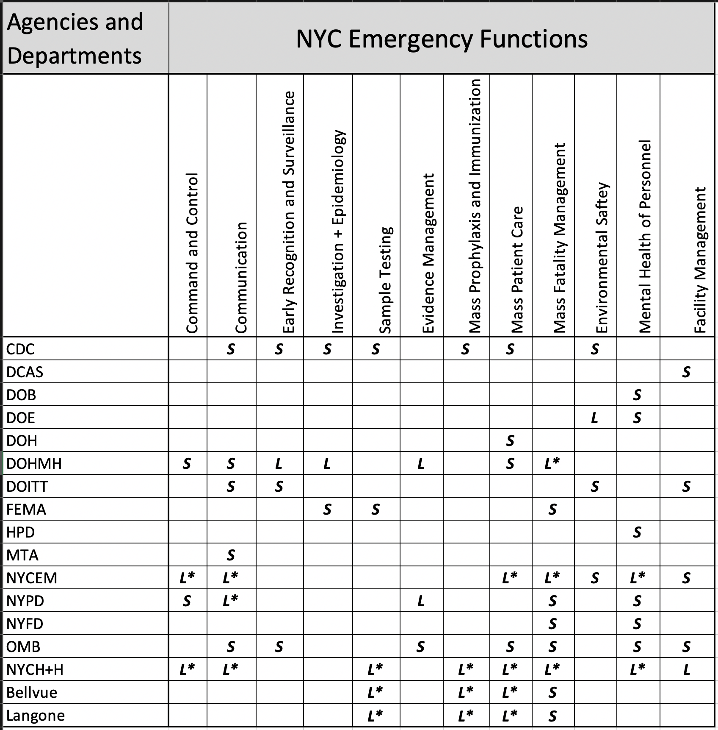

Surge Capacity
There are a total of 21 hospitals in New York City, with varying bed capacities. Total beds in the city hospitals prior to the pandemic amounts to 9385, with 132 ICU beds and 643 intensive care beds, refer to appendix 1 for list of hospital with bed and ICU/intensive care beds capacity.¹ In New York State, the occupancy average is 60% for children and 82% for adults, hospitals are able to withstand a surge of 268 new children cases and 555 adult cases for every million people.²
Due to the pandemic, hospitals in NYC took three measures to handle the surge in cases, this includes increasing ICU beds, ICU staffing, and critical care and infrastructure. Ventilators were also short in supply which peaked at over five times of utilization level pre pandemic.³ USNS Comfort was deployed to NYC to provide 1000 beds and 1200 personnel to aid hospitals in the city, initially to treat non COVID patients but was later amended to provide COVID care.⁴ The Javits Center served as a Federal asset field Hospital, also with 1000 beds and also limited to serving only COVID patients. The Javits Center field hospital was staffed with Federal health care workers and volunteers from throughout the country. Another Emergency Field Hospital was also deployed by Samaritan’s Purse, a religious non-profit organization active in disaster response work. They set up a field hospital in the East Meadow in NYC Central Park. They partnered with Mt Sinai and intergovernmental agencies to serve as overflow by providing a 68 bed respiratory care unit. Due to difficulties with reimbursements and decreased demand due to flattening of the curve, these facilities were underutilized. However, the Javits Center can be repurposed as a vaccination site as the materials have remained in place to redeploy the facility if needed. As the demands for hospital beds were initially not met, NYC Health + Hospitals added 3000 beds, 760 of which were ICU beds, and an additional 2500 health care workers by May 1, 2020, tripling the base amount of its initial capacity in 11 of its hospitals.⁵

Local Public Health Agency Roles and Responsibilities
Command and Control
In the event of mass evacuation and isolation, NYCEM will deploy ICS for all activities pertaining to safe isolation.
Communication
NYCEM, DOHMH, NYPD, Mayoral Offices, and NYC H+H, will facilitate initial biweekly meetings and communications to discuss operations, managements, and finances. Once all emergency preparedness activities are deployed, meetings will transition to weekly basis. In addition to internal communications, each organization will contribute to provide city wide disbursement of public health communications.

Early Recognition and Surveillance
Since COVID-19, the city has developed operational handbooks for areas of isolation including hotels and stadiums. In addition, the city has worked with numerous hotels to understand needs for transition between traditional use and emergency use. This transition can take up to two weeks. Once the DOHMH or CDC recognizes a potential threat and deploys a state of emergency, partner hotels will remain on standby and prepare to transition for emergency use. This requires strong partnerships with local unions and businesses.
Investigation + Epidemiology
Within the city, investigation and epidemiology of emergency disasters that require isolation or evacuation is to be led by the DOHMH within the city, who closely monitor the CDC, OSHA, FEMA, and other organizations that handle emergency preparedness.
Sample Testing
In case of an infectious agent, all hotels will have testing contracts with the city. Labcorp, NYU Langone, Quest, BioReference, ect. will be responsible for processing tests. All hotels will reserve daily testing quotas with these third party organizations so as to provide immediate results to those using these facilities. In all health instances, The International Air Transport Association (IATA) Dangerous Goods Regulations apply to shipments of infectious and hazardous substances via international and domestic air transportation. Currently, IATA has the most stringent requirements for transportation of infectious substances.⁶
Evidence Management
Division of Criminal Justice Services and NYPD will take joint command in operation all evidence management.
Mass Prophylaxis and Immunization
Following the determination that any treatment or immunization is effective, New York State will prioritize vaccination recipients based on science, clinical expertise, and federal guidelines. Critical populations will be identified and recommended by the Advisory Committee on Immunization Practices (with input from the National Academies of Sciences, Engineering, and Medicine). Prioritization decisions will take into account evolving surveillance data and closely monitor the clinical efficacy of the vaccination program”. (NY DOHMH, 2020). Below is a sample vaccination matrix and phase guide for COVID-19 that will be adjusted to suit the needs of future emergency disaster planning.

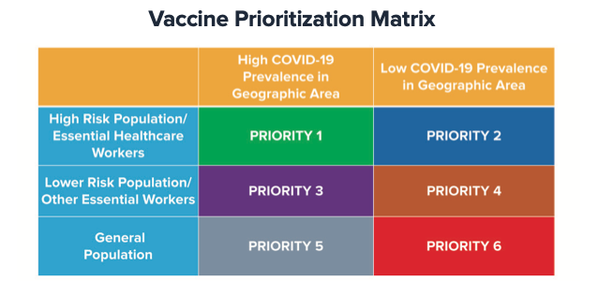
Figure 1. Vaccination matrix ⁷

Figure 2. Vaccination Phases ⁷
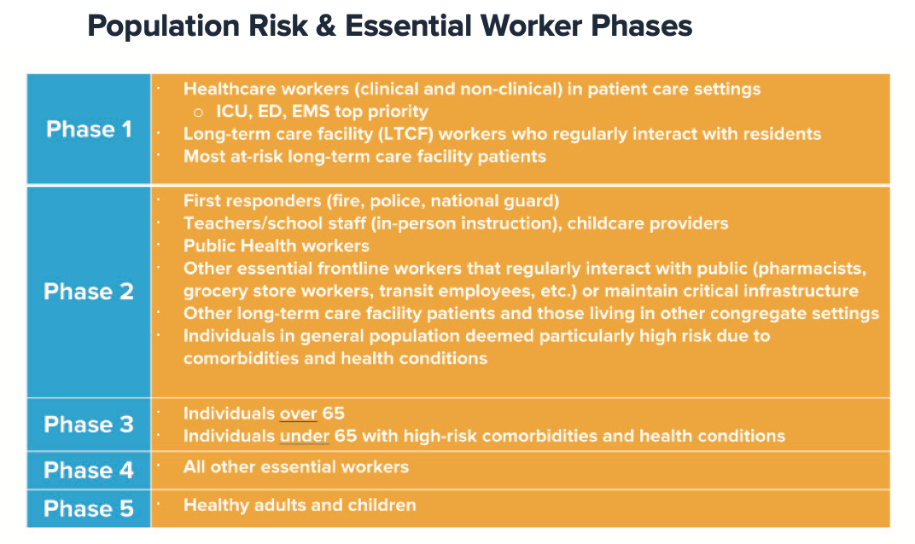

Mass Patient Care
NYC H+H, Presbyterian, Mt. Sinai, Langone, and Weill Cornell will expand patient capacity through the use of tents. In addition to acquisition of hotels for isolation, NYCEM and NYC H+H will also work with Arenas and Stadiums in NYC area to expand patient care capacity.
Mass Fatality Management
New York City Office of Chief Medical Examiner (OCME) will be responsible for Mass Fatality Management. OCME’s Hospital Toolkit contains guidance for NYC hospitals to manage fatality. Hart Island, located in the Bronx, will be used for mass burials.
Environmental Surety
NYS Department of Environmental Conservation will be responsible for canvassing and ensuring environmental safety.
Mental Health of Public Health Emergency Response Personnel
New York State Office of Mental Health will be tasked to respond to mental health services of frontline workers, and those affected by health disasters.

Annex 1: Threat and Hazards Assessment Table: New York, NY (NYC)
Natural | Technological | Human-caused
Resulting from acts of nature | Involves accidents or the failures of systems and structures | Caused by the intentional actions of an adversary
Coastal Erosion  Coastal Erosion can occur gradually or rapidly. During storms, erosion can occur rapidly with entire beaches being lost. Gradual erosion is a continuous process and will occur in 100% of certain locations: Coney Island, Brooklyn, Rockaway Peninsula, Queens, and South Shore, Staten Island.  Costal Storms  There are 3 types of coastal storms, tropical depression, tropical storm, and hurricane. Primarily affecting NYC in August-November, storm surge is a highly dangerous aspect of coastal storms for NYC. This was part of the reason Hurricane Sandy was so damaging.  Drought  There are 4 types of drought that can affect NYC, meteorological, hydrological, agricultural, and socioeconomic. Droughts commonly affect NYC on a city-wide basis because the city gets its water from outside its borders. Since 2003 there have been two periods of dry weather, but neither met the qualifications of drought.  Flooding  There are 4 types of floods that can affect NYC: Coastal flooding, Tidal flooding, Riverine flooding, and Inland flooding. Elderly and low-income populations are particularly at risk for floods. Floods happen often in NYC, usually for one borough but sometimes are city wide.  Winter Storms  There are various types of winter storms: Show Showers, Blizzard, Snowsquall, Thundersnow, and Ice Storms. Impacts can vary based on weather and type, ice storms have a greater potential for damage because of the quick development and greater chance to down power/communication lines. NYC should experience a snowstorm with 16 or more inches every nine years.  Severe Weather  Severe weather is categorized as thunderstorms, tornadoes, and windstorms. There are severe thunderstorms a few times a year, five tornadoes in the time frame of 2007-2014, and at least one high wind event per year. High winds pose a threat to NYC as there are many tall buildings in a dense area.  Wildfires  NYC wildfires do not have the same impact as those in the Western United States. Severity is dependent on weather conditions and most fires are small and do not affect built structures. While wildfires can occur anywhere in NYC, most of the fires in recent years have been in Staten Island.  Earthquakes  Density and aging infrastructure make NYC a risk for earthquakes even though it does not lie on an active zone. The MMI Scale is used to qualify the Richter scale. From 1973 to 2012, there were only two damaging earthquakes of 5.0 or greater that were felt in NYC.  Extreme Temperatures  Extreme weather occurs most in June-August for extreme heat and December and March for extreme cold. The way that NYC is built contributes to the urban heat island effect. From 2006-2014 there was at least one extreme temperature event every year.  Disease Outbreaks  Viral outbreaks are a large concern of NYC as we don’t know when they will happen. Often, the severity of outbreak depends on external countermeasures as much as the disease characteristics. Population growth, population access to healthcare, and evolution of antibiotic-resistant bacteria are all factors that will come into play. The most recent outbreak is COVID-19 which has affected ¼ of a million NYC residents. | Chemical, Biological, Radiological, and Nuclear  Severity of toxicity is dependent on a multitude of factors including type and amount released. It is difficult to accurately portray the probability of such events other than being increased near high risk facilities. Attacks of this nature can occur at ports or other facilities where high volumes of hazardous materials are moved on a frequent basis. Other disasters can cause the release of hazardous materials like Hurricane Sandy.  Infrastructure Failures  Aging systems and increased population growth contribute to potential infrastructure failure in NYC. They include energy systems, telecommunications systems, transportation systems, and water systems. Energy systems are more likely to have incidents during the summer months, during extreme heat events. Telecommunications systems are likely to have incidents when companies do not properly regulate their own systems. Transportation systems and water systems are likely to have incidents during other extreme weather events. | Cyber Threats  NYC is vulnerable to cyber-attacks as we increase dependance on interconnected electronic systems for regulation. The severity of an attack is ranked by the Gibson Index. City-wide effects can result if certain industries are targeted: financial centers, government buildings, media outlets, and transportation authorities. Attacks have occurred with more frequency every year from 2010-2013.

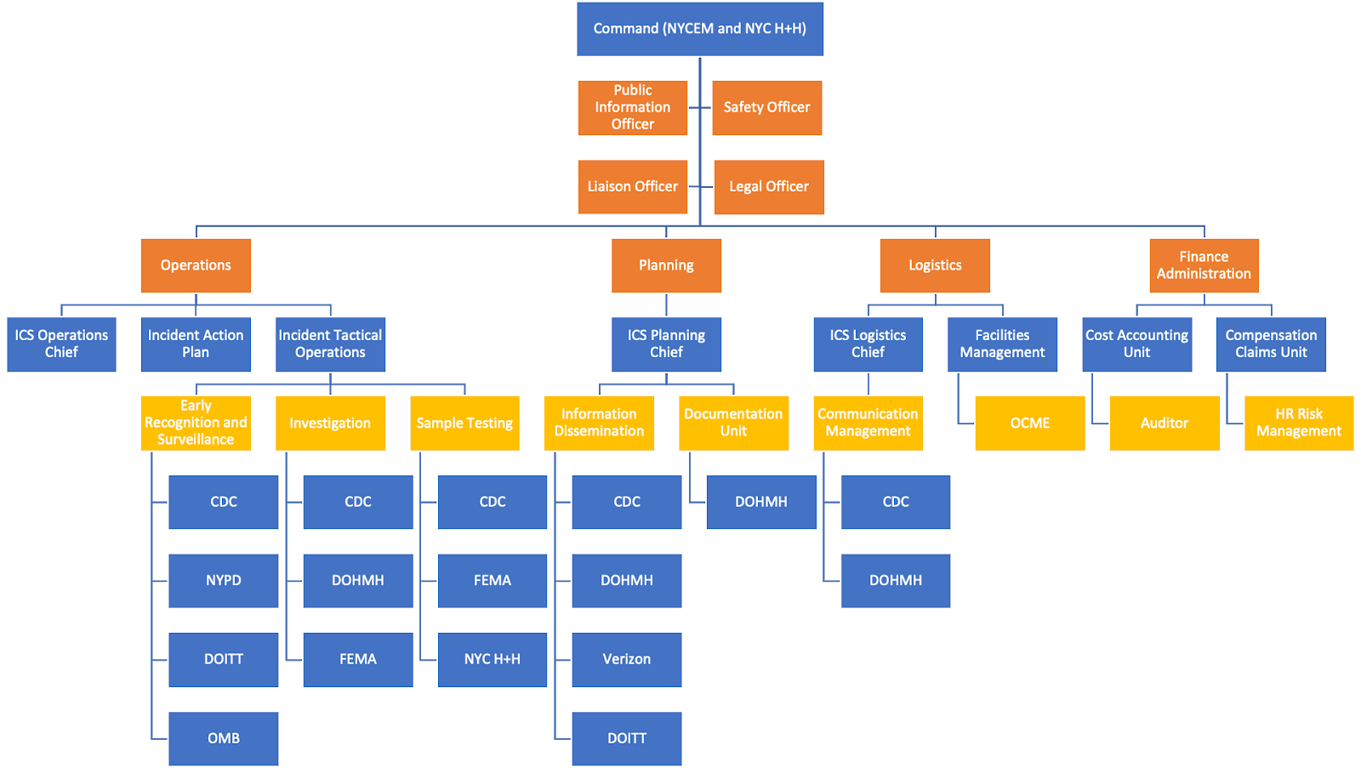
Annex 2: ICS Chart

Annex 3: Training Seminar
Training Seminar Title: Emergency Isolation
Objectives of your Training Seminar (What mitigation strategy are you advocating?) | The objective of this training is to prepare people for having to isolate due to an unknown illness in their home.
Estimate Length of Training | 3 hours
Target Audience and max size of audience. | All households across the boroughs of NYC
Who would be a good candidate (e.g., structural engineer, health dept. official, first responder?) as Facilitator of this session? Why? | NYC DOHMH will be a good facilitator to provide practice text messages and provide “health status” updates during the training
What do you want community members to do as a result of their attending this session? | After the session we want all attendees to:  1. Prepare an emergency kit and disaster plan with their families.  2. Stockpile medical supplies, nonperishable foods, and regular day to day things required to make isolation more comfortable.  3. Confirm hotspot-wifi capacity for all family members  4. Confirm isolation rooms /practices within households between healthy and sick  5. Aware of the city/state recommendations on isolation/quarantine period and practices  6. Recognize and evaluate the risks associated with nonessential travels or activities
Strategies to increase community uptake of your mitigation (We have lots of useful links for checklists on the Course Home page under the Important Links page.)  List the ones you think might be useful (in the appropriate language) or provide a title or two of a list or handout that you think would be good to give out to attendees. | 1. Hand out information sheets on insolation practices (no contact, proper disposal of contaminated trash, laundry, food deliveries)  2. Provide information on testing sites in the area  3. Provide information on how to protect people at higher risk (immunocompromised, elderly, infants)  4. Communication system for those who tests positive (notifying family, close contacts, government, workplace)

Appendix 1
Hospital Name | Bed Capacity | ICU | Intensive Care Beds
Bellevue Hospital Center | 912 | 5 | 40
David H. Koch Center For Cancer Care | 16 | 0 | 0
Harlem Hospital Center | 282 | 3 | 14
Henry J. Carter Specialty Hospital | 201 | 0
Hospital for Special Surgery | 215 | 0 | 4
Lenox Health Greenwich Village | 2 | 0 | 0
Lenox Hill Hospital | 632 | 0 | 15
Memorial Hospital for Cancer and Allied Diseases | 514 | 5 | 20
Metropolitan Hospital Center | 338 | 0 | 18
Mount Sinai Beth Israel | 696 | 0 | 26
Mount Sinai Hospital | 1139 | 21 | 85
Mount Sinai Morningside | 495 | 0 | 24
Mount Sinai West | 514 | 0 | 33
New York Eye and Ear Infirmary of Mount Sinai | 60 | 0 | 0
New York-Presbyterian Hospital - Allen Hospital | 196 | 0 | 6
New York-Presbyterian Hospital - Columbia Presbyterian Center | 1022 | 41 | 99
New York-Presbyterian Hospital - New York Weill Cornell Center | 862 | 23 | 85
New York-Presbyterian/Lower Manhattan Hospital | 180 | 0 | 13
NYU Langone Hospitals | 844 | 34 | 161
NYU Langone Orthopedic Hospital | 225 | 0 | 0
Rockefeller University Hospital | 40 | 0 | 0
 | 9385 | 132 | 643

Works Cited

Cheney C. 2020. CORONAVIRUS: HOW NEW YORK CITY'S PUBLIC HEALTHCARE SYSTEM MANAGED EPIC PATIENT SURGE. Retrieved November 1, 2020 from https://www.healthleadersmedia.com/clinical-care/coronavirus-how-new-york-citys-public-healthcare-system-managed-epic-patient-surge

Feuer W, Mangan D. March 30, 2020. New York coronavirus: Gov. Cuomo welcomes USNS Comfort to NYC. CNBC. Retrieved November 1, 2020 from https://www.cnbc.com/2020/03/30/new-york-coronavirus-gov-cuomo-welcomes-usns-comfort-to-nyc.html

Kanter RK, Moran JR. Hospital emergency surge capacity: an empiric New York statewide study. Ann Emerg Med. 2007 Sep;50(3):314-9. doi: 10.1016/j.annemergmed.2006.10.019. Epub 2006 Dec 18. PMID: 17178173.

New York City Emergency Management. 2014 New York City Hazard Mitigation Plan. New York City Emergency Management Website. https://www1.nyc.gov/assets/em/downloads/pdf/hazard_mitigation/plan_update_2014/final_nyc_hmp.pdf Published April 17, 2014. Accessed September 14, 2020.

New York State Department of Health. Retrieved November 1, 2020 from: https://profiles.health.ny.gov/hospital/bed_type/Total+Beds

New York University. (n.d.). Shipping and Receiving Biological Materials Including Specimens and Infectious Agents. Retrieved November 1, 2020, from Shipping and Receiving Biological Materials Including Specimens and Infectious Agents

New York State Department of Health. (2020, September). NEW YORK STATE’S COVID-19 VACCINATION PROGRAM. Retrieved November 1, 2020, from https://www.governor.ny.gov/sites/governor.ny.gov/files/atoms/files/NYS_COVID_Vaccination_Program_Book_10.16.20_FINAL.pdf

NYC Health + Hospitals to Triple ICU Capacity, Expand Personnel. April 2,2020. Retrieved November 1, 2020 from https://www.nychealthandhospitals.org/pressrelease/nyc-health-hospitals-to-triple-icu-capacity-expand-personnel/

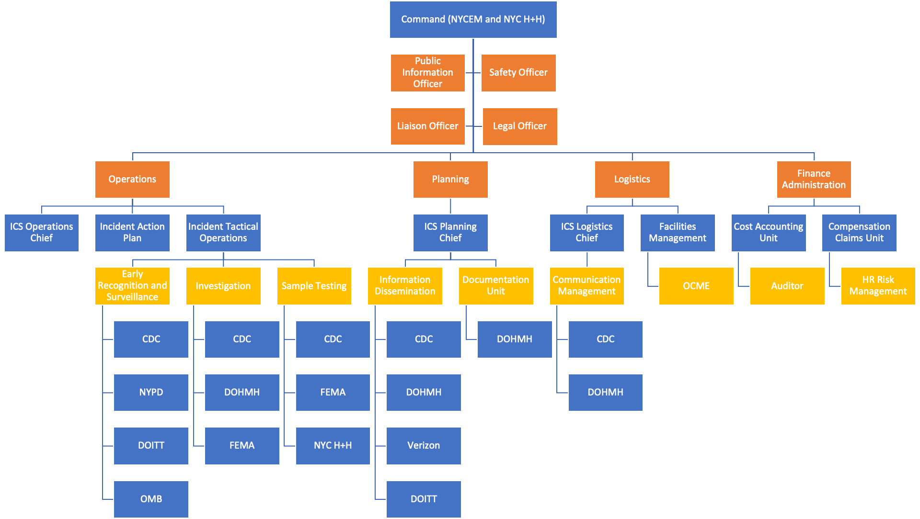
Annex 2: ICS Chart

Annex 3: Training Seminar
Training Seminar Title: Emergency Isolation
Objectives of your Training Seminar (What mitigation strategy are you advocating?) | The objective of this training is to prepare people for having to isolate due to an unknown illness in their home.
Estimate Length of Training | 3 hours
Target Audience and max size of audience. | All households across the boroughs of NYC
Who would be a good candidate (e.g., structural engineer, health dept. official, first responder?) as Facilitator of this session? Why? | NYC DOHMH will be a good facilitator to provide practice text messages and provide “health status” updates during the training
What do you want community members to do as a result of their attending this session? | After the session we want all attendees to:  1. Prepare an emergency kit and disaster plan with their families.  2. Stockpile medical supplies, nonperishable foods, and regular day to day things required to make isolation more comfortable.  3. Confirm hotspot-wifi capacity for all family members  4. Confirm isolation rooms /practices within households between healthy and sick  5. Aware of the city/state recommendations on isolation/quarantine period and practices  6. Recognize and evaluate the risks associated with nonessential travels or activities
Strategies to increase community uptake of your mitigation (We have lots of useful links for checklists on the Course Home page under the Important Links page.)  List the ones you think might be useful (in the appropriate language) or provide a title or two of a list or handout that you think would be good to give out to attendees. | 1. Hand out information sheets on insolation practices (no contact, proper disposal of contaminated trash, laundry, food deliveries)  2. Provide information on testing sites in the area  3. Provide information on how to protect people at higher risk (immunocompromised, elderly, infants)  4. Communication system for those who tests positive (notifying family, close contacts, government, workplace)

Appendix 1
Hospital Name | Bed Capacity | ICU | Intensive Care Beds
Bellevue Hospital Center | 912 | 5 | 40
David H. Koch Center For Cancer Care | 16 | 0 | 0
Harlem Hospital Center | 282 | 3 | 14
Henry J. Carter Specialty Hospital | 201 | 0
Hospital for Special Surgery | 215 | 0 | 4
Lenox Health Greenwich Village | 2 | 0 | 0
Lenox Hill Hospital | 632 | 0 | 15
Memorial Hospital for Cancer and Allied Diseases | 514 | 5 | 20
Metropolitan Hospital Center | 338 | 0 | 18
Mount Sinai Beth Israel | 696 | 0 | 26
Mount Sinai Hospital | 1139 | 21 | 85
Mount Sinai Morningside | 495 | 0 | 24
Mount Sinai West | 514 | 0 | 33
New York Eye and Ear Infirmary of Mount Sinai | 60 | 0 | 0
New York-Presbyterian Hospital - Allen Hospital | 196 | 0 | 6
New York-Presbyterian Hospital - Columbia Presbyterian Center | 1022 | 41 | 99
New York-Presbyterian Hospital - New York Weill Cornell Center | 862 | 23 | 85
New York-Presbyterian/Lower Manhattan Hospital | 180 | 0 | 13
NYU Langone Hospitals | 844 | 34 | 161
NYU Langone Orthopedic Hospital | 225 | 0 | 0
Rockefeller University Hospital | 40 | 0 | 0
 | 9385 | 132 | 643

Works Cited

- New York State Department of Health. Retrieved November 1, 2020 from: https://profiles.health.ny.gov/hospital/bed_type/Total+Beds

- Kanter RK, Moran JR. Hospital emergency surge capacity: an empiric New York statewide study. Ann Emerg Med. 2007 Sep;50(3):314-9. doi: 10.1016/j.annemergmed.2006.10.019. Epub 2006 Dec 18. PMID: 17178173.

- Cheney C. 2020. CORONAVIRUS: HOW NEW YORK CITY'S PUBLIC HEALTHCARE SYSTEM MANAGED EPIC PATIENT SURGE. Retrieved November 1, 2020 from https://www.healthleadersmedia.com/clinical-care/coronavirus-how-new-york-citys-public-healthcare-system-managed-epic-patient-surge

- Feuer W, Mangan D. March 30, 2020. New York coronavirus: Gov. Cuomo welcomes USNS Comfort to NYC. CNBC. Retrieved November 1, 2020 from https://www.cnbc.com/2020/03/30/new-york-coronavirus-gov-cuomo-welcomes-usns-comfort-to-nyc.html

- New York City Emergency Management. 2014 New York City Hazard Mitigation Plan. New York City Emergency Management Website. https://www1.nyc.gov/assets/em/downloads/pdf/hazard_mitigation/plan_update_2014/final_nyc_hmp.pdf Published April 17, 2014. Accessed September 14, 2020.

- NYC Health + Hospitals to Triple ICU Capacity, Expand Personnel. April 2,2020. Retrieved November 1, 2020 from https://www.nychealthandhospitals.org/pressrelease/nyc-health-hospitals-to-triple-icu-capacity-expand-personnel/

- New York University. (n.d.). Shipping and Receiving Biological Materials Including Specimens and Infectious Agents. Retrieved November 1, 2020, from Shipping and Receiving Biological Materials Including Specimens and Infectious Agents

- New York State Department of Health. (2020, September). NEW YORK STATE’S COVID-19 VACCINATION PROGRAM. Retrieved November 1, 2020, from https://www.governor.ny.gov/sites/governor.ny.gov/files/atoms/files/NYS_COVID_Vaccination_Program_Book_10.16.20_FINAL.pdf

