COVID-19 Disaster Plan
Prepared for:

Ashland Veterinary Hospital
513 S Washington HWY
Ashland, VA 23005

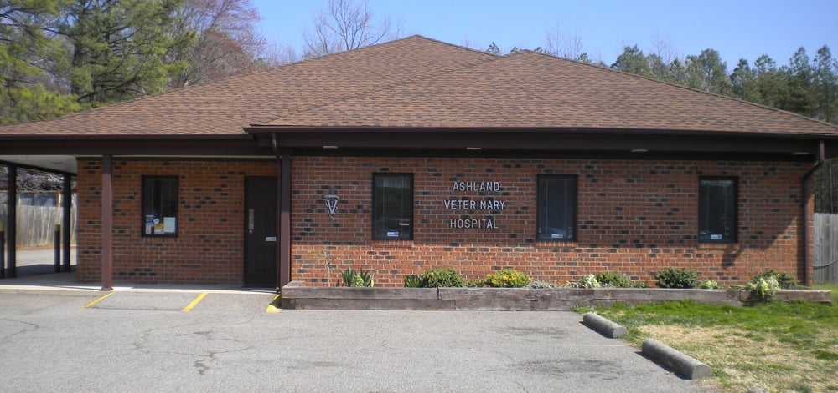

Rebecca Sherrod, MPH, MA, Team 11
New York University
College of Global Public Health
Management of Public Health Disasters
Fall 2020
Table of Contents
Preface 4
Background: 4
Signature Page 5
Veterinarians: 5
Licensed Veterinary Technicians Supervisor: 5
Veterinary Assistant Supervisors: 5
Client Service Representative: 5
Mission of Facility 6
Statement of Purpose 6
Mutual Aid Agreement: 7
Local and National COVID-19 Resources 7
Important National Resources: 7
Important Local Contacts and Resources: 7
Communication 7
Internal Communication: 7
External Communication: 7
Responsibilities for External Communication: 8
Communicating with Clients: 8
Community Training 8
Public Health Concept of Operations: 8
A. Four Stages of Emergency Management: 8
B. COVID-19-Affected Community Needs Assessment 9
C. Matching Needs to Resources 9
D. Evaluating the Effectiveness of Response 10
What do we currently know about COVID-19 and pets 10
Continuing Veterinary Practice as an Essential Service 11
Exposure and Illness in Staff 12
Notification by Employee 12
Return to Work 12
Evaluating and Testing Pets for SARS-CoV-2 13
Clinical Signs in Pets 13
Testing Pets for SARS-CoV-2 13
Personal Protection Equipment for Staff 15
Available at: https://www.avma.org/resources-tools/animal-health-and-welfare/covid-19/guidelines-ppe-covid-19-pandemic-demand-exceeds 15
Scrubs and Uniforms: 15
PPE: 15
CDC PPE recommendations based on companion animal history 16
Annex 1: Threats and Hazard Identification and Risk Assessment (THIRA) 17
Annex 2: Incident Command System 18
18
Annex 3: Community Training Plan 19
Annex 4: AVMA Guidance on Testing for SARS-COV-2 20
Works Cited 21

Preface

Background:
On January 30th, 2020, the World Health Organization declared a Public Health Emergency of International Concern in response to the outbreak of a novel Coronavirus (COVID-19) in Wuhan, China. By March 11th, 2020, the WHO declared the outbreak a pandemic, as the virus spread across the globe. The CDC confirmed the first case of COVID-19 in the United States in Washington state on January 20th, 2020. To date, there are over 12,000,000 confirmed cases within the United States of America, with over 250,000 dead (World Health Organization, 2020).

SARS-CoV-2 or “COVID-19” is a respiratory virus, similar to SARS or MERs-CoV. Common symptoms include fever, dry cough, shortness of breath, fatigue, loss of smell, loss of appetite, and body aches. There is currently no known cure. However, multiple vaccines are now in Phase III trials.

The pandemic has changed the process of everyday life, altering many workplace activities, including animal healthcare. The veterinarians and staff are essential employees and must make every effort to maintain a safe environment for themselves, the clients, and pets.

Signature Page

Veterinarians:

_____________________________________________________________________________
Jenny Campbell, DVM (Owner and Veterinarian) Date

_____________________________________________________________________________
Deborah Inge, DVM Date

_____________________________________________________________________________
Kim Cochran, DVM Date

_____________________________________________________________________________
Judy Mason, DVM Date

Licensed Veterinary Technicians Supervisor:

______________________________________________________________________________
Samantha Wood, LVT Date

Veterinary Assistant Supervisors:

______________________________________________________________________________
Jessica Parks Date

Client Service Representative:

______________________________________________________________________________
Ginny Creel Date

Mission of Facility

Ashland Veterinary is an AAHA accredited, a small animal hospital dedicated to protecting the human-animal bond through exceptional health care for pets. We work with pet families to promote long, healthy lives for their companions. The mission of this hospital is to fulfill the needs of our clients by providing quality health services through a responsive, professional staff with an emphasis on individual attention and commitment to community service. We are a team of animal-loving individuals who work together for your pets.

Statement of Purpose

The purpose of this plan is to address and plan for the following types of COVID-19 related events. Staff should update this plan every year to account for new guidelines and information.

- What do we currently understand about animals and COVID-19?
- Exposure and Illness
- Exposure and Illness in staff
- Exposure and Illness in clients
- Evaluating and Testing Pets for COVID-19
  - Clinical signs in pets
- Personal Protective Equipment for Staff
- Information for Clients about COVID-19
- When to postpone elective procedures, surgeries, and non-urgent veterinary visits

Mutual Aid Agreement:

Recognizing the need to assist and coordinate with local and regional organizations AVH will establish mutual aid agreements to ensure continued access to pet food, supplies, knowledge and information during COVID-19 outbreaks. AVH will reach agreements with the following organizations -

    - Chenault Veterinary Hospital
    - Fin and Feather Pet Center
    - Hanover Health Department

Local and National COVID-19 Resources

Important National Resources:

- OSHA Guidance on Preparing Workplaces for COVID-19
- AVMA COVID-19 Resource Page
- CDC Information for Healthcare Professionals about COVID-19
- American Animal Hospital Association COVID-19 Resources

Important Local Contacts and Resources:

- Chickahominy Health District
- Virginia Department of Health COVID-19 Resources for Health Professionals

Communication

Internal Communication:
During COVID-19, it is crucial to keep open lines of communication between staff. It is imperative to inform staff of their roles and responsibilities, the hospital's status, updated COVID-19 guidelines, etc. This could include morning and afternoon updates to ensure all shifts receive the same information or automatic calls or emails with reminders of updated guidelines.

External Communication:
During COVID-19, many clients will rely on the hospital for guidelines regarding pet healthcare. It is critical to have open lines of communication for all clients (existing and new). In addition to regular contact regarding appointments, questions, concerns, etc., periodic newsletters to inform clientele of the latest developments regarding their pets and COVID-19 should be maintained. Additionally, the hospital will need to maintain regular contact with any vendors or outside organizations to ensure access to critical resources (PPE, medications, etc.). The hospital should sign at least one doctor and one staff member to serve as client liaisons and one staff member as a liaison for vendors, including retailers, laboratories, pharmacies, etc.

Responsibilities for External Communication:
Not everyone in the hospital should be communicating with external organizations or clients about COVID-19 procedures and guidance. It is appropriate to have one to two people designated to talk with clients who call for COVID-19 related advice. These people could be the Client Service Representative and one of the doctors. Additionally, one person should be designated as the contact for vendors and ensuring supply access.

Communicating with Clients:
The CDC suggests sharing the following information with clients concerned about transmitting COVID-19 to and from pets. Please visit the CDC regularly for updated information (CDC, 2020).

    - A small number of pets worldwide with close contact with people with COVID-19 were infected with COVID-19
    - While information is limited, the risk of animals spreading COVID-19 is low
    - In some situations, people can spread COVID-19 to animals
    - Similarly, to humans, do not let your pets interact with people or pets outside of your household
    - If a household becomes ill with COVID-19, isolate this person from other household members AND pets

See Annex’s 5, 6, and 7 for helpful AVMA handouts for clients.

Community Training

Clients will have many questions regarding the safety of pets and caring of pets during COVID-19 pandemic. AVH should develop and 1-to-2-hour training session available to clients over social media, YouTube, or email. The training session should address basic COVID-19 FAQ’s and at home pet care for clients who test positive for COVID-19. The goals of this training session are the following –

- To inform clients of low risk of transmission between humans and pets
- How to care for pets if household member tests for COVID-19
- How to identify COVID-19 in pets
- The difference between urgent and non-urgent vet care needs

See Annex 3 for training seminar outline.

Public Health Concept of Operations:

Four Stages of Emergency Management:
Ashland Veterinary Hospital needs to identify and prepare for the four phases of emergency management.

Mitigation:
What strategies will AVH have to prevent COVID-19 (and other infectious diseases) transmission daily?

Preparedness:
What will AVH do ahead of time to plan for future COVID-19 outbreaks (training, gathering supplies, community awareness)?

Response:
What strategies and techniques will AVH have to respond to the COVID-19 outbreak and maintain as regular business continuity as possible?

Recovery:
Determine how AVH will scale back COVID-19 measures and return to regular hospital functions but with enhanced situational awareness. Veterinary staff should monitor local health department reports regarding community spread and to reevaluate the need to return to the response phase (see Annex for list of local contacts).

COVID-19-Affected Community Needs Assessment

It is essential to understand what community members (clients) need during COVID-19 outbreaks. For example, – clients may want flexibility in appointments (in-person vs. tele-visits) or can prescriptions be mailed versus picked up. Gathering this information will allow AVH to tailor its disaster plan to incorporate their clients' needs but should not compromise CDC guidelines and protocols to maintain staff and client safety. In some cases, the clients' requests may not be appropriate or feasible to maintain the safety of staff and pets.

It is also essential to keep in mind vulnerable populations when developing a community needs assessment. Assuming some of AVH's clients and staff identify as a vulnerable population, how will AVH adjust its disaster plan to identify and suit those needs. Vulnerable populations to keep in mind include –
- Chronically ill and disabled
- Low-income (and COVID-19 related income disparities)
- Elderly clients and staff

AVH can ask clients to complete anonymous surveys (online or email) to gather information regarding what clients would like to see regarding AVH's response to COVID-19.

Matching Needs to Resources

Using the results of the community-needs assessment, AVH should adjust the disaster plan. Depending on the results, the ICS's various section chiefs should meet to determine how these assessments will be incorporated or met. For example, if community members are concerned about how they will pay for animal healthcare or emergencies, the

Finance Section Chief should identify measures to provide reduced-cost services or establishing lines of credit for established patients. Another example could include tele-visit appoints for patients who are considered vulnerable. The Logistics, Planning, and Operational chiefs and safety officer should meet to determine the best way to conduct these visits, what technological resources need to be available, and how to educate clients to use video services.

Evaluating the Effectiveness of Response

Following response efforts and during the recovery phase, AVH should evaluate the effectiveness of response efforts from the client and the staff's perspective. AVH may survey a smaller subsection of clients to determine how they felt about AVH's response strategies. AVH should also conduct an internal assessment to understand success and barriers to meeting the needs of staff and conducting business during COVID-19. AVH should adjust internal workplace police based on this assessment. It might be beneficial to work with another local veterinary clinic to understand their techniques and standards. Future COVID-10 plan updates should be incorporate these evaluations and appropriate changes.

What do we currently know about COVID-19 and pets
SARS-CoV-2 is the novel zoonotic virus that causes COVID-19 in humans. Currently, the CDC and USDA recognize only a small number of cases of SARS-COV-2 in pets (cats and dogs) and only reported minimal respiratory symptoms in these cases (CDC, 2020). The AVMA reports that SARS-CoV-2 does not easily infect pets (AVMA, 2020b).

Continuing Veterinary Practice as an Essential Service

 | Phase I: Initial Resumption | Phase 2: Intermediate Resumption |  | Phase 3: New Normal
People | - Vulnerable* team members continue to shelter in place  - Team members with vulnerable* household members observe extra precautions  - Maximize physical distance in public  - Limit gatherings to < 10 people |  | - Vulnerable* team members continue to shelter in place; consider offering vulnerable team members duties that minimize their contact with other staff members or clients  - Team members with vulnerable* household members observe extra precautions  - Maximize physical distance in public  - Limit gatherings to < 50 people | - Vulnerable* team members back at work, but maintain social distance  - Other team members minimize time in crowded environments, inside and outside of the practice
Practices | - Return reduced staff gradually (25% at a time)  - Encourage telework for team members where possible  - Keep lobby and common areas where clients and/or team members congregate closed  - Strongly consider accommodations for vulnerable* team members |  | - Continue returning staff gradually and to normal schedules  - Encourage telework for team members where possible  - Limited lobby and common area access with adherence to social distancing  - Strongly consider accommodations for vulnerable* team members | - Normal work schedules  - Gradually return to normal lobby and common area access, adhere to social distancing
Elective surgeries | - Assess sufficiency of PPE (ensure able to treat urgent cases and that shortages affecting human health care in area have been addressed)  - Resume as clinically appropriate and with attention to impact on scheduling |  | - Assess sufficiency of PPE (ensure able to treat urgent cases)  - Perform as clinically appropriate | Perform as clinically appropriate
Travel | - Minimize non-essential travel  - Adhere to CDC self-isolation guidelines after trips |  | Non-essential travel can resume, restrictions to/from affected areas may continue | Restrictions to/from affected areas may continue
Veterinary medicine is an essential service. Employees should look to state and local guidelines for re-opening timelines. The AVMA, in accordance with the White House and CDC’s “Opening up America Again” plan, developed guidelines for phasing re-opening of veterinary clinics. Use the AVMA’s guidelines to guide AVH during response and recovery phases.
Adapted from: https://www.avma.org/resources-tools/animal-health-and-welfare/covid-19/practicing-veterinary-medicine-during-covid-19

Exposure and Illness in Staff

It is important to remember that employee’s health and medical conditions still fall under HIPPA even during a pandemic. With respect to HIPPA – the clinic should inform staff, and if applicable, clients, of possible or confirmed exposure to COVID-19 but should not release name of affected employee. This works both ways, if a client alerts clinic staff to COVID-19 diagnosis, the clients name should not be released.

Notification by Employee

The employee MUST notify manager if –
- Employee is exposed or diagnosed with COVID-19
- Employee has been in close proximity (e.g., living, working, socializing) with someone diagnosed with COVID-19
- Experiencing any of the following symptoms:
  - Fever
  - Cough
  - Shortness of breath
  - Breathing difficulties
  - Loss of taste or smell

Return to Work

The AVMA recommends two strategies c to determine, when an employee may return to work after confirmed or suspected illness with COVID-19 in addition to a strategy for employees who test positive for COVID-19 but are asymptomatic (AVMA, n.d.). AVH should determine which strategy it will use and understand how insurance impacts employee testing and care. Ability to test may depend on availability of testing resources (AVMA, 2020d).

Non-Test Based Strategy
Employees with COVID-19 symptoms but not test confirmation and were directed to isolate and care for themselves at home may return to work after meeting the following conditions-
- At least 3 days (72 hours) have passed since recovery – this means the lack of fever WITHOUT the use of fever-reducing medications and improvement of respiratory symptoms AND
- At least 10 days have passed since symptoms first appeared.

Test-Based Strategy
Employees with COVID-19 symptoms were directed to isolate and care for themselves at home may return to work after meeting the following conditions-
- Resolution of fever without the use of medications and improvement in respiratory symptoms AND
- Negative results of an FDA Emergency Use Authorized molecular assay for COVID-19 from at least two consecutive nasopharyngeal swabs collected 24 hours apart.

Asymptomatic and Test-Based Strategy
Employees with a laboratory confirmed COVID-19 but no symptoms may return to work after at least 10 days from their first positive test.

Evaluating and Testing Pets for SARS-CoV-2

Clinical Signs in Pets

There is limited information on the clinical symptoms of SARS-CoV-2 due to the small number of confirmed cases in pets. The CDC suggests clinical symptoms considered compatible with SARS-CoV-2 include the following (CDC, 2020) –
- Fever
- Coughing
- Difficulty breathing or shortness of breath
- Lethargy
- Sneezing
- Nasal/ocular discharge
- Vomiting
- Diarrhea

Testing Pets for SARS-CoV-2

The AVMA, CDC, USDA, American Association of Veterinary Laboratory Diagnosticians (AAVLD), National Association of State and Public Health Veterinarians (NASPHV), and the National Assembly of State Animal Health Officials currently DO NOT recommend routine testing of animals. The AVMA states “The decision to test an animal should be made collaboratively between the attending veterinarian and local, state, and/or federal public health and animal health officials after careful and deliberate consideration of available guidance and the criteria (AVMA, 2020a).” These previous regulatory authorities recommend testing for small animal clinics during the following situations -

- The animal has clinical signs consistent with SARS-CoV-2, more common causes of the patient’s clinical signs have been ruled out, and the animal has a history of
  - Close contact with a person with suspected or confirmed COVID-19, or
  - Exposure to a known high-risk environment where a human outbreak occurred, such as a residence, facility (e.g., nursing home, prison), or cruise ship
- Atypical patterns of disease suggesting a novel pathogen in a mass care situation (e.g., animal shelter, boarding facility, animal feeding operation, zoo) where exposure history is not known (appropriate diagnostics should be undertaken first to rule out more common causes of illness)
- The atypical pattern of disease suggesting infection with SARS-CoV-2 in recently imported animals (appropriate diagnostics should be undertaken first to rule out more common causes of illness)

Please refer to the flow chart in Annex 4 regarding testing developed by the AVMA.

Personal Protection Equipment for Staff

The following is a set of general PPE guidelines. These guidelines are changing rapidly. The AVMA provides the following ‘hierarchy of controls’ adapted from the CDC to help visualize how to prevent occupational exposure to COVID-19. However, some controls are not feasible (e.g., physically removing the hazard is not an option when dealing with COVID-19) (AVMA, 2020c). AVMA suggests the best way to decrease and prevent transmission of COVID-19 is to combine control methods from multiple levels of the hierarchy (AVMA, 2020c). The following guidelines fall under the final, and least effective type of hazard control – PPE.

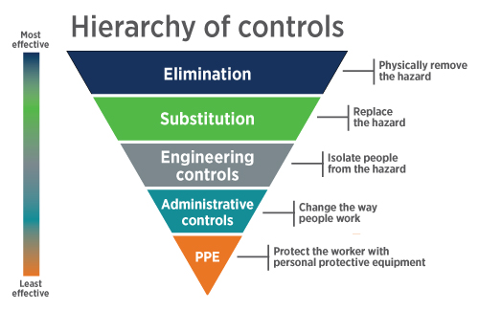

Available at: https://www.avma.org/resources-tools/animal-health-and-welfare/covid-19/guidelines-ppe-covid-19-pandemic-demand-exceeds

Scrubs and Uniforms:

Staff should wear uniforms and scrubs while working in the clinic. Staff should change in to scrubs when beginning shift and change out of scrubs before going home and should not be worn to and from work. Consider laundering all staff uniforms at the end of the day.

PPE:

The CDC recommends clinics have the following PPE available to staff (CDC, 2020) –

- Facemask
- Eye Protection (face shield, goggles)
- Gloves
- Protective Outerwear (gown or coveralls)
- N95 Respirator

CDC PPE recommendations based on companion animal history
Animal History | Facemask | Eye Protection (face shield, goggles) | Gloves | Protective Outerwear (gown or coveralls) | N95 Respirator or Suitable Alternative
Healthy companion animal without exposure to a person with COVID-19 compatible symptoms^{1, 2} | N | N | N | N | N
Companion animal with an illness that is not suspicious of SARS-CoV-2 infection⁵ AND without exposure to a person with COVID-19 compatible symptoms^{1, 2} | N | N | N | N | N
Companion animal that is not suspicious of SARS-CoV-2 infection BUT has exposure to a person with COVID-19 compatible symptoms | Y | N | Y | N | N
Companion animal with an illness that is suspicious of SARS-CoV-2 infection | Y | Y | Y | Y | N
Aerosol-generating procedure for any animal without an exposure to a person with COVID-19 compatible symptoms⁶ | Y | Y | Y | Y | N
Aerosol-generating procedure for any animal with an exposure to a person with COVID-19 compatible symptoms⁶ | N | Y | Y | Y | Y
Any procedure on an animal that is known to be currently infected with SARS-CoV-2 through detection by a validated RT-PCR assay | N | Y | Y | Y | Y
Any procedure where a person with suspected or confirmed COVID-19 will be present | N | Y | Y | Y | Y
Adapted from the CDC website https://www.cdc.gov/coronavirus/2019-ncov/community/veterinarians.html

Annex 1: Threats and Hazard Identification and Risk Assessment (THIRA)
Natural | Technological | Human-caused
Resulting from acts of nature | Involves accidents or the failures of systems and structures | Caused by the intentional actions of an adversary
Pandemic/Epidemic  - Based on the current COVID-19 pandemic and past Influenza outbreaks, AVH is susceptible to both types of infectious disease events.  Hurricane and Tropical Storm  - Due to geographical location, the AVH is at increased risk for damage from storms. Impacts of storms could include power outages, flooding, and infrastructure damage.  Winter Storms  - Due to geographical location the surrounding area is frequently hit by winter storms including snow and ice. This can impact ability of staff to travel to work, or inability to access animals overnighting at clinic.  Extreme Heat  - During summer months there is an increased risk of extreme heat. AVH may see increased activity surrounding overheating in animals.  Earthquakes  - Earthquakes occasionally hit this region of Virginia. While low risk there have been instances of infrastructure damage. | Water Contamination  - The AVH uses city water. Therefore, a backup water system should be in place. There is an increased risk of illness in staff and/or pets and inability to perform certain health and hygiene tasks if water becomes unavailable.  Power Outages  - AVH has backup power generators if the power grid fails. This is critical if animals are under anesthesia or using relying on lifesaving equipment.  Firewall Failure  - AVH uses electronic medical records. If the system fails, staff will be unable to access important medical documents and must rely on paper documents.  Telephone System  - AVH relies on telephones to contact patients. | Workplace Violence  - Due to stressful nature of workplace the AVH is at an increased risk of workplace violence.  Active Shooter  - AVH is located off of Interstate 95. While the risk is low there have been instances of active shooters in this area.  Hostage Situation  - Disgruntled clients may seek to harm AVH staff.

Annex 2: Incident Command System
Operational Section Chief
(Samantha Woods)
- Collect and manage all relevant operational data
- Conduct and facilitate planning meetings
- Determine need for specialized resources
- Report significant changes in incident status
- Monitors incident-related costs
- Provides overall fiscal guidance.
- Provide all transportation, communications, supplies, equipment maintenance and fueling, food and medical services for personnel
- Request additional resources as needed
Finance/Admin Section Chief
(Kevin McLoughlin)
Logistics Chief
(Ginny Creel)
Planning Section Chief
(Chloe Bucther)
Public Information Officer
(Dr. Deborah Inge)
Liaison Officer
(may not be necessary)
Safety Officer
(Dr. Kim Cochran)
Incident Commander
(Dr. Campbell)
COVID 19 Specialist
(Determine who this will be as it may need to be an outside source)
- Ensure safety of operations
- Manage operations
- Request additional resources for operations
- Make or approve expedient changes to incident plan

Annex 3: Community Training Plan

Training Seminar Title: COVID-19 Management in Pets
Objectives of your Training Seminar (What mitigation strategy are you advocating?) | How to effectively care for pets during COVID-19 outbreak  - Community resilience  - Public Information and Warning
Estimate Length of Training | 2 hours
Target Audience and max size of audience. | Clients of Ashland Veterinary Hospital. No max size as it will be recorded and disseminated through AVH’s Facebook page and emailed to clients with emails on file.
Who would be a good candidate (e.g., structural engineer, health dept. official, first responder?) as Facilitator of this session? Why? | Doctor, Veterinary Technician, and/or Veterinary Assistant.  A vet tech or assistant can demonstrate appropriate handling of sick pets or how to handle pest when you are sick. A doctor should be the only person giving medical advice.
What do you want community members to do as a result of their attending this session? | - To be informed on the risks of COVID-19 spread from humans to pets.  - How to care for pets if owner (human) is COVID-19 positive.  - How to care for pets that test COVID-19 positive.  - To feel confident about caring for their pets independently  - To feel comfortable continuing regular veterinary care and visits during COVID-19 outbreak  - Know who to contact for help with pet related questions
Strategies to increase community uptake of your mitigation | - Stream and record video versus holding in person training session  - Provide handouts with summaries and contact information (Pdf or emailed copies)  - Allow community members to email or call-in questions BEFORE event so they may be answered during training session but also dedicate additional time afterwards for questions  - Market training session through mailers, Facebook, and email.

Annex 4: AVMA Guidance on Testing for SARS-COV-2
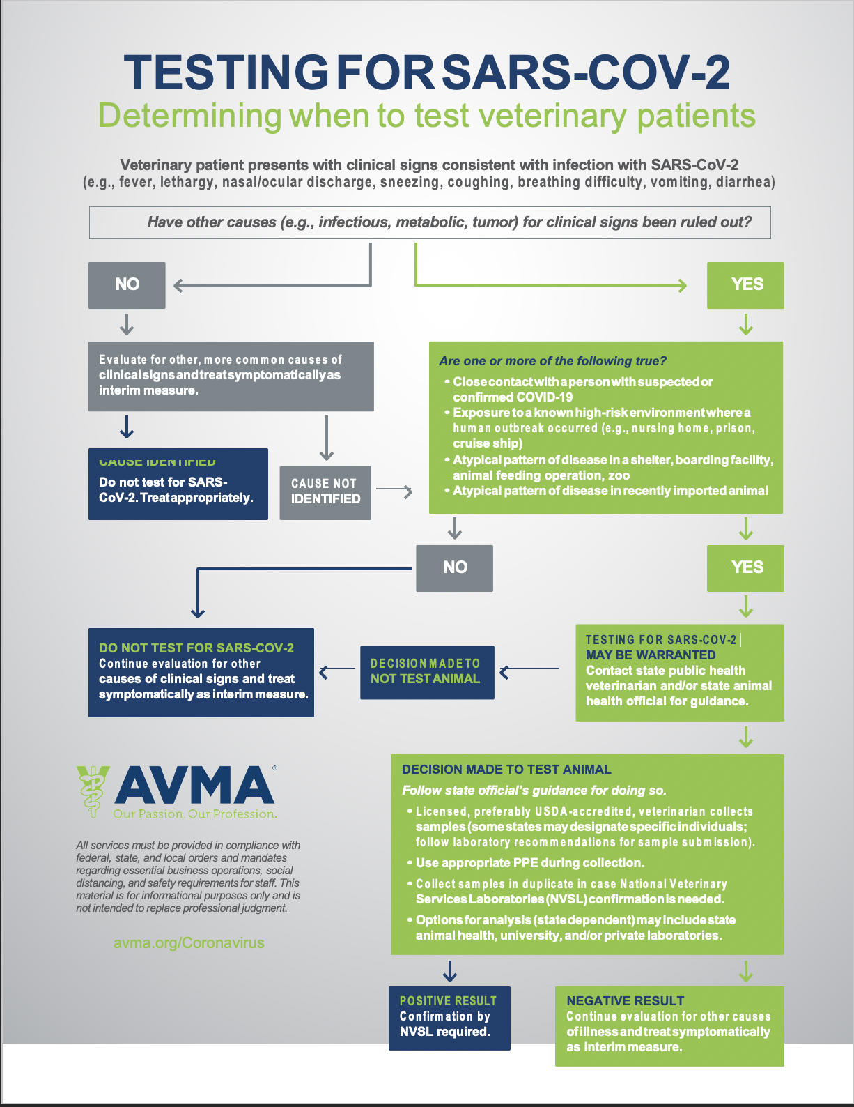
Available at: https://ebusiness.avma.org/files/coronavirus/COVID-19-Testing-Flowchart.pdf

Works Cited

AVMA. (n.d.). Guidance for managing veterinary employees with confirmed or suspected COVID-19 exposure or disease. AVMA. https://www.avma.org/resources-tools/animal-health-and-welfare/covid-19/guidance-managing-employees-confirmed-suspected-covid-19-exposure-disease
AVMA. (2020a, May 26). Testing animals for SARS-CoV-2. AVMA. https://www.avma.org/resources-tools/animal-health-and-welfare/covid-19/testing-animals-sars-cov-2
AVMA. (2020b, June 11). SARS-CoV-2 in animals. AVMA. https://www.avma.org/resources-tools/animal-health-and-welfare/covid-19/sars-cov-2-animals-including-pets
AVMA. (2020c, June 12). Guidelines for PPE use as veterinary facilities resume providing normal services. AVMA. https://www.avma.org/resources-tools/animal-health-and-welfare/covid-19/guidelines-ppe-covid-19-pandemic-demand-exceeds
AVMA. (2020d, July 2). Practicing veterinary medicine during COVID-19. AVMA. https://www.avma.org/resources-tools/animal-health-and-welfare/covid-19/practicing-veterinary-medicine-during-covid-19
CDC. (2020, August 12). Veterinary Clinics. Centers for Disease Control and Prevention. https://www.cdc.gov/coronavirus/2019-ncov/community/veterinarians.html#currently-know-animals-covid19

